Arburg Exhibit at NPE 2024
Allrounder 720 A: Efficient injection compression molding of IML thin-walled cups

- Powerful: Electric Allrounder "Ultimate"
- Energy-efficient: Injection compression molding as an alternative to thermoforming
- Comprehensive: Arburg presents a great many sustainable, digital and automated solutions

Loßburg, 08/04/2024
An electric Allrounder 720 A in the "Ultimate" performance variant demonstrates at NPE 2024 that high-quality injection molding technology can be an alternative to thermoforming. The exhibit uses injection compression molding to produce thin-walled IML cups that can be easily recycled after use.

The directly driven high-performance machine with a clamping force of 320 tons (2,900 kN) is equipped with a 29.8 ounces (size 1300) injection unit that is specifically optimized for high performance. Thanks to high-precision servo motors from Arburg's sister company AMKmotion, very high injection volume flows and injection speeds of up to 15.7 inches (400 mm) per second can be achieved.

IML cups only 0.015 inch (0.37 mm) thick
The exhibit uses a 4-cavity mold from Brink to produce thin-walled IML round cups from polypropylene (PP) using injection compression molding at an injection pressure of just 23,000 psi (1,600 bar). For process monitoring, the mold is equipped with six high-resolution inductive position measuring and embossing sensors. Four molded parts, each weighing 0.37 ounces (10.4 g) and with a wall thickness of only 0.015 inch (0.37 mm), are produced in a cycle time of 3.95 seconds. The plastic has a biomass footprint and ISCC-certified. Also integrated into the production cell is a side-entry robot from Brink that inserts the labels, removes the finished cups and stacks them on a conveyor belt.

Resource-saving and recyclable
In this particularly resource-saving application for the packaging industry, special emphasis was placed on energy efficiency and on a part design that saves materials. Thanks to the all-electric packaging machine in combination with injection compression molding, the energy footprint is improved by 20 per cent with a significant reduction in part weight from 0.45 to 0.37 ounces (13 to 10.4 g). The flowpath/wall thickness ratio is 380:1. Normally, this would require a very high level of injection pressure – at the expense of energy requirements and mold wear. This is why injection compression molding is used for this application. Compared to classic injection molding, this process requires significantly less injection pressure and it is possible to work with mold temperatures of 68 instead of 54 degrees Fahrenheit (20 respectively 12 °C). The special "Next Cycle IML" label can be separated from the PP of the cup during recycling, so that the product can be recycled by type after use. In contrast to thermoforming, there are no pre-produced foils and stamping waste.

(Youtube-Video: https://youtu.be/GzD9VTv-9fM?si=qFaKLrjc_YhohJa-)

Photos

720A_IML-cups_196678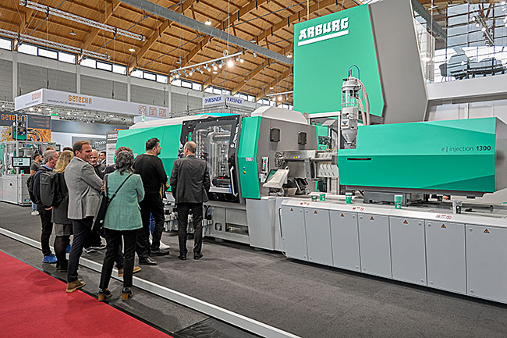
Energy- and resource-saving alternative to thermoforming: An electric Allrounder 720 A "Ultimate" produces thin-walled IML cups at NPE 2024 using the injection compression molding process.

720A_cups_196311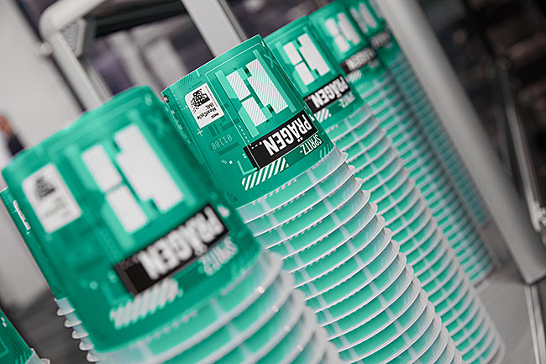
The recyclable IML round cups made of PP monomer material have a wall thickness of only 0.015 inch (0.37 mm).

Photos: ARBURG

Photo download:
https://media.arburg.com/web/b85fdbce19c0fe8e/allrounder-720a-npe-2024/

Press release
File: ARBURG press release Allrounder 720 A NPE 2024_en_US.docx
Characters: 2,584
Words: 403

This and other press releases are available for download from our website at www.arburg.com/de/presse/ (www.arburg.com/en/press/)

Contact
ARBURG GmbH + Co KG
Press office
Susanne Palm
Dr Bettina Keck
Postfach 1109
72286 Lossburg
Tel.: +49 (0)7446 33-3463
Tel.: +49 (0)7446 33-3259
presse_service@arburg.com

About Arburg
Founded in 1923, the German family-owned company is one of the world’s leading manufacturers of plastic processing machines. The ARBURG family also includes AMKmotion and ARBURGadditive, including innovatiQ.
The portfolio includes injection molding machines, 3D printers for industrial additive manufacturing, robotic systems and customer- and industry-specific turnkey solutions. It also includes digital products and services.
ARBURG is a pioneer in the plastics industry when it comes to energy and production efficiency, digitalisation and sustainability. ARBURG machines are used to manufacture plastic products for industries such as mobility, packaging, electronics, medicine, construction and equipment engineering and leisure.
The company headquarters are located in Lossburg, Germany. In addition, ARBURG has its own organisations at 36 locations in 26 countries and, together with trading partners, is represented in over 100 countries. Of a total of around 3,700 employees, some 3,100 work in Germany while around 600 are based in ARBURG organisations around the world.
ARBURG is certified in accordance with ISO 9001 (quality), ISO 14001 (environment), ISO 27001 (information security), ISO 29993 (training) and ISO 50001 (energy).
Further information: www.arburg.com, www.amk-motion.com and www.arburg.com/arburgadditive.

