Arburg at Chinaplas 2024
World premiere and trade fair appearance a complete success

- World premiere: Electric Allrounder from the new Golden Electric Evo series
- Crowd pullers: arburgSOLUTIONworld, new Asia machine and extensive expert solutions
- Powerful trade fair presence: Focus on mobility and medical technology applications

Lossburg, 29/04/2024
Arburg had an extremely satisfactory trade fair appearance at Chinaplas 2024, which attracted a great deal of attention. Returning to Shanghai after a six-year break, the trade fair saw huge crowds at the National Exhibition and Convention Center and Arburg's stand in Hall 4.1. A key highlight was the premiere and unveiling of the Allrounder 470 E Golden Electric Evo – the new electric entry-level machine for the Asian market. There was also great interest in arburgSOLUTIONworld and the focal topics of digitalisation, mobility and medicine.

"The number and quality of visitors was just right. We presented ourselves to excellent effect at our centrally located stand in Hall 4.1, where most of the Asian machine manufacturers were also located. With our "local-to-local" approach and product, we are also moving ever closer to our customers in China and Asia from a strategic perspective," says a delighted Zhao Tong, Managing Director of Arburg China, commenting on the very successful conclusion of Chinaplas 2024. "The new electric entry-level machine designed for this dynamic market impressed trade visitors with its attractive price/performance ratio and short delivery times." Dr Christoph Schumacher, Vice President Global Marketing, adds: "We are very satisfied with the repositioning of the Arburg stand. Our planning worked out perfectly. The same applies here: even closer to the markets!" In addition to presenting attractive machines, the unique 'arburgSOLUTIONworld' and pioneering digital products at the trade fair, the company also showcased its comprehensive solution and consulting expertise in the field of plastics processing. Besides innovative machine technology and digitalisation, this also included the hugely important topics of sustainability and automation.

New electric machine – fully customised for Asia
Arburg is taking a new approach with its local-to-local activities: Whereas Allrounders were previously built exclusively at the German headquarters in Lossburg, value-added stages are now being internationalised. Arburg has systematically tailored the Allrounder Golden Electric Evo, which is available in sizes 370, 470, 520 and 570, to the Asian market. The production of all components and parts requiring expertise and key technologies continues to take place in Germany. Assembly is carried out at the Arburg Technology Factory in Pinghu, where the range of automation and turnkey solutions is also being continuously expanded in cooperation with local partners. "It is important and essential to note that 'Made by ARBURG' remains 'Made by ARBURG'", says Dr Christoph Schumacher.
The new electric entry-level machine is characterised by the high precision of its injection units, short cycle times, faster dry cycle times and a reduction in the energy requirement of up to 50 per cent. At Chinaplas 2024, the exhibit, an Allrounder 470 E Golden Electric Evo, produced precise LSR components for use in cars. A Flexlift linear robotic system was tasked with handling the parts.

arburgSOLUTIONworld and digitalisation
"arburgSOLUTIONworld", an exhibition area centred around a four-metre-high LED column, also met with great interest. This is where Arburg experts offered individual advice on important topics including digitalisation, automation, moulds, sustainability and service. Interest in digitalisation is high in China, which has the world's largest 5G network. A key element here is the Arburg host computer system ALS, which is now available in version 8.0. The modernised look and feel includes new icons and machine displays as well as a completely redesigned navigation area. The benefits of this MES system lie in efficient planning and control as well as 100 per cent traceability.
New features for the "arburgXworld" customer portal were also presented, including "ask ARBURG", an AI-supported premium app. The app incorporates the company's extensive injection moulding expertise and can answer specific questions about machines and processes as well as identify and rectify the causes of faults – with no need for an on-site service.

Exciting applications provide valuable impetus
With a total of four machine exhibits at Chinaplas 2024, Arburg presented exciting examples of applications in the key areas of medicine and mobility, which feature prominently in the dynamic Asian market. Arburg's ability to also implement very successful turnkey systems in China and Asia in collaboration with local partners was demonstrated by a production cell built around an Allrounder 1600 T vertical rotary table machine, which overmoulded metal inserts with glass fibre-reinforced PBT to form complex fluid distributors. The punching and preparation of the inserts was already integrated into the system. A three-axis micro-robot provided three different variants in one tray. A six-axis robot removed twelve inserts from this, placed them in the mould and finally removed the finished parts and sprue.

Visitors from the medical technology sector familiarised themselves with the advantages of the hybrid Allrounder 470 H. The Allrounder machines from the Hidrive (H) series are particularly good at saving energy and resources, and are also efficient in production, reliable and user friendly. The production cell used a 2+2-cavity family mould from Changshen to produce two different adapters for medical technology in a fully automatic process, including camera inspection and sample part storage. A Flexlift 10+2 linear robotic system was used for handling.

A Freeformer 300-3X demonstrated how associated EOAT can be additively manufactured quickly and cost effectively. In the Arburg Plastic Freeforming (APF) process, this was used to 3D print grippers in a multi-material combination. In general, Freeformers are suitable for the 3D printing of functional components, EOAT and operating equipment based on original plastic granules – even from very soft materials and in hard-soft combinations.

Photos

ARBURG Chinaplas 2024 Shanghai CN_10 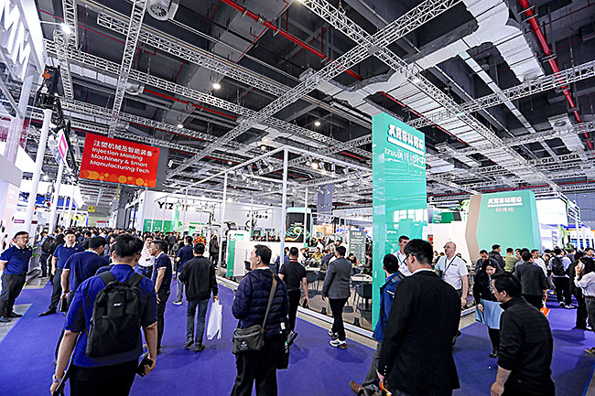
Concentrated expertise in plastics processing: Arburg successfully presented new machines and digital products, innovative applications and turnkey systems at Chinaplas 2024.

Chinaplas 2024 Shanghai CN_009
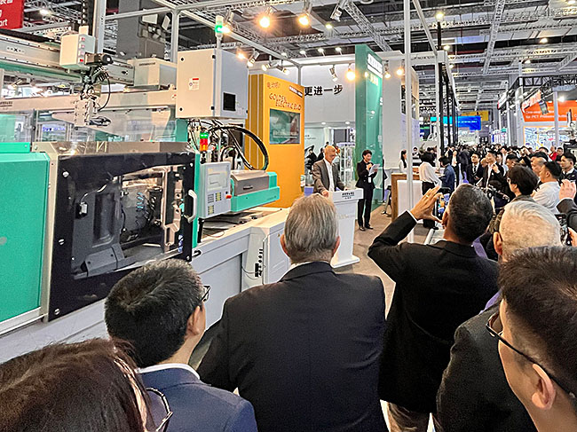
World premiere of the first Arburg machine systematically tailored to the Asian market: the Allrounder Golden Electric Evo, available in sizes 370, 470, 520 and 570.

Chinaplas 2024 Shanghai CN_007
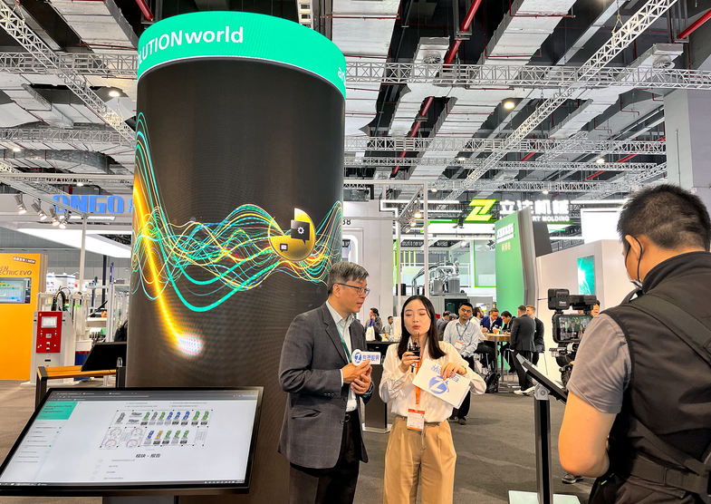
Huge interest: In "arburgSOLUTIONworld", trade visitors were able to obtain individual advice on important topics such as digitalisation, automation and moulds.

Photos: ARBURG
Photo download:
https://media.arburg.com/web/302c3bc4a459841b/chinaplas-2024-press-review

Press release
File: 0000.doc
Characters: 5,955
Words: 887

This and other press releases are available for download from our website at www.arburg.com/de/presse/ (www.arburg.com/en/press/)

Contact
ARBURG GmbH + Co KG
Press office
Susanne Palm
Dr Bettina Keck
Postfach 1109
72286 Lossburg
Tel.: +49 (0)7446 33-3463
Tel.: +49 (0)7446 33-3259
presse_service@arburg.com

About Arburg
Founded in 1923, the German family-owned company is one of the world's leading manufacturers of plastic processing machines. The ARBURG family also comprises AMKmotion and ARBURGadditive, including innovatiQ.
Its portfolio includes injection moulding machines, 3D printers for industrial additive manufacturing, robotic systems and customer- and industry-specific turnkey solutions. It also includes digital products and services.
ARBURG is a pioneer in the plastics industry when it comes to energy and production efficiency, digitalisation and sustainability. ARBURG machines are used to manufacture plastic products for industries such as mobility, packaging, electronics, medicine, construction and equipment engineering, and leisure.
The company headquarters are located in Lossburg, Germany. In addition, ARBURG has its own organisations at 36 locations in 26 countries and, together with trading partners, is represented in over 100 countries. Of a total of around 3,700 employees, some 3,100 work in Germany while around 600 are based in ARBURG organisations around the world.
ARBURG is certified in accordance with ISO 9001 (quality), ISO 14001 (environment), ISO 27001 (information security), ISO 29993 (training) and ISO 50001 (energy).
Further information can be found at: www.arburg.com, www.amk-motion.com and www.arburg.com/arburgadditive.

