Arburg exhibit at NPE 2024
Allrounder More: Turnkey system producing
two-component eyeglasses

- Multi-component injection molding: Functional eyeglasses made from optical LSR and thermoplastic
- Turnkey system: Automated application "Engineered by Arburg USA"
- Partner stands: Further Allrounder machines producing temples, lanyards and cases for eyeglasses

Lossburg,28/03/2024
A perfect example for the efficient production of high-quality plastic parts using injection molding is a turnkey system based around an Allrounder More 2000. With the "two-component eyeglasses" application, Arburg (stand W 3743) will be demonstrating at NPE 2024 its renowned wide-ranging expertise in multi-component injection molding, LSR processing, automation and networked production. Exciting for trade visitors: At the partner stands of Kistler (W3321), Shin-Etsu (S26055) and Adler (S31151), further components will be manufactured so that the eyeglasses can be supplemented with temples, lanyard and case.

The production of ready-to-use two-component eyeglasses provides an impressive demonstration of Arburg's extensive expertise and portfolio, which not only includes machine and process technology, but also robotic systems, control and digitalization.

Two-component eyeglasses as a hard/soft combination
The Allrounder More machines are Arburg's special series for multi-component injection molding. They offer lots more space for molds, rotary units, media connections and a usable ejector stroke as well as numerous optimized features for greater ease of use and simple maintenance. Precision is ensured by a highly dynamic electric toggle-type clamping unit with energy-efficient, liquid-cooled servo motors.
At NPE 2024, an Allrounder More 2000 with 220 tons (2,000 kN) of clamping force and two electric injection units will process optical liquid silicone (LSR) and thermoplastic (PA). The two-component eyeglasses are produced in a 1+1-cavity mold in a cycle time of around 85 seconds. First, the vertical injection unit molds the frame made of PA. An index unit then rotates the pre-molded part into the second station. There, a horizontal injection unit adds the soft LSR lens. Part handling is performed by a Yaskawa six-axis robot.

Central Gestica control system
As well as the two injection units in sizes 0.2 and 2.3 oz (Euromap 400 and 100), the central Gestica machine controller also programs a Yaskawa industrial robot "powered by Arburg" directly with speed and ease. Temperature control devices and other peripheral equipment can also be integrated. This includes the LSR dosing unit from Elmet, which communicates with the Gestica via OPC UA and the Euromap 82.3 interface. This simplifies programming, as well as monitoring, storage and evaluation of process data.

Turnkey system "Engineered by Arburg USA"
With the fully automated application on show at the trade fair, Arburg Inc. will also be showcasing its turnkey expertise for the North American market. The experts at Arburg in the USA work closely with the company headquarters and contribute comprehensive specialist knowledge in order to find creative solutions and implement complete turnkey solutions tailored precisely to the specific requirements of the customer. This increases part quality, process reliability, availability, ability to create value and production efficiency. As a general contractor, the subsidiary looks after not only the implementation and installation, but also advance planning and service for its customers' complete production cells.

Further eyeglasses components on partner stands
Of particular interest to trade visitors is the practical implementation of the idea to manufacture additional components completing the glasses at three partner stands at NPE 2024:
- An electric Allrounder 370 E Golden Electric will produce matching eyeglasses temples made of ABS at the Kistler stand (W3321). Part handling will be performed by an Integralpicker V. Visitors will also be able to have the temples personalised with their own name.
- Complementary lanyards made of LSR will be produced on an electric Allrounder 470 A at the Shin-Etsu stand (S26055).
- At the Adler stand (S31151), another electric Allrounder 470 A will be producing a matching glasses case made of PP.

Images

MORE2000_177220
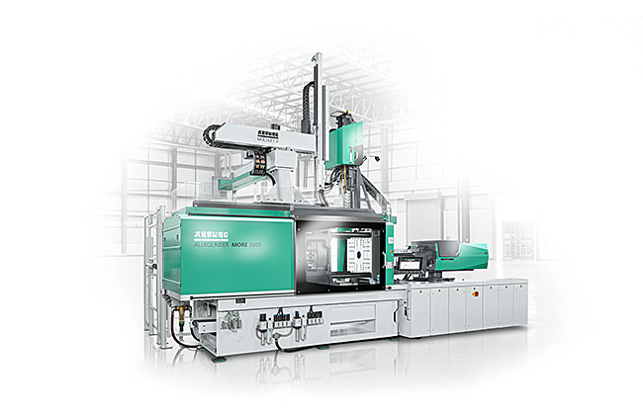
An Allrounder More 2000 with 220 tons (2,000 kN) of clamping force and two electric injection units will be producing two-component eyeglasses at NPE 2024. In this application, part handling will be performed by a Yaskawa six-axis robot.

MORE2000_glasses_2024-03-05_0447
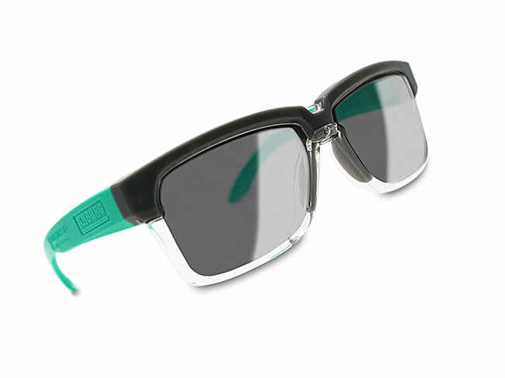
Two-component eyeglasses: An Allrounder More 2000 will be producing eyeglasses made of optical LSR as well as frames made of thermoplastic (PA) at NPEv2024. Other components, such as temples, lanyards and glasses cases, will be produced at partner-company stands.

Photos: ARBURG

Photo download links:
https://media.arburg.com/web/1f9d023f59bd073d/allrounder-more2000-npe-2024/

Press release
File: 05 ARBURG press release Allrounder More2000 NPE 2024_en_US.docx
Characters: 3,881
Words: 571

This and other press releases are available for download from our website at www.arburg.com/de/presse/ (www.arburg.com/en/press/)

Contact
ARBURG GmbH + Co KG
Press office
Susanne Palm
Dr. Bettina Keck
Postfach 1109
72286 Lossburg, Germany
Tel.: +49 7446 33-3463
Tel.: +49 7446 33-3259
presse_service@arburg.com

About Arburg
Founded in 1923, the German family-owned company is one of the world's leading manufacturers of plastic processing machines. The ARBURG family also includes AMKmotion and ARBURGadditive, including innovatiQ.
The portfolio includes injection molding machines, 3D printers for industrial additive manufacturing, robotic systems and customer- and industry-specific turnkey solutions. It also includes digital products and services.
ARBURG is a pioneer in the plastics industry when it comes to energy and production efficiency, digitalisation and sustainability. ARBURG machines are used to manufacture plastic products for industries such as mobility, packaging, electronics, medicine, construction and equipment engineering, and leisure.
The company headquarters are located in Lossburg, Germany. In addition, ARBURG has its own organisations at 36 locations in 26 countries and, together with trading partners, is represented in over 100 countries. Of a total of around 3,700 employees, some 3,100 work in Germany while around 600 are based in ARBURG organisations around the world.
ARBURG is certified in accordance with ISO 9001 (quality), ISO 14001 (environment), ISO 27001 (information security), ISO 29993 (training) and ISO 50001 (energy).
Further information: www.arburg.com, www.amk-motion.com and www.arburg.com/arburgadditive.

