Arburg exhibit at NPE 2024
Allrounder 520 A: Highly innovative IML application for medical technology

- Innovative: In-mold labelling (IML) for centrifuge tubes creates added value
- Sustainable: Medical technology products with adhesive-free IML labels made from mono-material
- In partnership: Joint project around high-performance electric machine

Lossburg, 20/03/2024
While in-mold labelling (IML) is standard for packaging products, this process is still rarely used in the medical industry. Using a centrifuge tube plus label made of PP mono-material as an example, Arburg will be presenting a sustainable IML application with high repetition accuracy and added value for the pharmaceutical and medical technology industries at NPE 2024. The ready-to-use product is manufactured in a fast, space-saving and cost-efficient way using a turnkey system centered around an electric Allrounder, without any additional hygiene risks.

Prestigious partners Kebo (mold), MCC Verstraete (label), Beck (automation) and Intravis (camera inspection) are all involved in the innovative joint IML project centered around an electric Allrounder 520 A in clean room design.

Sustainable: Product made from mono-material
The pioneering technology was first presented as a proof of concept at Fakuma 2023 and met with a great response. The product is also particularly interesting in terms of sustainability: the tube and label are both made of PP, meaning that the mono-material product can be easily recycled. Because the integrated label can contribute to the stability of the tube, its wall thickness can be reduced if necessary and plastic material can be reduced in volume production. In addition, work steps such as bonding and printing are eliminated, meaning that no adhesives are required and there is no waste due to contamination with liquid color.

Electric: High-performance machine for medical technology

Another important aspect is the compact footprint of the production cell, which fits into predefined production grids. The centerpiece is an electric Allrounder 520 A "Ultimate" with a clamping force of 165 tons (1,500 kN), designed for fast and sophisticated processes. The high-performance machine in clean room design meets the requirements of class ISO 7. With an 8-cavity mold from Kebo, ready-to-use tubes, each with a capacity of 0,51 US fl.oz. (15 ml), are produced from PP in a cycle time of around 10 seconds. The servo-electric drives of the injection molding machine ensure precise and reproducible mold positioning. A label adjustment head from Beck ensures that the labels are precisely aligned and applied, while a camera system from Intravis integrated into the automation handles the visual inspection of the finished parts in real time. In a real application, the tubes could also be screwed together and packaged in tubular bags in the production cell.

Precise: Accurate positioning of the functional labels

While the print to cut distance for IML decorations for packaging products is usually around 0.4 to 0.6 inch (1 to 1.5 mm), it is only around 0.08 inch (0.2 mm) for the centrifuge tube application example. The labels with a wall thickness of 57 micrometers must be positioned as precisely as possible in the cavities. The labels are precisely aligned and applied using an automated system from Beck. A label adjustment head equalizes the manufacturing tolerance to a few hundredths. This is an important requirement for functionality and significantly reduces quality fluctuations and rejects.

Integrated: Additional functions

Primarily, the tubes have a scale on the scratch-resistant label that indicates the exact fill level. These types of labels with inscriptions are also interesting for insulin pens and medical measuring cups, for example. Another function is the monitoring of temperature profiles. An additional temperature-sensitive element allows any interruption in the cold chain to be detected at a glance: as soon as the temperature of the filled tube rises above seven degrees Celsius, for example, the thermochromic printing ink changes irreversibly. Additional information on recycling and warehouse management can also be added to the product using a QR code, for example. In the future, it is also conceivable that the process, quality and patient data for each individual part will be 100 percent traceable via an RFID code.

Photos

196713
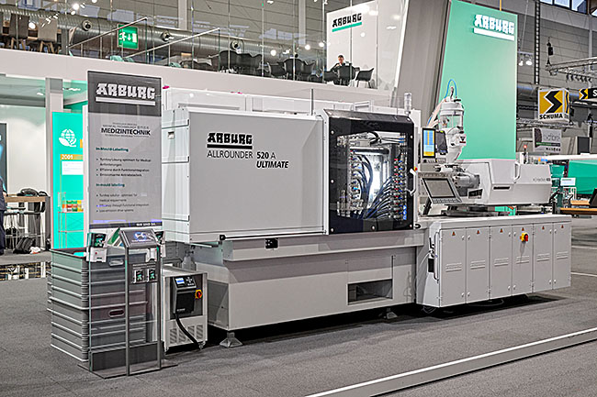
An electric Allrounder 520 A Ultimate demonstrates an innovative application for medical technology. The high-performance machine will be producing IML centrifuge tubes at NPE 2024 as part of a joint project.

196400
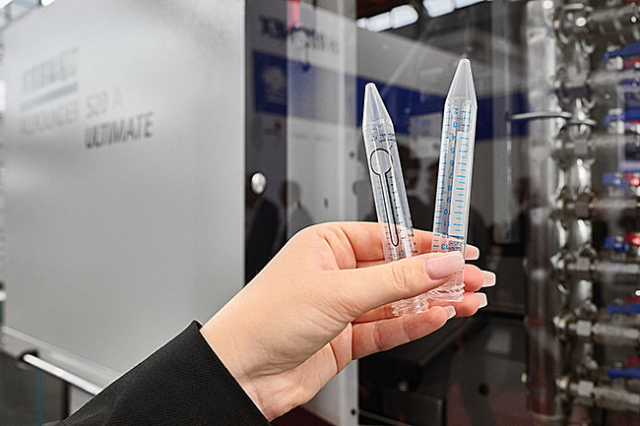
Thanks to functional IML labels, the centrifuge tubes have features such as a filling scale and temperature-sensitive elements. Automation from Beck ensures precise positioning.

Photo: ARBURG

Photo download – updated with images from the trade fair:
https://media.arburg.com/web/76b3b9ea3b85880f/allrounder-520-a-iml-medical-npe-2024/

Press release
File: ARBURG press releaseAllrounder 520 A IML Medical NPE 2024_de.docx
Characters: 3,963
Words: 608

This and other press releases are available for download from our website at www.arburg.com/de/presse/ (www.arburg.com/en/press/)

Contact
ARBURG GmbH + Co KG
Press office
Susanne Palm
Dr Bettina Keck
Postfach 1109
72286 Lossburg
Tel.: +49 (0)7446 33-3463
Tel.: +49 (0)7446 33-3259
presse_service@arburg.com

About Arburg
German family-owned company Arburg is one of the world's leading manufacturers of plastic processing machines. Its product portfolio encompasses Allrounder injection molding machines with clamping forces of between 125 and 6,500 kN, the freeformer for industrial additive manufacturing and robotic systems, customer and industry-specific turnkey solutions and further peripheral equipment.
Arburg is a pioneer in the plastics industry when it comes to energy and production efficiency, digitalisation and sustainability. The "arburgXworld" program comprises all digital products and services and is also the name of the customer portal. The company’s strategies regarding the efficient use of resources and circular economy, as well as all related aspects and activities, are outlined in the 'arburgGREENworld' program.
Arburg's main aim is to enable its customers to manufacture their plastic products, from one-off parts to large-volume batches, to optimum quality standards and in a way that conserves resources, is sustainable and minimises unit costs. Target groups include the automotive and packaging industries, communication and entertainment electronics, medical technology and the white goods sector.
First-class customer support on-site is guaranteed by the international sales and service network: Arburg has own organisations in 26 countries at 36 locations and is represented in over 100 countries together with trade partners. Its machines are produced at the company's German headquarters in Lossburg. Of a total of roughly 3,700 employees, around 3,100 work in Germany, with another 600 employees based in Arburg's organisations around the world. Arburg is certified to ISO 9001 (quality), ISO 14001 (environment), ISO 27001 (information security), ISO 29993 (training) and ISO 50001 (energy).
Further information about Arburg can be found at www.arburg.com

