Arburg exhibit at Chinaplas 2024
Allrounder 1600 T: Automated rotary table application for the mobility sector

- Automated: Turnkey system based around a rotary table machine with a six-axis robot
- Complete: Production cell with upstream stamping and pin separation
- Complex: Fluid distributors with metal inserts for use in automotive applications

Lossburg, 03/04/2024
The combination of rotary table machine and automated parts handling produces a high-end application that is extremely attractive for many industries. At Chinaplas 2024, a turnkey system based around an Allrounder 1600 T will attract the attention of interested parties from the mobility sector in particular. An upstream stamping unit with conveyor system is integrated in the production cell. Parts handling is performed by a six-axis robotic system.

The Allrounder T vertical injection moulding machines from Arburg are ideal for the production of challenging moulded parts. Their servo-electric three-station rotary table can perform various rotary sequences. It has no pillars, so as not to restrict the free space for moulds and media connections.

Overmoulding of metal inserts
The exhibit, an Allrounder 1600 T, features a rotary table with a diameter of 1,600 millimetres and 2,000 kN of clamping force. The product, a complex fluid distributor, contains different metal inserts, which are overmoulded with 35 per cent glass-fibre reinforced PBT. A 4-cavity mould from Concraft produces four finished parts in a cycle time of around 60 seconds. The shot weight is 74.5 grams.

Complex: Automation with two robotic systems
The automation system provides three different types of inserts in a tray via a three-axis micro-robot. Then a six-axis robot with Concraft grippers and a load of 10 kg picks up a total of twelve inserts from this tray, and places them in the four cavities of the mould. After each injection process, it removes both the sprue and the finished parts.
The turnkey system has been customised with a stamping unit with stamping line conveyor system, also from local partner Concraft. There, the inserts are first stamped out and have the pins separated, before they are placed in the mould and overmoulded. Implementation of the Kuka six-axis robot and the total system sequence was handled in the Arburg Technology Factory (ATF) in Pinghu.

Practical: Features of the Allrounder rotary table machine
The electric drive together with precision position system ensures the high accuracy of the system and thus reliably protects the mould against damage and wear. Simultaneous insertion, overmoulding and removal ensure short cycles.
The large selection of options for a flexible configuration is as advantageous as the high safety standard, which is above the CE standard. Particularly in challenging areas like medicine or mobility, the Allrounder T provides precise results – also thanks to the pressure accumulator and lots of smart features on the Selogica control system that simplify setup and operation of the systems.

Images

172831_1600T

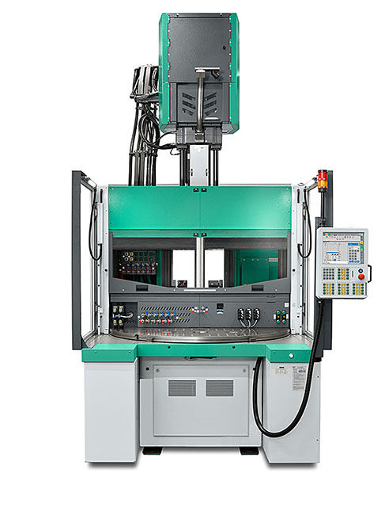

At Chinaplas 2024, a turnkey system based around an Allrounder 1600 T rotary table machine will be producing complex automotive components.

188483_connector

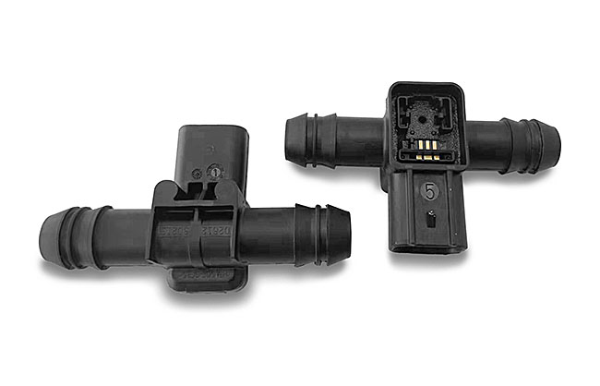

The complex fluid distributors made from glass-fibre reinforced PBT each contain three different metal inserts.

Photos: ARBURG

Photo download links:
https://media.arburg.com/web/441a883fb0e1f11c/allrounder-1600t-chinaplas-2024/

Press release
File: ARBURG press release Allrounder1600T Chinaplas 2024_en_GB.docx
Characters: 2,640
Words: 414

This and other press releases are available for download from our website at www.arburg.com/de/presse/ (www.arburg.com/en/press/)

Contact
ARBURG GmbH + Co KG
Press office
Susanne Palm
Dr. Bettina Keck
Postfach 1109
72286 Lossburg, Germany
Tel.: +49 7446 33-3463
Tel.: +49 7446 33-3259
presse_service@arburg.com

About Arburg
Founded in 1923, the German family-owned company is one of the world's leading manufacturers of plastic processing machines. The ARBURG family also includes AMKmotion and ARBURGadditive, including innovatiQ.
The portfolio includes injection moulding machines, 3D printers for industrial additive manufacturing, robotic systems and customer- and industry-specific turnkey solutions. It also includes digital products and services.
ARBURG is a pioneer in the plastics industry when it comes to energy and production efficiency, digitalisation and sustainability. ARBURG machines are used to manufacture plastic products for industries such as mobility, packaging, electronics, medicine, construction and equipment engineering, and leisure.
The company headquarters are located in Lossburg, Germany. In addition, ARBURG has its own organisations at 36 locations in 26 countries and, together with trading partners, is represented in over 100 countries. Of a total of around 3,700 employees, some 3,100 work in Germany while around 600 are based in ARBURG organisations around the world.
ARBURG is certified in accordance with ISO 9001 (quality), ISO 14001 (environment), ISO 27001 (information security), ISO 29993 (training) and ISO 50001 (energy).
Further information: www.arburg.com, www.amk-motion.com and www.arburg.com/arburgadditive.

