Two wind turbines produce electricity for Arburg

Tailwind for even more clean energy

- Arburg wind turbines supply electricity for the company's own use
- Wind energy provides the electricity equivalent of around 340 households
- Use of the regional power line expansion

Lossburg, 27 July 2023
Nature offers sun and wind in abundance and with it, endless possibilities for generating electricity from free resources. Arburg has been doing this for a long time and has now intelligently expanded its sources of clean energy once again. Two wind turbines that have already been in operation since 2001 have been producing electricity for the company's own use since the end of January 2023.

This increase in regenerative energy was made possible by the expansion of the regional 20 kV power grid and the clever use that Arburg's forward-looking management team made of the synergy effects that arose when the overhead power lines were laid underground. Michael Hehl, Managing Partner, says: "Connecting the wind turbines to our in-house power grid and using the energy generated for Arburg made perfect sense, especially in the current situation. As part of the 20 kV expansion of the Lossburg power grid, we were able to limit the costs of integration." The company still had to invest several hundreds of thousands of euros in this 2.4-kilometre-long cable connection, but it was money well spent according to Michael Hehl since by feeding the wind energy generated into the grid, Arburg can use the electricity equivalent of around 340 households in the company itself.

Regional energy and even more CO₂ savings
With this move, Arburg is consistently pursuing its goal of becoming even more independent of fossil raw materials through the use of natural resources. Generating and using regional energy is also another step towards increased carbon neutrality. Florian Schmitz, head of the Building Services department, calculates: "The cost of the power line to the wind turbines will have paid for itself in less than five years. With the additional 1.7 megawatts of generator power, we are adding another pillar to our regional regenerative energy concept. The direct connection is only logical: to generate energy directly where it is needed." He notes that for Arburg, wind energy is the logical complement to its geothermal energy system and the nine photovoltaic plants with a total output of 2.75 MWp.

Power generation at a height of 99 metres
The wind turbines not only provide additional electricity for Arburg, but also offer exciting insights into the technology of these behemoths that tower 99 metres into the Black Forest sky. The simple explanation for this height is that wind must have a certain strength in order to generate electricity at all. So the higher the wind turbine, the stronger the wind blows on top. Under normal conditions, the tips of the 26-metre-long rotor blades, which cover a total of 2,124 square metres, reach a top speed of 200 kilometres per hour. To prevent the turbine from self-destructing through excessive rotation, the blades always rotate in a way that stops them from becoming too fast in the first place. They reach a maximum of 31.4 revolutions per minute. The control technology and generator are located in a nacelle the size of a standard car garage.

Photo

191244
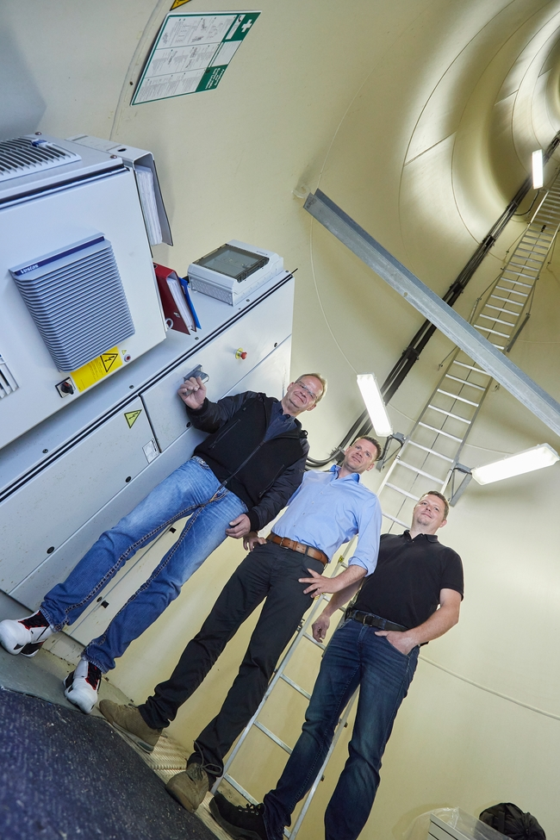

Go for wind power: Managing Partner Michael Hehl (l.), Florian Schmitz, Director Building Services Engineering (centre), and Markus Legler, Team Manager Electrician, are pleased with the connection, which has been feeding electricity into the company's own medium-voltage grid since January 2023.

Photo: Arburg
Photo download:
https://media.arburg.com/portals/downloadcollection/285A555BE0CE6CC646214253DF6E380B

Press release
File: ARBURG press release wind power 2023_en_GB.docx
Characters: 3,0124
Words: 494

This and other press releases are available for download from our website at www.arburg.com/de/presse/ (www.arburg.com/en/press/)

Contact
ARBURG GmbH + Co KG
Press office
Susanne Palm
Dr Bettina Keck
Postfach 1109
72286 Lossburg
Tel.: +49 (0)7446 33-3463
Tel.: +49 (0)7446 33-3259
presse_service@arburg.com

About Arburg
German family-owned company Arburg is one of the world's leading manufacturers of plastic processing machines. Its product portfolio encompasses Allrounder injection moulding machines with clamping forces of between 125 and 6,500 kN, the Freeformer for industrial additive manufacturing and robotic systems, customer and industry-specific turnkey solutions and further peripheral equipment.
Arburg is a pioneer in the plastics industry when it comes to production efficiency, digitalisation and sustainability. The “arburgXworld” program comprises all digital products and services and is also the name of the customer portal. The company’s strategies regarding the efficient use of resources and circular economy, as well as all related aspects and activities, are outlined in the 'arburgGREENworld' program.
Arburg's main aim is to enable its customers to manufacture their plastic products, from one-off parts to large-volume batches, to optimum quality standards and in a way that conserves resources, is sustainable and minimises unit costs. Target groups include the automotive and packaging industries, communication and entertainment electronics, medical technology and the white goods sector.
First-class customer support on-site is guaranteed by the international sales and service network: Arburg has own organisations in 25 countries at 35 locations and is represented in over 100 countries together with trade partners. Its machines are produced at the company's German headquarters in Lossburg. Of a total of roughly 3,600 employees, around 3,000 work in Germany, with another 600 employees based in Arburg's organisations around the world. Arburg is certified to ISO 9001 (quality), ISO 14001 (environment), ISO 27001 (information security), ISO 29993 (training) and ISO 50001 (energy).
Further information about Arburg can be found at www.arburg.com

