"Plásticos em Revista" award ceremony
Award-winning: electric allrounder wins award

- Winner: Arburg has the best equipment for electric injection moulding machines
- Survey: 9,000 companies choose winners
- Award ceremony: Event with over 450 guests

Lossburg/ São Paulo 07.02.2023
On 7 December 2022, the annual award ceremony of the Brazilian magazine "Plásticos em Revista" took place in São Paulo. The electric injection moulding machine from Arburg was awarded the "Prêmio Plásticos em Revista (PPR)" in the best equipment category. Leandro Goulart, Head of Marketing and Sales at Arburg's Brazilian subsidiary, accepted the award at the event with over 450 invited guests.

The PPR was awarded in eight categories: Distributors, Components, Recycling, Professionals, Transformers, Contribution to the Sector, PCR Products and Equipment. When choosing the best equipment, a distinction was made between different processes and drives. The Arburg injection moulding machine was the winner in the electric drive category. A total of 39 prizes were awarded.

Established prize
The "Plásticos em Revista" magazine award was launched in 2003 to recognise the achievements of processors, compounders, raw material traders, machinery manufacturers and recyclers, as well as professionals in the petrochemical industry. Between September and October 2022, the registered 9,000 contacts from plastics companies in the "Plásticos em Revista" database were able to participate in an online survey. They could each cast one vote, which was evaluated by an independent company.

Photo

185660.jpg
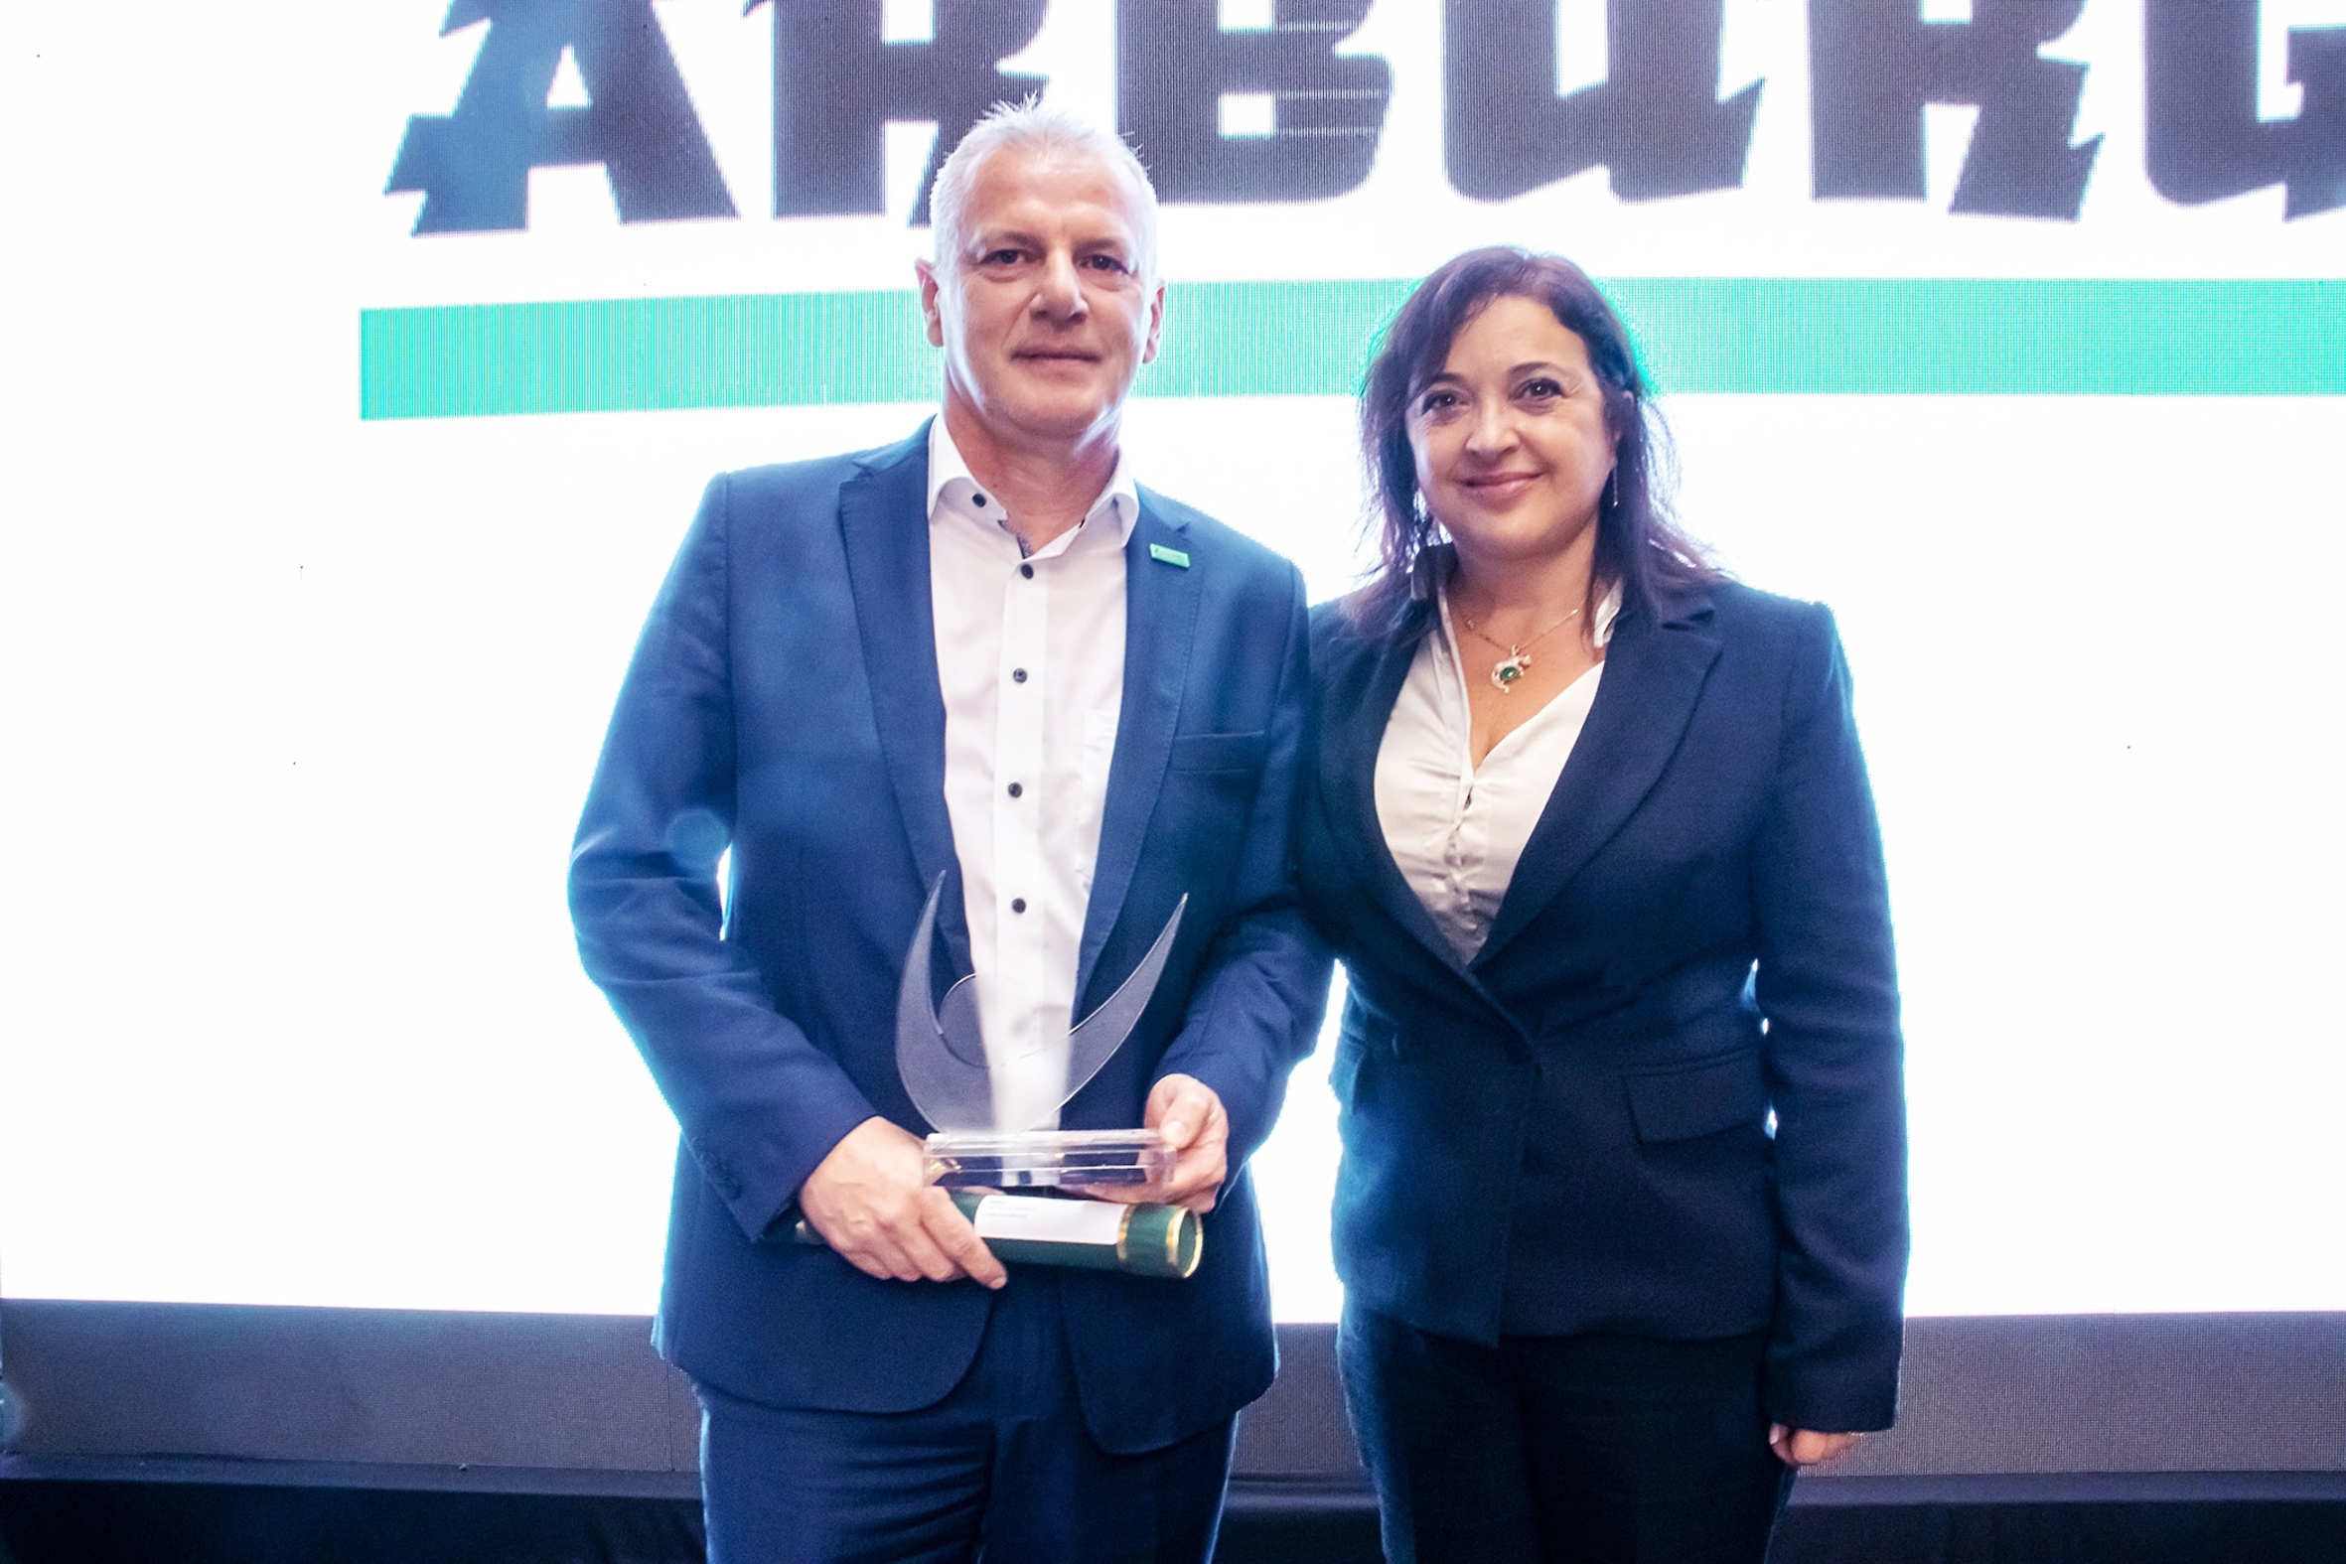
Leandro Goulart, Head of Marketing and Sales Arburg Brazil, accepts the PPR for "TOP Equipment in Electric Drives" for Arburg from Jane Campos, Radici Plastics Ltda.

Photo: Samuel Felix (Plásticos em Revista)
Photo download:
https://media.arburg.com/portals/downloadcollection/D5E706EAD1D54544D3A0D14518A23985

Press release
File: 0000.doc
Characters: 1.281
Words: 189

This and other press releases are available for download from our website at www.arburg.com/de/presse/ (www.arburg.com/en/press/)

Contact
ARBURG GmbH + Co KG
Press office
Susanne Palm
Dr Bettina Keck
Postfach 1109
72286 Lossburg
Tel.: +49 (0)7446 33-3463
Tel.: +49 (0)7446 33-3259
presse_service@arburg.com

About Arburg
German family-owned company Arburg is one of the world's leading manufacturers of plastic processing machines. Its product portfolio encompasses Allrounder injection moulding machines with clamping forces of between 125 and 6,500 kN, the Freeformer for industrial additive manufacturing and robotic systems, customer and industry-specific turnkey solutions and further peripheral equipment.
Arburg is a pioneer in the plastics industry when it comes to production efficiency, digitalisation and sustainability. The “arburgXworld” program comprises all digital products and services and is also the name of the customer portal. The company’s strategies regarding the efficient use of resources and circular economy, as well as all related aspects and activities, are outlined in the “arburgGREENworld” program.
Arburg’s central aim is for customers to be able to produce their plastic products, from one-off parts to large-volume batches, in optimum quality at minimum unit costs. The target groups include, for example, the automotive and packaging industries, communication and entertainment electronics, medical technology and the white goods sector.
An international sales and service network ensures first-class customer support at a local level: Arburg has its own organisations at 34 locations in 25 different countries and, together with its trading partners, is represented in more than 100 countries. Its machines are produced at the company's German headquarters in Lossburg. Of a total of roughly 3,600 employees, around 3,000 work in Germany. About 600 further employees work in Arburg's organisations around the world. Arburg has triple certification, in accordance with ISO 9001 (quality), ISO 14001 (environment) and ISO 50001 (energy).
Further information about Arburg can be found at www.arburg.com

