Machine milestone for H&K Müller
100th Allrounder for H&K Müller

- New Allrounder 420 C Golden Edition
- Machine fleet made up exclusively of Allrounders
- Over 50 years of trusting cooperation

Lossburg, 31/07/2023
This year, more than 50 years of cooperation between H&K Müller GmbH & Co. KG and Arburg were crowned by the delivery of the company's 100th machine. The hydraulic Allrounder 420 C Golden Edition is equipped with a Multilift Select handling device and produces screw-top cans as well as measuring and dosing spoons for the pharmaceutical, cosmetics and food sectors.

H&K Müller, based in Engelskirchen, Germany, manufactures plastic cans, reusable cups, measuring cups and measuring spoons, dosing aids, packaging systems as well as sustainable packaging and technical plastic injection moulded parts of various kinds. The company claims to have Europe's largest freely accessible standard range of screw-on plastic cans and cans with snap-on lids made of plastic. Around 110 employees work in research and development, mould construction, injection moulding, customer-specific decoration using screen and embossed printing in the in-house print shop, as well as logistics.
H&K Müller supplies its products mainly to customers in the food, cosmetics, pharmaceutical, dental, veterinary, chemical and technical industries.

Successful cooperation since 1972
For more than 50 years, H&K Müller has relied exclusively on Arburg technology. Including the new hydraulic Allrounder 420 C Golden Edition, the total number of injection moulding machines in the clamping force range from 500 to 2,200 kN that the company now has in operation is 52. Many systems are equipped with Multilift handling devices to enable automated series production. In the past two years, two turnkey systems have been developed and commissioned together with Arburg. Both work successfully in automated series production, where items that previously required a lot of manpower are produced in large output quantities.
Philipp and Justus Müller from the management of H&K Müller GmbH & Co. KG are completely enthusiastic about the technology and the company's cooperation with Arburg. "Using these systems means that the packaging process can be completely handled by the docked automation. This helps reduce the manpower required in production and allows us to run shorter cycles," says Philipp Müller. His brother Justus Müller adds: "We appreciate the reliable and cooperative relationship with Arburg and look forward to many more years of successful cooperation."

Recyclates on the rise
Products made from 100 per cent recycled material are also produced on the Allrounders. In addition, the company is continuously working on new recyclates and bio-based and biodegradable materials and additives. A large part of the standard range is already available in recycled, bio-based and biodegradable materials derived from a waste product of the sugar cane industry. The company is working tirelessly to be able to offer these options for all products in the future.
H&K Müller is certified four times in accordance with ISCC Plus, DIN EN ISO 9001 Quality Management, 22000 Food Safety and 50001 Energy Management.

Sustainable products, sustainable production
Resource-saving, environmentally conscious and sustainable action has been a fundamental part of H&K Müller's corporate philosophy for many years. A balance between economic success and social responsibility has been the cornerstone of its business activities for decades – as it has been for Arburg.
H&K Müller attaches particular importance to energy and raw material efficiency in plastic injection moulding and in the production of sustainable packaging. The new production facility, which was opened in 2009, is heated almost exclusively with waste heat from production, and the increased use of electric drives also saves CO₂. In this way, and by using photovoltaics, operations are almost emission-free.
For all new machine acquisitions, H&K Müller takes care to ensure a high level of energy efficiency and carries out constant energy monitoring via electricity meters on the production lines. On average, 98,000 kilograms of pre-consumer plastic material from prototype production and production waste are recycled directly in-house every year. A large part of this flows back into production for the manufacture of items that are not subject to food or pharmaceutical safety regulations. Material that cannot be used by the company itself is sold to other companies that can use it in their manufacturing processes. This creates a closed-loop system as a sustainable contribution to environmental protection and sustainability.

Photo

194584

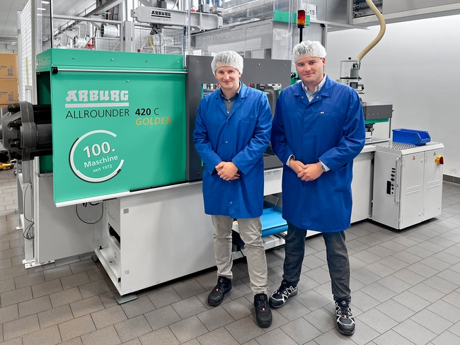

Justus (l.) and Philipp Müller from the management of H&K Müller are happy about the anniversary: The 100th Arburg machine is an Allrounder 420 C Golden Edition.

Photo: H&K Müller
Photo download:
https://media.arburg.com/portals/downloadcollection/ED652F09AB49C5E35E74D9246C7F8EE3

Press release
File: ARBURG press release 100 machine H&K Mueller_en-GB.docx
Characters: 4,462
Words: 672

This and other press releases are available for download from our website at www.arburg.com/de/presse/ (www.arburg.com/en/press/)

Contact
ARBURG GmbH + Co KG
Press office
Susanne Palm
Dr Bettina Keck
Postfach 1109
72286 Lossburg
Tel.: +49 (0)7446 33-3463
Tel.: +49 (0)7446 33-3259
presse_service@arburg.com

About Arburg
German family-owned company Arburg is one of the world's leading manufacturers of plastic processing machines. Its product portfolio encompasses Allrounder injection moulding machines with clamping forces of between 125 and 6,500 kN, the Freeformer for industrial additive manufacturing and robotic systems, customer and industry-specific turnkey solutions and further peripheral equipment.
Arburg is a pioneer in the plastics industry when it comes to production efficiency, digitalisation and sustainability. The “arburgXworld” program comprises all digital products and services and is also the name of the customer portal. The company’s strategies regarding the efficient use of resources and circular economy, as well as all related aspects and activities, are outlined in the 'arburgGREENworld' program.
Arburg's main aim is to enable its customers to manufacture their plastic products, from one-off parts to large-volume batches, to optimum quality standards and in a way that conserves resources, is sustainable and minimises unit costs. Target groups include the automotive and packaging industries, communication and entertainment electronics, medical technology and the white goods sector.
First-class customer support on-site is guaranteed by the international sales and service network: Arburg has own organisations in 25 countries at 35 locations and is represented in over 100 countries together with trade partners. Its machines are produced at the company's German headquarters in Lossburg. Of a total of roughly 3,600 employees, around 3,000 work in Germany, with another 600 employees based in Arburg's organisations around the world. Arburg is certified to ISO 9001 (quality), ISO 14001 (environment), ISO 27001 (information security), ISO 29993 (training) and ISO 50001 (energy).
Further information about Arburg can be found at www.arburg.com

