Arburg at Formnext 2023
ARBURG offers a suitable solution for everyone

- Machine versatility: from access-level printers via LSR machines to the high-temperature freeformer
- Material diversity: Processing of fibre-reinforced plastics, certified Ultem, TPE and LSR
- Diverse range of applications: from grippers via shoe insoles and soft hearts to aerospace air distributors

Lossburg, 14/11/2023
At Formnext 2023 ARBURGadditive demonstrated its comprehensive competence in additive manufacturing with six machine exhibits, extensive consultations, including on digital products and solutions, as well as numerous component samples. One highlight was the new high-temperature freeformer 750-3X by ARBURGadditive, which was producing air distributors from genuine Ultem granulate. Soft TPE hearts with a sponge structure are a unique product that can only be manufactured additively in Arburg plastic freeforming (APF) and which turned out to be a popular give-away. APF parts made from PA with 25 percent glass fibres were on show for the first time and were also met with huge resonance from trade fair visitors.

"At the leading global trade fair Formnext 2023, we presented ourselves as a globally active solution provider whose open systems provide the perfect answer for the widest range of requirements in additive manufacturing," concludes Dr. Victor Roman, Managing Director at ARBURGadditive, of this extraordinarily successful trade fair show. "Our freeformers and 3D printers process a wide range of plastic granules, filaments and liquid silicones into functioning and high-quality components using reliable processes such as in medicine technology or aerospace. In addition we offer digital products and services such as the arburgXworld customer portal, the ProcessLog app for process documentation and smart software solutions. I have no doubt that, with our technologies and know-how, we will exploit this huge potential in the future. The outlook from out perspective is outstanding.“

Machine manufacturer with 100-year success story
"Few other companies in the AM world can look back on a 100-year history of success and have acquired as much experience in machine construction and software development for plastics processing during this time as Arburg has," adds Dr. Christoph Schumacher, Director of Global Marketing at the Arburg parent company. "At the trade fair booth, it was quite literally easy to grasp how great the advantages are of being able to offer, with the freeformers and 3D printers of the TiQ and LiQ series, a suitable solution for virtually every challenge – whether this be soft and cuddly or hard as nails, and at the same time being able to rely on enormous know-how and a global infrastructure."

Numerous innovations and further developments
Since autumn 2023 a freeformer 750-3X has been available in a high-temperature version, the build chamber of which can be tempered to 200 degrees Celsius; with plastification of the plastic granules taking place at up to 450 degrees Celsius. The manufacture of geometrically intricate ventilation ducts for aerospace manufactured from original Ultem 9085 was demonstrated as a typical application. Another new development that the ARBURG Plastic Freeforming team is currently working on is the processing of fibre-glass reinforced thermoplastics. As an example, initial first results were introduced using technical parts made from PA with 25 percent fibre-glass.
Equally interesting were personalised multi-material shoe insoles made from flexible TPE and a hard area made from PP, on a standard freeformer 750-3X. This extra soft ARBURG Plastic Freeforming product was manufactured by a freeformer 200-3X from TPE with a sponge structure. At Formnext, 15 small and highly popular hearts, were manufactured in around 90 minutes build time. In the specific customer application, this material is used for personalised breast prostheses.

3D printers from innovatiQ round off an extensive range
Also of interest was an application made from liquid silicone: A 3D printer LiQ 5 processed the certified standard-LSR KEG-2003H-50A/B by Shin-Etsu for the first time, which for instance can be used to manufacture individual orthopaedic accessories or products for the food and drinks industry. InnovatiQ has also developed a new slicer software LAM technology (Liquid Additive Manufacturing) specially for this.
The filament printer TiQ 5 Pro offers new features such as an integrated material dryer, active build chamber tempering and software-optimised material discharge meaning that polycarbonate can now also be processed reliably and reproducibly for instance. A sophisticated example of a part was a high-speed water scooter board made of individual carbon-fibre reinforced elements that had been laminated and combined to create a finished board and proved a real attraction. By way of contrast there was also the filament printer TiQ 2, which enables economical entry into additive manufacturing, for instance for the manufacture of robot grippers and operating resources.

Photos

196893
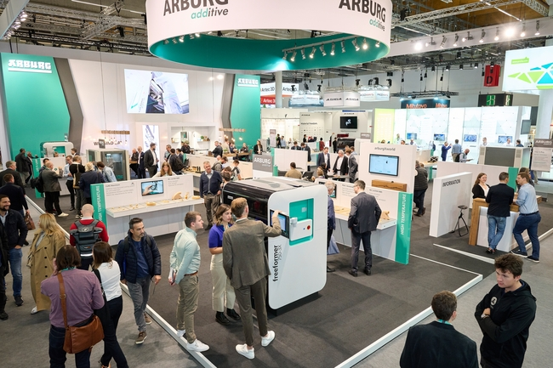
Creating huge interest: At the world's leading global trade fair Formnext 2023, numerous international specialist visitors informed themselves about the comprehensive Arburg portfolio and its innovations in the area of additive manufacturing.

196892
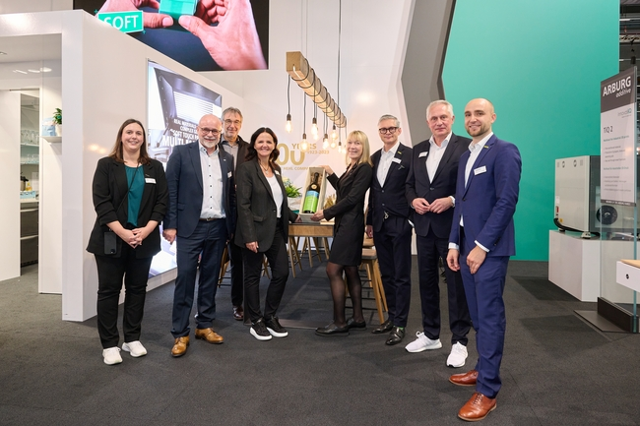
Congratulations on "100 years of the Hehl family company“ on behalf of Messe Frankfurt and the Formnext event organiser Mesago (from right): Christoph Stücker, Deputy Vice President Formnext, Martin Roschkowski, Managing Director Mesago, Sascha F. Wenzler, Vice President Formnext, Petra Haarburger, Managin Director Mesago, Juliane Hehl, Arburg Managing Partner, Uwe Behm, Managing Director Messe Frankfurt, Dr. Christoph Schumacher, Arburg Vice President Global Marketing and Ina Kumm, Sales Managerin Mesago.

196887
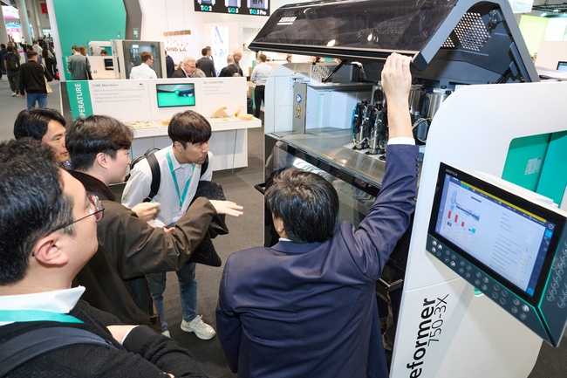
A high-temperature version of the new Freeformer 750-3X was a highlight at Formnext 2023. This additively manufactures ventilation ducts for the aerospace industry from Ultem 9085 original plastic granules.

196885
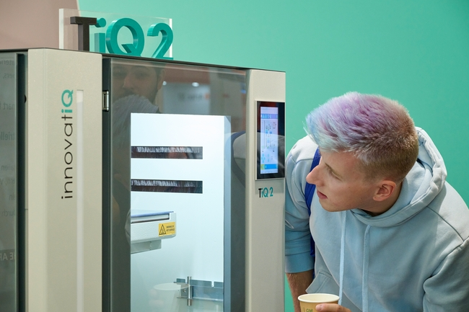
The economical filament-printer TiQ 2 by innovatiQ was particularly of interest for newcomers to industrial additive manufacturing e.g. of robot grippers and operating equipment.

196863
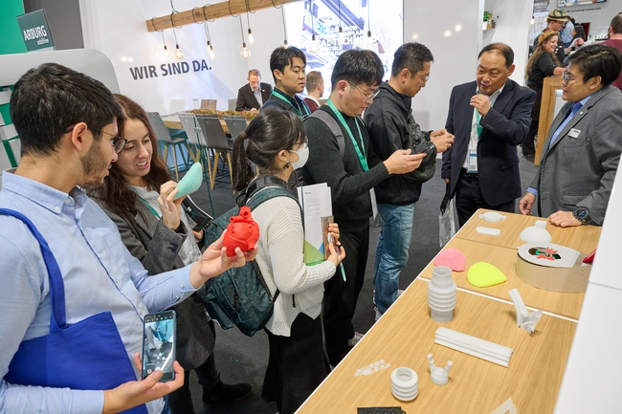
From extra soft to hard as nails – numerous examples of parts illustrated the wide range of materials and applications for freeformers and 3D printers by ARBURGadditive.

196894
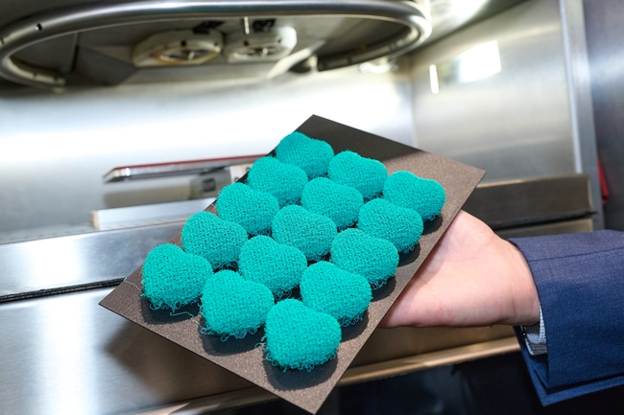
An eye-catcher and popular give-away at Formnext 2023 were soft foam hearts made from TPE, manufactured live by a freeformer 200-3X.

196873
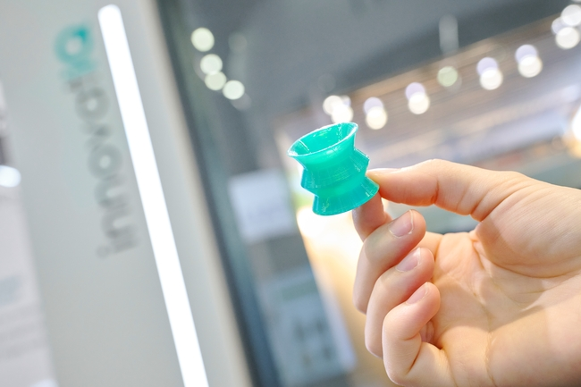
The LiQ 5 machine by innovatiQ is predestined for the 3D printing of LSR parts made from certified standard-LSR in moulded injection quality.

196862
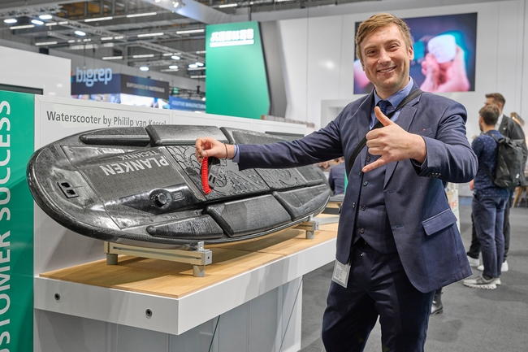
With the aid of a TiQ 5 Pro and innovatiQ hobby inventor Phillip van Kessel turned his idea of the perfect high-speed water scooter board into a reality.
Photos: ARBURG
Photo download:
https://media.arburg.com/portals/downloadcollection/314CF89884F836D8300DAD6920AB4DB4

Press release
File: 0000.doc
Characters: 4,655
Words: 702

This and other press releases are available for download from our website at www.arburg.com/de/presse/ (www.arburg.com/en/press/)

Contact
ARBURG GmbH + Co KG
Press office
Susanne Palm
Dr Bettina Keck
Postfach 1109
72286 Lossburg
Tel.: +49 (0)7446 33-3463
Tel.: +49 (0)7446 33-3259
presse_service@arburg.com

About Arburg
German family-owned company Arburg is one of the world's leading manufacturers of plastic processing machines. Its product portfolio encompasses Allrounder injection moulding machines with clamping forces of between 125 and 6,500 kN, the freeformer for industrial additive manufacturing and robotic systems, customer and industry-specific turnkey solutions and further peripheral equipment.
Arburg is a pioneer in the plastics industry when it comes to production efficiency, digitalisation and sustainability. The "arburgXworld" program comprises all digital products and services and is also the name of the customer portal. The company’s strategies regarding the efficient use of resources and circular economy, as well as all related aspects and activities, are outlined in the 'arburgGREENworld' program.
Arburg's main aim is to enable its customers to manufacture their plastic products, from one-off parts to large-volume batches, to optimum quality standards and in a way that conserves resources, is sustainable and minimises unit costs. Target groups include the automotive and packaging industries, communication and entertainment electronics, medical technology and the white goods sector.
First-class customer support on-site is guaranteed by the international sales and service network: Arburg has own organisations in 26 countries at 36 locations and is represented in over 100 countries together with trade partners. Its machines are produced at the company's German headquarters in Lossburg. Of a total of roughly 3,800 employees, around 3,200 work in Germany, with another 600 employees based in Arburg's organisations around the world. Arburg is certified to ISO 9001 (quality), ISO 14001 (environment), ISO 27001 (information security), ISO 29993 (training) and ISO 50001 (energy).
Further information about Arburg can be found at www.arburg.com

