Arburg Anniversary Days 2023
Plastic hearts beat faster in Lossburg

- Enthusiastic: 5,700 customers from 53 nations at the Arburg Anniversary Days 2023 in Lossburg
- In demand: New anniversary machine, solutions for energy efficiency, digitalisation and sustainability
- Rich in experience: Over 50 exhibits, Efficiency Arena, Automation Arena, service topics, specialist lectures and company tours

Lossburg, 13/03/2023
5,700 customers from 53 nations came to the Arburg Anniversary Days at the "Think Tank" in Lossburg, Germany, from 8 to 11 March 2023. At the event, which is called Technology Days in other years, everything that makes plastic hearts beat faster was to be found. The exhibition area covered the entire company: In addition to more than 50 exhibits and innovative applications, Arburg impressed with its combined expertise on important topics such as sustainability, digitalisation, energy efficiency and automation.

The enthusiastic guests were able to experience live and in colour what the family-owned company with its 100-year history is all about at the exhibits in the Customer Center, in the Efficiency Arena, in the training and service areas, in the Automation Arena, as well as during tours of the company and specialist lectures: Sustainable action, innovative ideas, forward thinking and combined expertise in resource-saving and production-efficient plastic parts manufacturing.

Highlight: Milestone machine with new technology
A hybrid Allrounder 470 H against a golden background attracted a great deal of interest in the Customer Center. The milestone machine sets the stage for a new machine technology from Arburg – it saves energy, conserves resources, is production-efficient, user-friendly and reliable all at the same time. The technical features include a new oil management concept, flow splitting for simultaneous movements of hydraulic secondary axes and the extended use of the Arburg servo hydraulic system. With the "Comfort", "Premium" and "Ultimate" performance variants, various injection units and a wide range of options, the new Allrounder 470 H machines can be precisely adapted to specific customer requirements.

Live: Plastic processing you can touch
In total, over 50 exhibits produced live injection-moulded and 3D-printed components at the Anniversary Days. Numerous new products, exciting applications and innovative processes were on show. Around every second machine processed alternative plastics or recyclates. For example, an Allrounder 470 S produced dosing spoons from corn starch that dissolve in water and are compostable, while an Allrounder 320 C Golden Edition processed post-consumer recyclate obtained from used refrigerators and returned to the cycle. An invisible "tracer" was also compounded into the material, through which each part could be identified in a forgery-proof manner. In a particularly resource-saving application for the packaging industry, special emphasis was placed on a material-saving component design and energy efficiency: An Allrounder 720 A "Ultimate" produced four thin-walled IML round cups with a wall thickness of only 0.37 millimetres in a cycle time of 3.95 seconds. Combining the new all-electric packaging machine with the injection compression moulding process improves the energy footprint by 20 percent while significantly reducing the component weight from 13 to 10.8 grams.
Other application highlights included, for example, the fully automated injection stretch blow moulding of vaccine containers, the production of ready-to-use Luer Lock connectors for the pharmaceutical industry and the production of tyre levers that can be traced via an "invisible fingerprint".
Freeformer exhibits and 3D printers from innovatiQ presented the entire range for industrial additive manufacturing. One highlight was the new Freeformer 750-3X with a build chamber around 2.5 times larger and with a higher construction speed compared to the Freeformer 300-3X – with the same external dimensions. The process is also faster and more economical. Also on display were Freeformers in high-temperature and soft versions for processing plastic granules, as well as the TiQ and LiQ series, which 3D print on the basis of filaments and liquid silicone.

"Action Plan: Energy": Advice and retrofitting in demand
Energy efficiency was an important theme of the Anniversary Days 2023. The new "Action Plan: Energy" is particularly interesting in this respect. This includes advice on a host of measures to help customers significantly reduce costs in injection moulding production and optimise energy requirements throughout the entire production process, beyond the machine itself.
How existing machines can be energy-optimised through retrofits – for example with fully insulated cylinders, Arburg energy saving systems AES and IE3 class motors – was demonstrated in a practical manner in the service area. There, visitors were also able to find out how to quickly get a new warehouse machine via the customer portal app "Ready2Go". Arburg can also provide documented consumption measurements for businesses that require detailed energy data for certification.

Efficiency Arena: Focus on sustainability and digitalisation
Everything in the Efficiency Arena revolved around the key topics of digitalisation, resource conservation and the circular economy. At a total of nine stations, six on the topic of arburgGREENworld and three on arburgXworld, Arburg and selected partners along the entire value chain demonstrated how digitalisation and innovative solutions enable a sustainable circular economy. Taking centre stage was a hybrid Allrounder that produces Fischer dowels from the "Greenline" series. The plastic product consists of 50 percent castor oil. The machine was equipped with the recyclate package and Arburg's new "aXw Control RecyclatePilot", which ensures a stable shot weight by means of adaptive process control and can compensate for fluctuating material qualities. The sprues were ground immediately and fed back into the process as post industrial recyclate (PIR).
Selected partners provided information on current topics such as marking, identifying, sorting and recycling, supported by the transmission of data along the value chain.
Arburg also presented its sustainability strategies, the arburgXworld customer portal and the ALS host computer system in the Efficiency Arena.

Automation Arena: Major interest in turnkey solutions
Probably the most sought-after give-away at the event was the tool box already known from the world's leading trade fair K 2022, this time in the anniversary design. It was manufactured by a turnkey system around a hybrid Allrounder 1120 H and finished with gold Arburg lettering. Together with its partner Zahoransky, Arburg presented an innovative turnkey solution and a new process for injection stretch blow moulding in the Automation Arena: Medical vaccine containers, "vials", are produced from crystal-clear, unbreakable COC in just one work step. The pre-moulded parts were produced by a vertical Allrounder 1600 T in a special version without a rotary table. They were then transferred directly in the mould to two other stations and stretched and inflated in the process. The plan is to produce around 22 million parts a year with this system and a 16-cavity injection mould.
A turnkey system based around a hybrid Allrounder 630 H in cleanroom design was particularly sustainable and a prime example of digitally networked plastic parts production. The injection moulding machine processed crystal clear recycled PET and communicated with the mould, hot runner controller, material dryer and automation via the Gestica control system and OPC UA. 32 blood vials each were produced in a cycle time of around 6.5 seconds, which corresponds to well over 17,000 blood vials per hour.
Another highlight was a customer project with a vertical rotary table machine Allrounder 1600 T and a total of five integrated robotic systems. Another turnkey system with two integrated Allrounders boasted a high level of autonomy of around twelve hours for pallets, intermediate layers and finished products.

Success story: 100 years of the Hehl family company
On the occasion of the anniversary, there was also a special event location to visit this year: the Arburg Cube. There, visitors were able to embark on a multimedia journey through the 100-year history of the Hehl family business and also enjoy culinary delights. Another special feature of the Anniversary Days 2023 was the welcoming of the 100,000th visitor to the industry event on 8 March, which has attracted thousands of customers from all over the world to Lossburg every year since 1999.

Photos

187907 / 187948
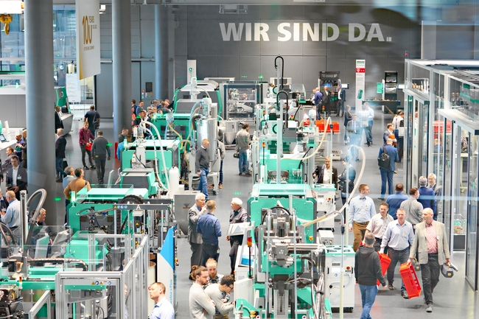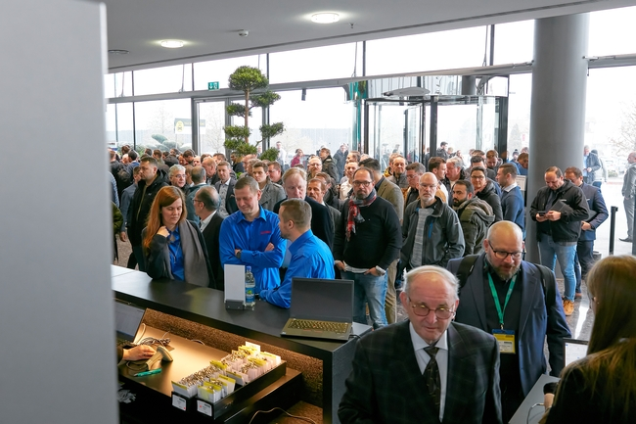

5,700 customers from 53 nations came to the Arburg Anniversary Days at the "think tank" in Lossburg, from 8 to 11 March 2023. The first port of call was the Customer Center (picture 187907) with numerous exhibits and exciting applications in injection moulding and 3D printing.

187698
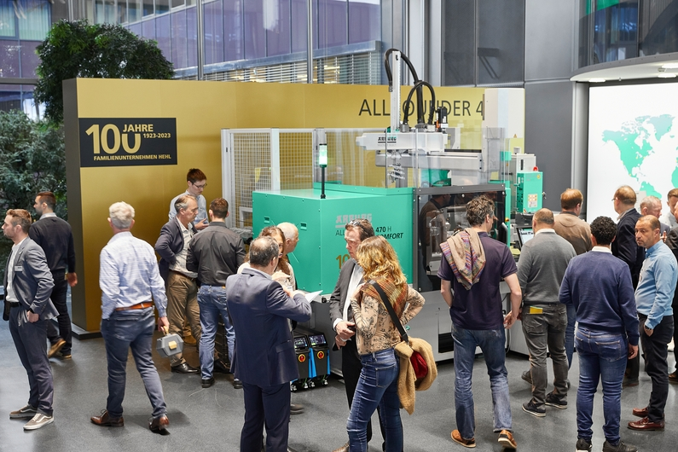

Milestone machine: The hybrid Allrounder 470 H sets the stage for a new machine technology that saves energy, conserves resources, is production-efficient, user-friendly and reliable.

187785 / 187693

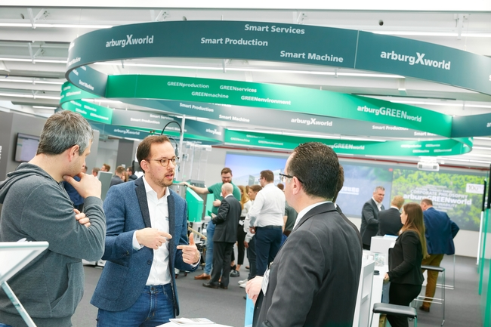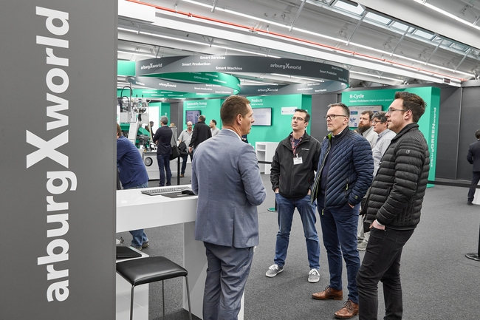

The Efficiency Arena with its focus on arburgGREENworld and arburgXworld was once again a key port of call this year. Together with selected partners, innovative solutions relating to resource conservation, digitalisation and the circular economy were presented.

187612 / 188016
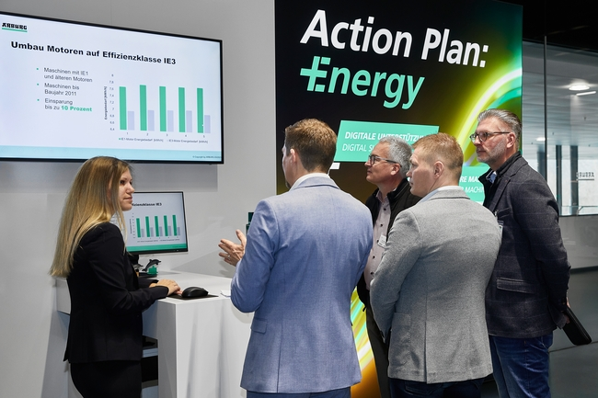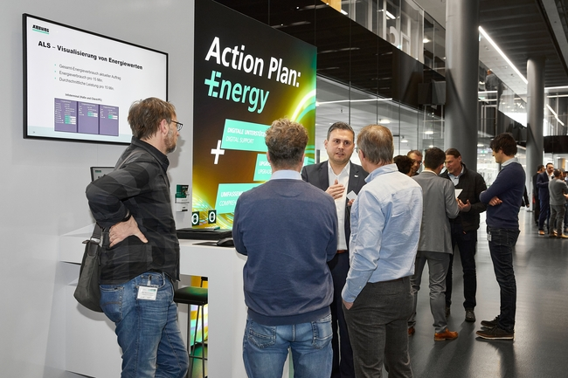
Energy efficiency was an important theme of the Anniversary Days 2023. The "Action Plan: Energy", with which Arburg offers its customers, for example, comprehensive advice, machine upgrades and energy measurements, generated a correspondingly high response.

188259 / 187860

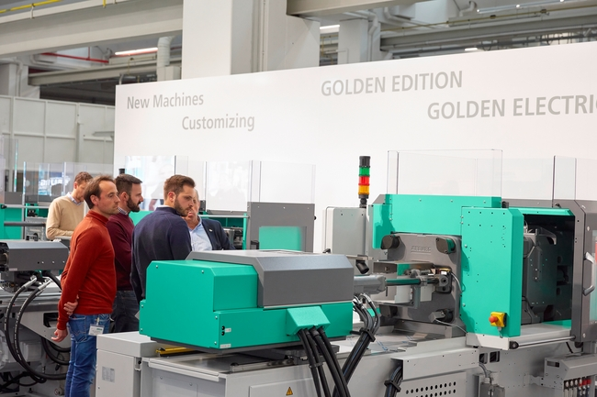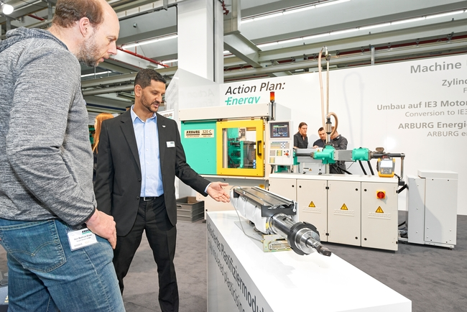

In the service area, the complete range of after-sales products services was presented – from genuine spare parts to preventive maintenance and digital services. There was particular demand for "Ready2Go" machines available at short notice and energy-saving options such as fully insulated cylinder modules for retrofitting existing machines.

187639 / 187934
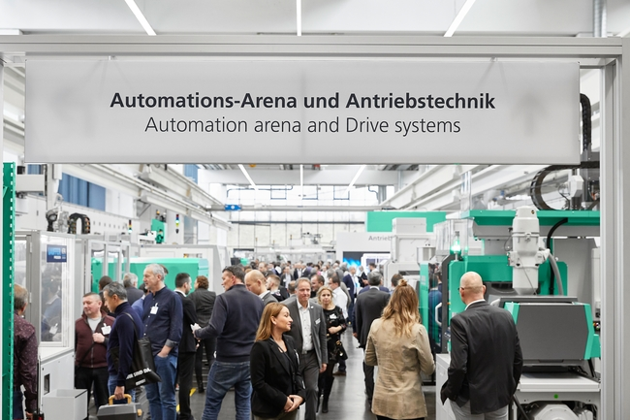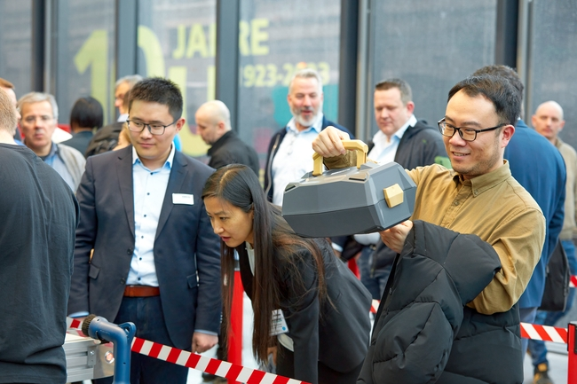

There was enormous interest in automation and turnkey systems. In the Automation Arena, selected exhibits and current customer projects were on display – from the automated production of the coveted tool box in the anniversary design to highly complex turnkey systems.

187706
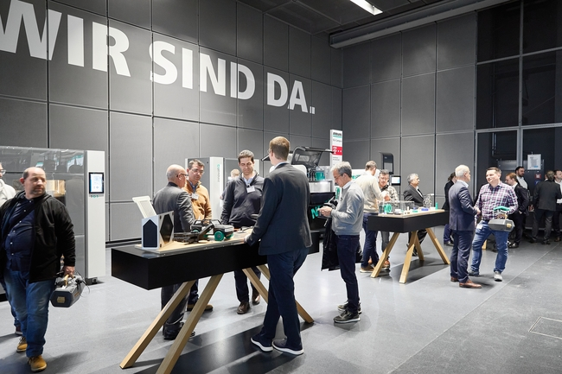

The portfolio of ARBURGadditives was on display in the Customer Center and the Arburg Prototyping Center. Here, visitors were able to learn all about additive manufacturing and 3D printing from the machine exhibits and numerous component examples.

187640 / 187635
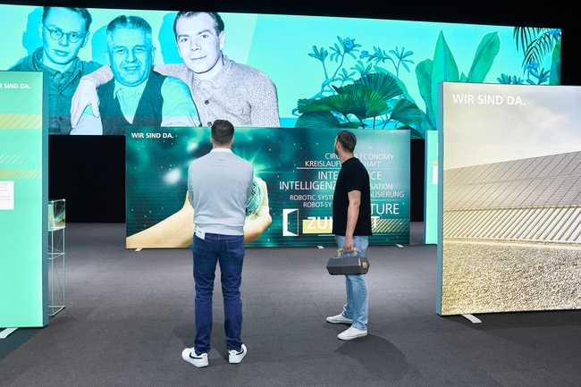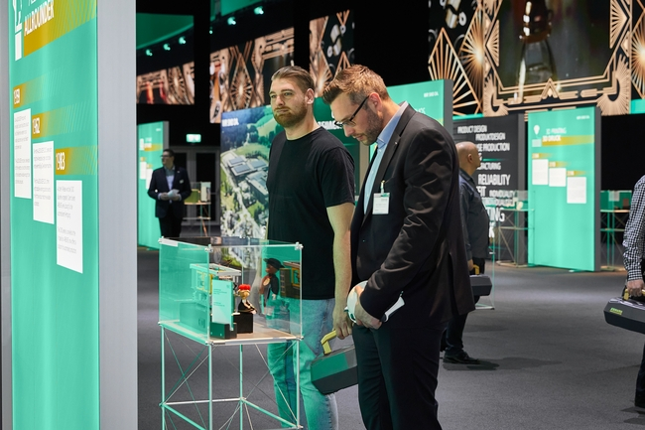

The "Arburg Cube" event location was also very popular, where visitors were able to find out about the milestones and history of "100 years of the Hehl family company" in an entertaining way.

187992

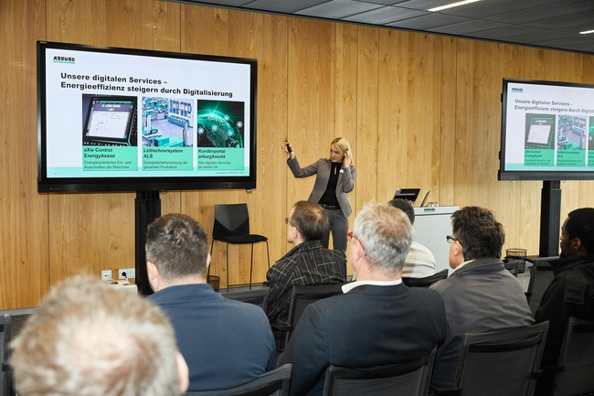

Top-class experts from various industries and sectors presented trends in plastics processing in the context of specialist lectures.

187762

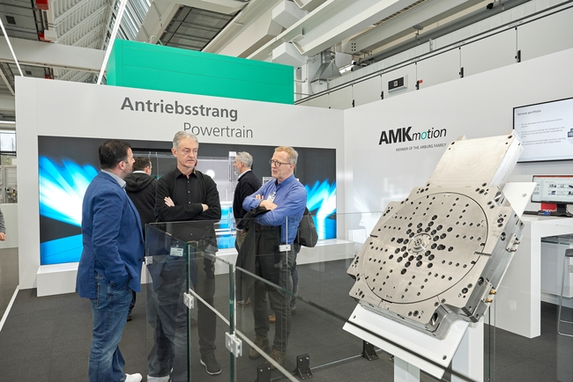

In the AMKmotion exhibition area, an interactive exhibit on the drive train and an electrically driven rotary unit were on display.

187534

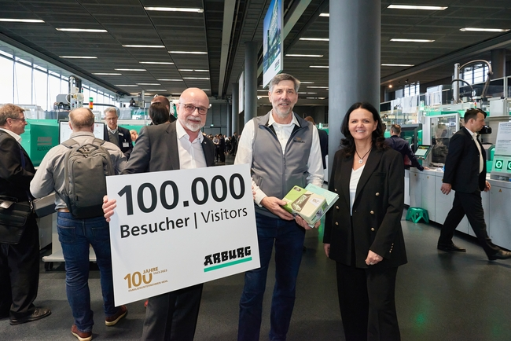

On the afternoon of 8 March, Arburg welcomed the 100,000th visitor to the industry event at the Anniversary Days 2023): Max Meier (centre), Trelleborg Switzerland, Juliane Hehl, Arburg Managing Partner responsible for Global Marketing and Business Development, and Dr Christoph Schumacher, Head of Global Marketing.

All photos: ARBURG
Photo download:
https://media.arburg.com/portals/downloadcollection/976AA39CB49943987E904E80CC9A1BD7

Press release
File: ARBURG Press review Anniversary Days 2023_en_GB.docx
Characters: 4,265
Words: 1,244

This and other press releases are available for download from our website at www.arburg.com/de/presse/ (www.arburg.com/en/press/)

Contact
ARBURG GmbH + Co KG
Press office
Susanne Palm
Dr Bettina Keck
Postfach 1109
72286 Lossburg
Tel.: +49 (0)7446 33-3463
Tel.: +49 (0)7446 33-3259
presse_service@arburg.com

About Arburg
German family-owned company Arburg is one of the world's leading manufacturers of plastic processing machines. Its product portfolio encompasses Allrounder injection moulding machines with clamping forces of between 125 and 6,500 kN, the Freeformer for industrial additive manufacturing and robotic systems, customer and industry-specific turnkey solutions and further peripheral equipment.
Arburg is a pioneer in the plastics industry when it comes to production efficiency, digitalisation and sustainability. The “arburgXworld” program comprises all digital products and services and is also the name of the customer portal. The company’s strategies regarding the efficient use of resources and circular economy, as well as all related aspects and activities, are outlined in the “arburgGREENworld” program.
Arburg’s central aim is for customers to be able to produce their plastic products, from one-off parts to large-volume batches, in optimum quality at minimum unit costs. The target groups include, for example, the automotive and packaging industries, communication and entertainment electronics, medical technology and the white goods sector.
An international sales and service network ensures first-class customer support at a local level: Arburg has its own organisations at 34 locations in 25 different countries and, together with its trading partners, is represented in more than 100 countries. Its machines are produced at the company's German headquarters in Lossburg. Of a total of roughly 3,600 employees, around 3,000 work in Germany. About 600 further employees work in Arburg's organisations around the world. Arburg has triple certification, in accordance with ISO 9001 (quality), ISO 14001 (environment) and ISO 50001 (energy).
Further information about Arburg can be found at www.arburg.com

