"Faberlab powered by Arburg" Additive Center to open
Bundled expertise!

- Opening: the Additive Center is set to open on March 2 in Origgio near to Milan
- Cooperation: 3D printing service provider Faberlab and Arburg pool their know-how
- Additive manufacturing: systems from Arburg and innovatiQ

Lossburg, 17.02.2023
After a year-long planning and development phase, the "Faberlab powered by Arburg" Additive Center will be opened on March 2, 2023 at Faberlab, service provider for industrial additive manufacturing. The backdrop to the factory opening: in the future, the two companies will collaborate at Faberlab’s Origgio location in Greater Milan. The aim is to demonstrate the potentials of industrial additive manufacturing to prospective and existing customers of 3D printing technology on real machines. A freeformer 200-3X, a high-temperature freeformer 300-3X and an innovatiQ TiQ 5 printer with a large build chamber for processing high-performance thermoplastics will be put into operation at Faberlab.

Customers are set to benefit from the combined knowledge of Faberlab and Arburg. The partners will collaborate closely to provide advice on technology and all possible services associated with industrial additive manufacturing. Ivan Panfiglio, manager for additive manufacturing in Italy, is the point of contact at Arburg for customers of this technology.
This pilot project is based on the same blueprint as the Arburg Prototyping Center (APC), which the company operates at its headquarters in Lossburg as well as at its branches in the USA and China. Now, customers will be able to have benchmark components manufactured and materials qualified in Italy as well. A sales associate from Arburg s.r.l will be the specific point of contact for this customer segment and will also be responsible for contact with Faberlab. By strategically expanding its AM expertise in this way, Arburg can now specifically meet local expectations and cater to the needs of the Italian market as a whole. The on-site team is able to support Freeformer and TiQ customers even faster and in a more specific and extremely practical way.
Faberlab, in turn, has developed high-caliber expertise and knowledge in recent years through its work for the mechanical engineering, medical technology, aerospace, automotive and plant engineering industries. It now brings this know-how to the collaboration.

Centre for additive manufacturing
Alongside Raffaele Abbruzzetti, Managing Director of Arburg s.r.l. and his specialists from Italy, Dr. Victor Roman, Managing Director of ARBURGadditive GmbH + Co KG, and Dr. Didier von Zeppelin, Manager Additive Manufacturing from Lossburg, are also expected to attend the opening of the "digital laboratory" in Origgio. They will both be available for technical discussions on the opening day.
Faberlab and Arburg complement one another perfectly, which is why the "Faberlab powered by Arburg" Additive Center is also offering services such as rapid prototyping, component design and training. In other words, all-round support along the entire value chain, from development to production. "We support companies and research institutions by developing functional prototypes using different technologies, in particular ARBURG Plastic Freeforming APF and innovatiQ’s FDM technology", says Raffaele Abbruzzetti describing the portfolio.
In concrete terms, this means that benchmark parts, functional prototypes and small series can be additively manufactured in Origgio from a wide variety of original materials, around the clock if needs be. This allows prospective customers of manufacturing systems to determine in advance whether ARBURG Plastic Freeforming or the FDM technology is actually suitable for the desired part, material and application before they commit to a purchase. To help them become more familiar with the technology, existing and prospective customers are also given the opportunity to participate in technology training courses and work with the machine themselves on site. The Additive Center is also equipped with laser cutting machines, formlabs and cutting edge digital manufacturing technologies that allow the object being manufactured to have a customised additive design.

Almost everything is possible
Additive printing without compromise is the claim of the "Faberlab powered by Arburg" Additive Center in Origgio. Without compromise means that not only standard additive components but complex functional components as well can be produced as hard/soft combinations or with support material. A wide range of original materials, material combinations and colours at the highest level of quality and stability are available for industrial scale production. Two of many examples are 3D printing using ABS for impact-resistant components with a high quality surface finish and the additive processing of SEBS, a highly elastic and soft TPE with good colourability and malleability. In Italy too, every requirement for industrial additive manufacturing can now be met.

Photo

185411.jpg

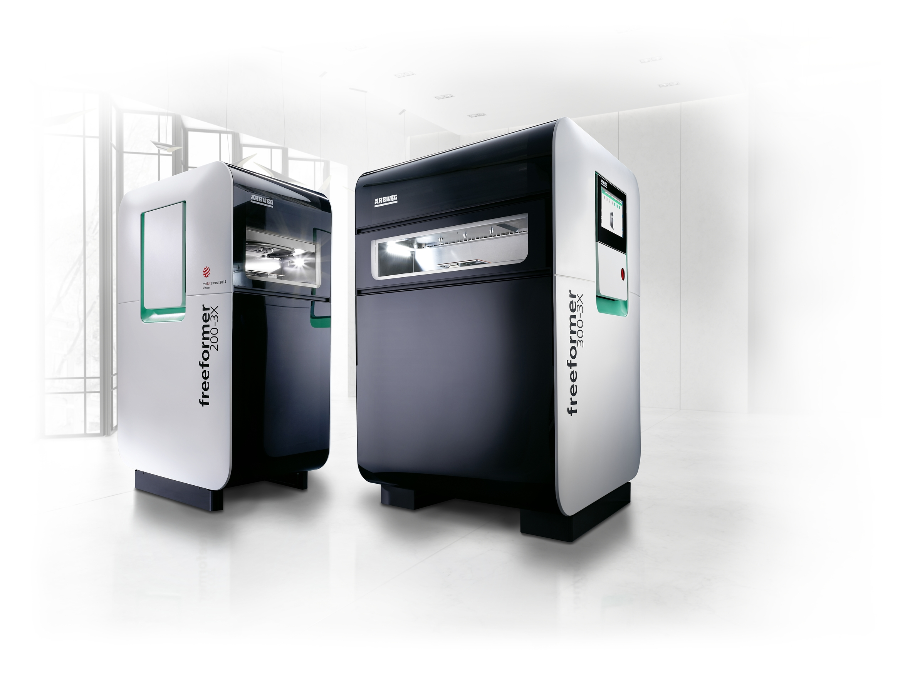

A freeformer 200-3X and a high-temperature freeformer 300-3X will be in operation at Faberlab to produce benchmark parts using the APF method.

177908

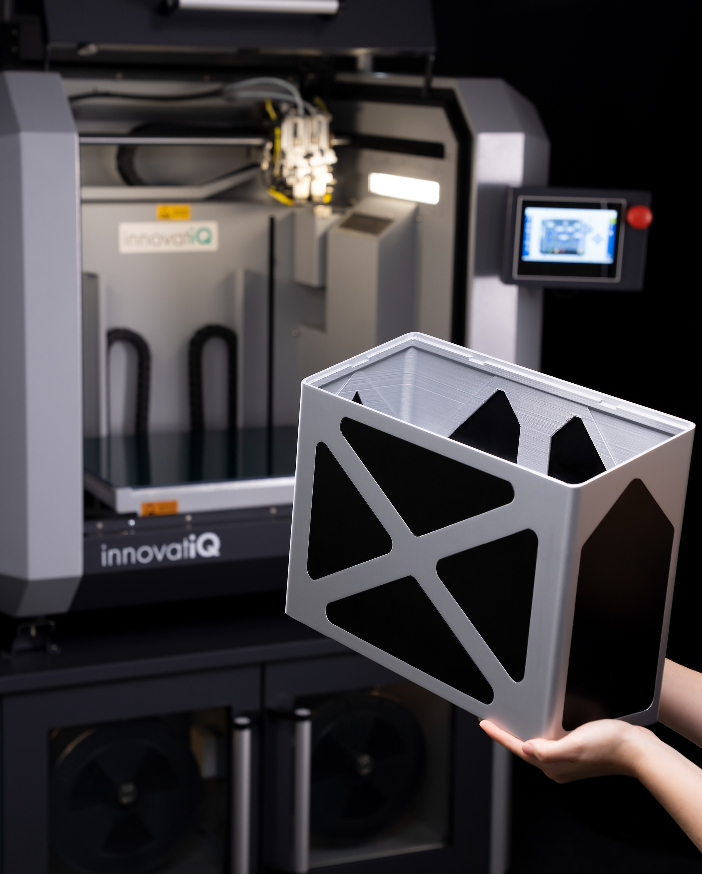

An innovatiQ TiQ 5 printer is available at Faberlab for the production of components using FDM technology.

Photo: innovatiQ
Photo download:
https://media.arburg.com/portals/downloadcollection/EACEAAC9036BDF8AAC7464F60B43D1D0

Press release
File: Pressemitteilung Eroeffnung Faberlab_en_GB.docx
Characters: 4.700
Words: 698

This and other press releases are available for download from our website at www.arburg.com/de/presse/ (www.arburg.com/en/press/)

Contact
ARBURG GmbH + Co KG
Press office
Susanne Palm
Dr Bettina Keck
Postfach 1109
72286 Lossburg
Tel.: +49 (0)7446 33-3463
Tel.: +49 (0)7446 33-3259
presse_service@arburg.com

About Arburg
German family-owned company Arburg is one of the world's leading manufacturers of plastic processing machines. Its product portfolio encompasses Allrounder injection moulding machines with clamping forces of between 125 and 6,500 kN, the Freeformer for industrial additive manufacturing and robotic systems, customer and industry-specific turnkey solutions and further peripheral equipment.
Arburg is a pioneer in the plastics industry when it comes to production efficiency, digitalisation and sustainability. The “arburgXworld” program comprises all digital products and services and is also the name of the customer portal. The company’s strategies regarding the efficient use of resources and circular economy, as well as all related aspects and activities, are outlined in the “arburgGREENworld” program.
Arburg’s central aim is for customers to be able to produce their plastic products, from one-off parts to large-volume batches, in optimum quality at minimum unit costs. The target groups include, for example, the automotive and packaging industries, communication and entertainment electronics, medical technology and the white goods sector.
An international sales and service network ensures first-class customer support at a local level: Arburg has its own organisations at 34 locations in 25 different countries and, together with its trading partners, is represented in more than 100 countries. Its machines are produced at the company's German headquarters in Lossburg. Of a total of roughly 3,600 employees, around 3,000 work in Germany. About 600 further employees work in Arburg's organisations around the world. Arburg has triple certification, in accordance with ISO 9001 (quality), ISO 14001 (environment) and ISO 50001 (energy).
Further information about Arburg can be found at www.arburg.com

