"Faberlab powered by Arburg" Additive Center to open
Here we go!

- Launch: additive Center stages open house event with around 120 guests in Origgio near to Milan
- Know-how: 3D printing service provider Faberlab and Arburg collaborate to share their expertise
- Additive: three machines from Arburg and innovatiQ help processing become more versatile

Lossburg, 6/4/2023
The "Faberlab powered by Arburg" Additive Center was officially launched on March 2, 2023 as part of an open house event. The centre at Faberlab, service provider for industrial additive manufacturing, offers companies beyond the region the unique opportunity to familiarise themselves with additive machines from Arburg and innovatiQ in practical situations.

In Origgio in the Greater Milan, customers benefit from the close collaboration between Faberlab and Arburg and the expertise the two companies have pooled. The knowledge surrounds not only the technology itself, but also every conceivable service related to industrial additive manufacturing and across the entire value chain from development to production. Including, for example, rapid prototyping, component design, and also training.
Until now, no other centre in Italy has been able to offer this expertise to companies, research institutes or training facilities. Arburg is providing a freeformer 200-3X, a high-temperature freeformer 300-3X and an innovatiQ TiQ 5 printer with a large build chamber for processing high-performance thermoplastics. Ivan Panfiglio, manager for additive manufacturing in Italy, is the point of contact at Arburg for customers of this technology.

This pilot project is based on the Arburg Prototyping Center (APC), which the company operates at its headquarters in Lossburg as well as at its branches in the USA and China. Now, customers can have benchmark components manufactured and materials qualified in Italy as well. Having strategically expanded the reach of its AM activities in this way, Arburg can now specifically meet local expectations and cater to the needs of the Italian market as a whole.

Centre for additive manufacturing goes into operation
The opening of the "digital lab" in Origgio was attended by a total of 118 guests seeking advice, new networks and technical discussions with the specialists. Eltek Spa, a customer of Arburg from Casale Monferrato, presented visitors with a case history of products created on the Freeformer.
As Massimo Zanin, senior development engineer at Eltek Spa, remarks: "Eltek has around a hundred Arburg injection moulding machines. This is how we came across Faberlab and the Freeformer. We consider this a very special machine, not just a conventional filament 3D printer. For plastics processors like ourselves, it is important to have a system that can use the same plastics for prototyping as it does for the series product. Our prototypes should have more or less the same mechanical properties as the original. The Freeformer is the printer that best meets these requirements. Together, Faberlab and Arburg would have helped Eltek make the best use of the machine."
An Eltek product built entirely on the Freeformer has given research a huge boost. This concerns a rapid antibiogram, in other words a microbiological test procedure that allows the response of a bacterium to an antibiotic to be analysed. A patient’s pathology can then be understood very quickly, saving lives.

Voices at the opening
Dr. Victor Roman, Managing Director ARBURGadditive from Lossburg, commenting on the collective work in Italy: "3D technology and its reach is of fundamental importance at a time when companies need innovations to reduce the time and cost required to realise projects. By the same token, the partnership developed with Faberlab is an integral part of this process and an element that we consider strategic for the Italian market as a whole."

Raffaele Abbruzzetti, Managing Director of Arburg Srl in Italy, also sees the collaboration in a positive light: "This is an important collaboration between two independent companies, but with the mutual interest of offering additive manufacturing and its prospects with machines and, above all, start of production on demand. This is how Arburg has established the possibility to produce samples and qualify new materials directly on site at the request of Italian customers. Faberlab can now use the experience it has garnered over the years with a complete machine fleet. ‘Faberlab powered by Arburg’ can now play an active role in supporting industry, institutions and research centres in an industrial region as important as Lombardy and beyond."
Davide Baldi from Faberlab also applauds the collaboration and the technology: "The collaboration between Faberlab and Arburg is an opportunity for both companies. Arburg has developed an innovative and unique product that can be promoted through this partnership – with the Freeformer. Faberlab offers a laboratory like no other, bringing additive technology to businesses and promoting technological development. We also have a large pool of companies in the plastics sector, many of which are already Arburg customers. In this way, the needs of the two partners can be merged very well.
Arburg’s Freeformer works hand-in-glove with production and, as an open system, fits with Faberlab’s development goals to perfection. "The collaboration is also an opportunity for companies to get closer to an innovative new technology."

Almost everything is possible
In the "Faberlab powered by Arburg" Additive Center in Origgio, without compromise means that not only standard additive components but complex functional components as well can be produced as hard/soft combinations or with support material. A wide range of original materials, material combinations and colours at the highest level of quality and stability are available for industrial scale production. Two of many examples are 3D printing using ABS for impact-resistant components with a high quality surface finish and the additive processing of SEBS, a highly elastic and soft TPE with good colourability and malleability. In Italy too, every requirement for industrial additive manufacturing can now be met.

Photo

188487 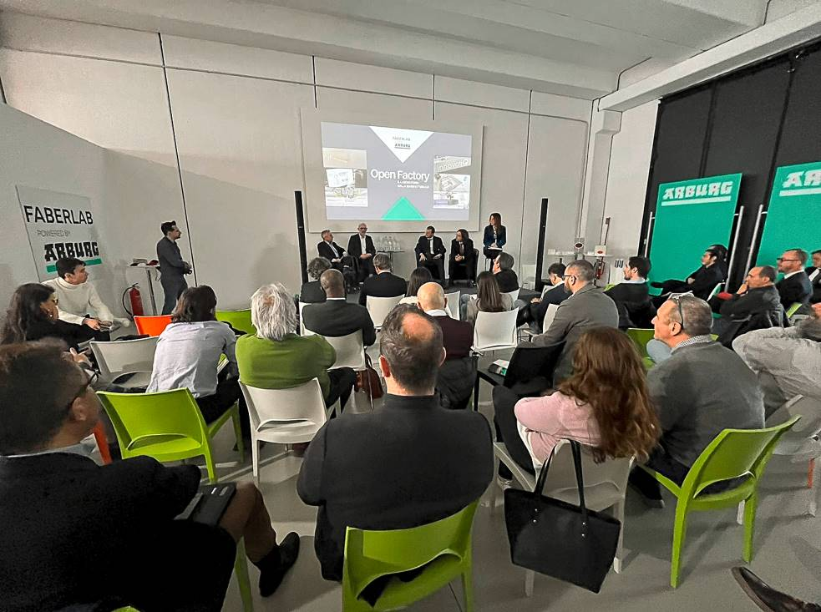

The range of services on offer from the "Faberlab powered by Arburg" Additive Center was presented to the guests in detail during the opening ceremony.

188488 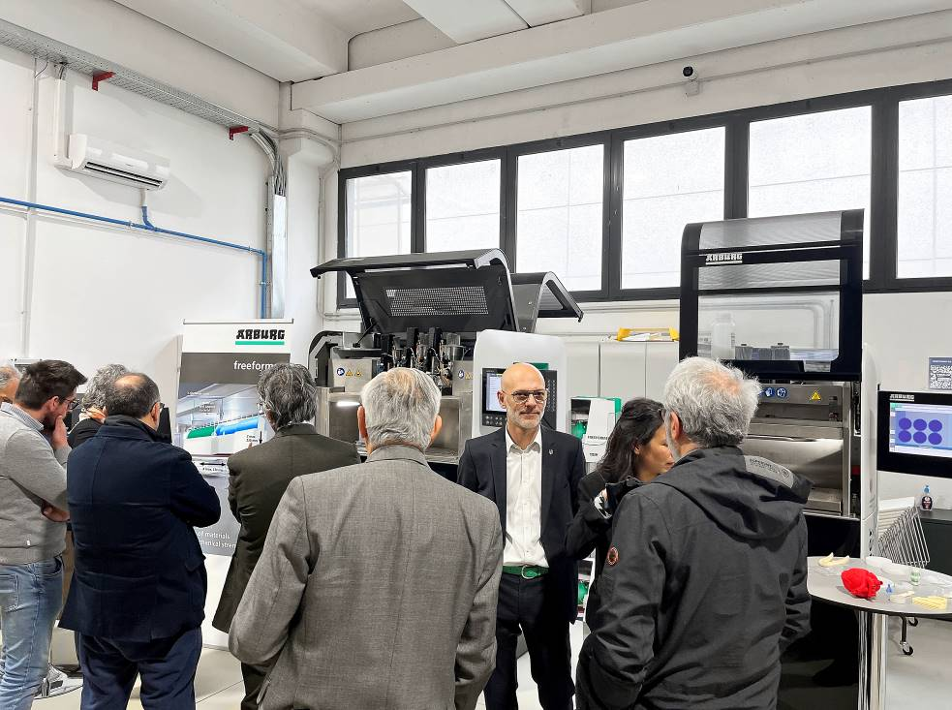

Dr. Didier von Zeppelin, an expert from ARBURGadditive, explained the potentials of Arburg Plastic Freeforming on the two freeformers directly.

Photos: Arburg

Photo download:
https://media.arburg.com/portals/downloadcollection/A6AD4FF625369EBA5C087B6BE33CAEE4

Press release
File: ARBURG Press release Open House Faberlab_en_GB.docx
Characters: 5.810
Words: 895

This and other press releases are available for download from our website at www.arburg.com/de/presse/ (www.arburg.com/en/press/)

Contact
ARBURG GmbH + Co KG
Press office
Susanne Palm
Dr Bettina Keck
Postfach 1109
72286 Lossburg
Tel.: +49 (0)7446 33-3463
Tel.: +49 (0)7446 33-3259
presse_service@arburg.com

About Arburg
German family-owned company Arburg is one of the world's leading manufacturers of plastic processing machines. Its product portfolio encompasses Allrounder injection moulding machines with clamping forces of between 125 and 6,500 kN, the Freeformer for industrial additive manufacturing and robotic systems, customer and industry-specific turnkey solutions and further peripheral equipment.
Arburg is a pioneer in the plastics industry when it comes to production efficiency, digitalisation and sustainability. The “arburgXworld” program comprises all digital products and services and is also the name of the customer portal. The company’s strategies regarding the efficient use of resources and circular economy, as well as all related aspects and activities, are outlined in the “arburgGREENworld” program.
Arburg’s central aim is for customers to be able to produce their plastic products, from one-off parts to large-volume batches, in optimum quality at minimum unit costs. The target groups include, for example, the automotive and packaging industries, communication and entertainment electronics, medical technology and the white goods sector.
An international sales and service network ensures first-class customer support at a local level: Arburg has its own organisations at 34 locations in 25 different countries and, together with its trading partners, is represented in more than 100 countries. Its machines are produced at the company's German headquarters in Lossburg. Of a total of roughly 3,600 employees, around 3,000 work in Germany. About 600 further employees work in Arburg's organisations around the world. Arburg has triple certification, in accordance with ISO 9001 (quality), ISO 14001 (environment) and ISO 50001 (energy).
Further information about Arburg can be found at www.arburg.com

