Arburg Senior Partner Eugen Hehl passed away

- Arburg: Dynamic corporate development significantly shaped
- Plastics industry: Globally outstanding entrepreneurial personality
- Region: Socially committed, Christian values, characterised by sustainability

Lossburg, 13/12/2023
On 12 December 2023, Eugen Hehl, Senior Partner of Arburg GmbH + Co KG, passed away at the age of 94. In addition to his entrepreneurial vision, the trained master mechanic was recognised above all for his services to the development of global sales at Arburg and the company's construction infrastructure, as well as his strong social commitment to and in the region. The family-owned company is one of the world's leading manufacturers of plastic processing machines.

As Chairman of the Management Team for many years and responsible for global sales at Arburg, Eugen Hehl played a key role in the company's global success. Technically trained, but with a keen instinct for sales in particular, he played a decisive role in shaping the family business for more than seven decades in congenial co-operation with his brother Karl, who passed away in 2010. With his ideas and solutions regarding construction, he gave the company an unmistakable profile worldwide. As Managing Partner, Eugen Hehl played a key role in the global success of the family company as the "master builder of the company".

Global sales structures established
In 1951, Eugen Hehl began to build up his own, initially regional, sales structures by travelling extensively. As early as 1957, he raised the company's sales to an international level by participating in the first trade fair in Amsterdam in the Netherlands. Eugen Hehl pursued committed visions throughout his life. As early as 1962, he travelled to Japan and the USA to further boost machine sales.
With a love of detail and determination, the ambitious hunter, morning fitness enthusiast and tea drinker also implemented the construction activities at the main plant and the successively established Arburg subsidiaries around the world from the very beginning. With foresight, he had buildings in Lossburg that were between two and four years old partially demolished in 1966 in order to enable what is known as grid construction and thus improved future expansion alternatives on the company premises. Many of the Arburg subsidiaries around the world resemble the headquarters in terms of their exterior design and are therefore clearly recognisable.

Strong social commitment
At Arburg, in his home town Lossburg and far beyond the region, Eugen Hehl was held in high esteem both personally and professionally. Together with his brother Karl, Eugen Hehl was also known for his strong social commitment. The two of them had the Gebrüder Hehl Foundation established in Lossburg, which officially began its work in 1999. The retirement home operated by “Bruderhaus-Diakonie,” a non-profit, Christian diaconal foundation in Baden-Württemberg, is open to older people for assisted living, short-term and elderly care. Eugen Hehl was also active in the church, including in the church choir of the Lossburg parish.

Outstanding achievements
In November 2000, the Federal Republic of Germany honoured Eugen Hehl with the Federal Cross of Merit for his achievements. The company also received the Baden-Württemberg Business Medal in 1990 and the Baden-Württemberg Competence Award for Innovation and Quality in 2015. Further awards include honorary citizenship of the municipality of Lossburg in November 1997 and the Golden Master Craftsman's Certificate in 2005. The American Society of Plastics Engineers (SPE) presented Eugen and Karl Hehl with the Business Management Award in 2007 for their joint life's work. Eugen Hehl was inducted into the "Plastics Hall of Fame" in 2015 for his life's work. In 2020, the senior partner received the Richard Vieweg Medal of Honour, the highest award of the Association of German Engineers (VDI).

In Eugen Hehl, Arburg and the entire industry have lost a down-to-earth and success-orientated person, entrepreneur and pioneer. The Managing Partners, in particular his two children Juliane and Michael Hehl, who together with their cousin Renate Keinath are currently managing the company in the third generation, the Managing Directors and all employees will remember him with honour and gratitude.

Photo

197335

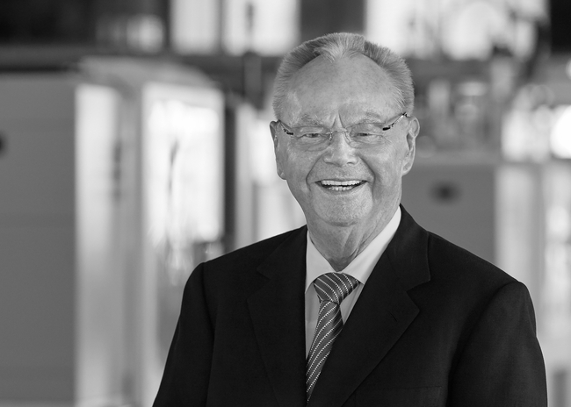

Arburg mourns the loss of its Senior Partner Eugen Hehl, who passed away on 12 December 2023 at the age of 94. Eugen Hehl made a particular contribution to the development of the global sales organisation and the structural development of the company.

Photo: ARBURG

Photo download:
https://media.arburg.com/portals/downloadcollection/824FDA1540726A214F374FEF6558ADBC

Press release
File: ARBURG Press release Eugen Hehl 2023-12-13_en_GB.docx
Characters: 4.060
Words: 637

This and other press releases are available for download from our website at www.arburg.com/de/presse/ (www.arburg.com/en/press/)

Contact
ARBURG GmbH + Co KG
Press office
Susanne Palm
Dr Bettina Keck
Postfach 1109
72286 Lossburg
Tel.: +49 (0)7446 33-3463
Tel.: +49 (0)7446 33-3259
presse_service@arburg.com

About Arburg
German family-owned company Arburg is one of the world's leading manufacturers of plastic processing machines. Its product portfolio encompasses Allrounder injection moulding machines with clamping forces of between 125 and 6,500 kN, the freeformer for industrial additive manufacturing and robotic systems, customer and industry-specific turnkey solutions and further peripheral equipment.
Arburg is a pioneer in the plastics industry when it comes to energy and production efficiency, digitalisation and sustainability. The "arburgXworld" program comprises all digital products and services and is also the name of the customer portal. The company’s strategies regarding the efficient use of resources and circular economy, as well as all related aspects and activities, are outlined in the 'arburgGREENworld' program.
Arburg's main aim is to enable its customers to manufacture their plastic products, from one-off parts to large-volume batches, to optimum quality standards and in a way that conserves resources, is sustainable and minimises unit costs. Target groups include the automotive and packaging industries, communication and entertainment electronics, medical technology and the white goods sector.
First-class customer support on-site is guaranteed by the international sales and service network: Arburg has own organisations in 25 countries at 35 locations and is represented in over 100 countries together with trade partners. Its machines are produced at the company's German headquarters in Lossburg. Of a total of roughly 3,800 employees, around 3,200 work in Germany, with another 600 employees based in Arburg's organisations around the world. Arburg is certified to ISO 9001 (quality), ISO 14001 (environment), ISO 27001 (information security), ISO 29993 (training) and ISO 50001 (energy).
Further information about Arburg can be found at www.arburg.com

