Arburg Exhibit at Fakuma 2023
Allrounder 720 A: Efficient injection compression moulding of IML thin-walled cups

- Powerful: Electric Allrounder "Ultimate"
- Energy-efficient: Injection compression moulding as an alternative to thermoforming
- Comprehensive: Arburg presents a great many sustainable, digital and automated solutions

Loßburg, 17/10/2023
An electric Allrounder 720 A "Ultimate" demonstrates at Fakuma 2023 that high-quality injection moulding technology can be an alternative to thermoforming. The exhibit uses injection compression moulding to produce thin-walled IML cups that can be easily recycled after use.

The directly driven high-performance machine with a clamping force of 2,900 kN is equipped with a size 1300 injection unit that is specifically optimised for high performance. Thanks to high-precision servo motors from Arburg's sister company AMKmotion, very high injection volume flows and injection speeds of up to 400 millimetres per second can be achieved.

IML cups only 0.37 millimetres thick
The exhibit uses a 4-cavity mould from Brink to produce thin-walled IML round cups from polypropylene (PP) using the injection compression moulding process. The flowpath/wall thickness ratio is 380:1. For process monitoring, the mould is equipped with six high-resolution inductive position measuring and embossing sensors. Four moulded parts, each weighing 10.8 grams and with a wall thickness of only 0.37 millimetres, are produced in a cycle time of 3.95 seconds. The plastic has a biomass footprint and ISCC-certified. Also integrated into the production cell is a side-entry robot from Brink that inserts the labels, removes the finished cups and stacks them on a conveyor belt.

Resource-saving and recyclable
In this particularly resource-saving application for the packaging industry, special emphasis was placed on energy efficiency and on a part design that saves materials. Thanks to the all-electric packaging machine in combination with injection compression moulding, the energy footprint is improved by 20 per cent with a significant reduction in part weight from 13 to 10.8 grams. Meanwhile, the flowpath/wall thickness ratio is 380:1. Normally, this would require a very high level of injection pressure – at the expense of energy requirements and mould wear. This is why injection compression moulding is used for this application. Compared to classic injection moulding, this process requires significantly less injection pressure and it is possible to work with mould temperatures of 20 instead of 12 degrees Celsius. The special "Next Cycle IML" label can be completely separated from the PP of the cup during recycling, so that the product can be recycled by type after use. In contrast to thermoforming, no pre-produced foils are used and no stamping waste is produced.

Photos

183540
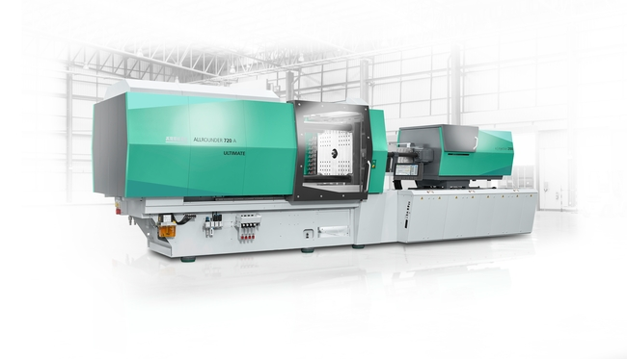
Energy- and resource-saving alternative to thermoforming: An electric Allrounder 720 A "Ultimate" produces thin-walled IML cups at Fakuma 2023 using the injection compression moulding process.

188838
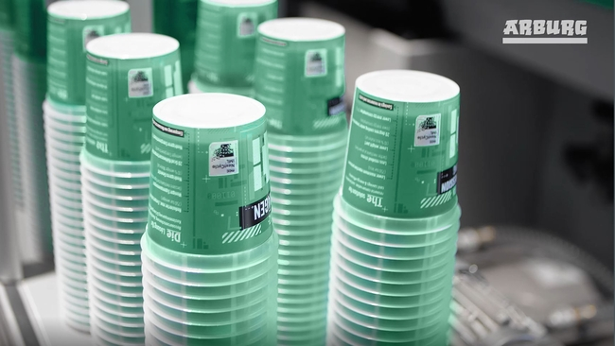
The recyclable IML round cups made of PP monomer material have a wall thickness of only 0.37 millimetres.

Photos: ARBURG
Foto Download – aktualisiert mit Motiven von der Messe:
https://media.arburg.com/portals/downloadcollection/8C8AEA88DCF33374F992E971D4E31E3A

Press release
File: 07 ARBURG press release Allrounder 720A IML cups Fakuma 2023_en_GB.docx
Characters: 2,718
Words: 419

This and other press releases are available for download from our website at www.arburg.com/de/presse/ (www.arburg.com/en/press/)

Contact
ARBURG GmbH + Co KG
Press office
Susanne Palm
Dr Bettina Keck
Postfach 1109
72286 Lossburg
Tel.: +49 (0)7446 33-3463
Tel.: +49 (0)7446 33-3259
presse_service@arburg.com

About Arburg
German family-owned company Arburg is one of the world's leading manufacturers of plastic processing machines. Its product portfolio encompasses Allrounder injection moulding machines with clamping forces of between 125 and 6,500 kN, the Freeformer for industrial additive manufacturing and robotic systems, customer and industry-specific turnkey solutions and further peripheral equipment.
Arburg is a pioneer in the plastics industry when it comes to energy and production efficiency, digitalisation and sustainability. The “arburgXworld” program comprises all digital products and services and is also the name of the customer portal. The company’s strategies regarding the efficient use of resources and circular economy, as well as all related aspects and activities, are outlined in the 'arburgGREENworld' program.
Arburg's main aim is to enable its customers to manufacture their plastic products, from one-off parts to large-volume batches, to optimum quality standards and in a way that conserves resources, is sustainable and minimises unit costs. Target groups include the automotive and packaging industries, communication and entertainment electronics, medical technology and the white goods sector.
First-class customer support on-site is guaranteed by the international sales and service network: Arburg has own organisations in 25 countries at 35 locations and is represented in over 100 countries together with trade partners. Its machines are produced at the company's German headquarters in Lossburg. Of a total of roughly 3,800 employees, around 3,200 work in Germany, with another 600 employees based in Arburg's organisations around the world. Arburg is certified to ISO 9001 (quality), ISO 14001 (environment), ISO 27001 (information security), ISO 29993 (training) and ISO 50001 (energy).
Further information about Arburg can be found at www.arburg.com

