Arburg exhibit at Fakuma 2023
Allrounder 375 V: Transparency thanks to digital "Fingerprint"

- Automated: Compact turnkey system with
suspended six-axis robot
- Good to go: Ready-to-use bicycle tool in one step
- Digital: Tyre levers 100 per cent traceable thanks to "Invisible Tracing"

Lossburg, 17/10/2023
The application example of a tyre lever will show at Fakuma 2023 how digitalisation and automation go hand in hand to produce plastic parts efficiently and with 100 per cent traceability. Each product is clearly identifiable using "Invisible Tracing", a technology from partner Detagto.

The turnkey system with multi-axis robot, overmoulding of inserts and parts assembly is a sophisticated production solution with a high degree of autonomy. With the bicycle tool, tyres and inner tubes can be quickly and easily removed from the rim and mounted again.

Processing of recyclate (PIR)
The tyre levers are produced ready to use by a compact turnkey system built around an Allrounder 375 V with 500 kN clamping force and a 1+1-cavity family mould. The vertical machine overmoulds inserts with 50 per cent glass fibre-reinforced PA 66/6 into a "remover" and an "installer". The insert is made of ISCC-certified POM, while the PA material is a single-grade post-industrial recyclate (PIR). The cycle time is around 45 seconds. The exhibit is equipped with Arburg's recyclate package for homogeneous material preparation and consistently high product quality.

Space-saving automation
The complete parts handling process is carried out by a Kuka six-axis robot. No additional floor space is required for automation: the six-axis robot is suspended to save space and integrated into the machine controller. It first feeds clips provided via a vibratory bowl feeder to a camera inspection and inserts them into the mould. The removed moulded parts are given a DM code in a laser station. Then they are supplemented with operating instructions and the two-part tyre lever is assembled ready to use.

Mark-free "Invisible Tracing"
Before the tyre lever is placed on a conveyor belt, a camera system in a separate station photographs a defined area of the component's surface. The comparatively new "Invisible Tracing" technology from partner Detagto is used here. The image data of the registered surface is converted into a few kilobytes of easily storable character string and compressed before being transferred to a database. As every surface has tiny differences, similarly to a human fingerprint, each component can be clearly identified later at a separate test bay – in a way that is reliable, tamper-proof and requires little effort.

100 per cent traceable using ATCM and R-Cycle
On the exhibit, this invisible "fingerprint" is transferred to the Arburg Turnkey Control Module (ATCM) Scada system, ensuring 100 per cent traceability The ATCM is the key technology for linking and tracing material and process data. For this purpose, the data from the injection moulding process is recorded for each component ID and linked with the results from the optical inspection of the insert and digital "fingerprint".
The application is also an application example as part of the R-Cycle initiative, which Arburg was the first machine manufacturer to involved in from the start. Using what is known as the GS1 barcode standard, R-Cycle enables the automated storage of recycling-related data in digital product passports and forms the starting point for recyclable processes and their operationalization.

(Video on the application: https://youtu.be/wHxqWm_pboc)

Photos

184914

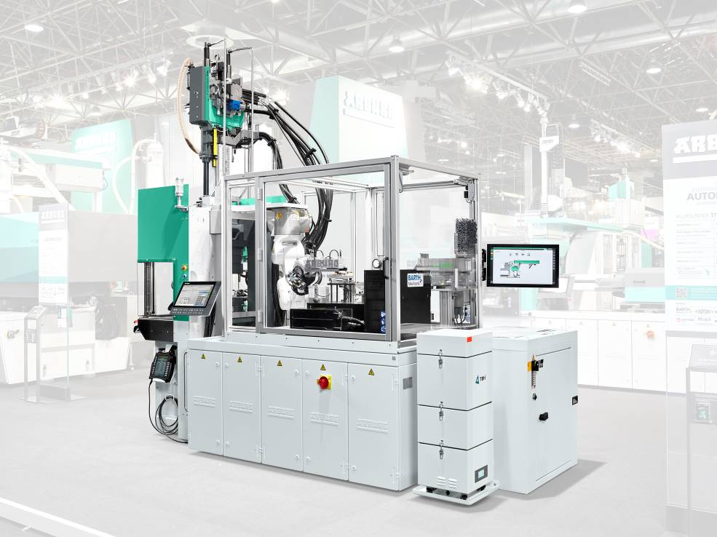

Compact: A turnkey system built around an Allrounder 375 V with a suspended six-axis robot and Arburg Turnkey Control Module (ATCM).

183357
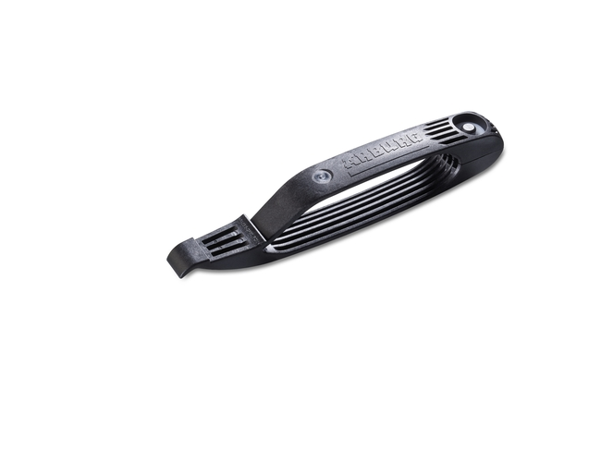

The turnkey system built around a vertical Allrounder 375 V overmoulds inserts with post-industrial recyclate (PIR) into two-part, ready-to-use tyre levers.

187985

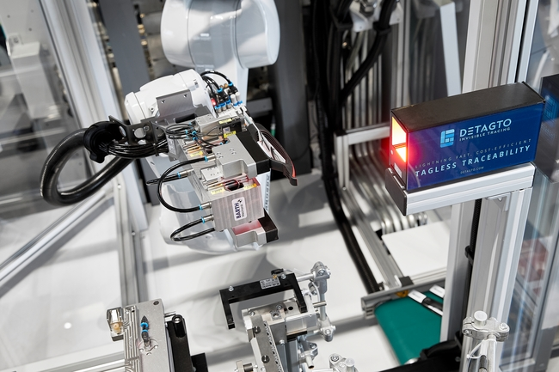

Each product receives a "digital fingerprint" and is clearly traceable via "Invisible Tracing".

Photos: ARBURG

Photo download – updated with motifs from the trade fair:
https://media.arburg.com/portals/downloadcollection/0D30DC77B2A6D19342C4B7A9ECDC6170

Press release
File: 06 ARBURG press release Allrounder 375V tyre lever Fakuma 2023_en_GB.docx
Characters: 3,184
Words: 500

This and other press releases are available for download from our website at www.arburg.com/de/presse/ (www.arburg.com/en/press/)

Contact
ARBURG GmbH + Co KG
Press office
Susanne Palm
Dr Bettina Keck
Postfach 1109
72286 Lossburg
Tel.: +49 (0)7446 33-3463
Tel.: +49 (0)7446 33-3259
presse_service@arburg.com

About Arburg
German family-owned company Arburg is one of the world's leading manufacturers of plastic processing machines. Its product portfolio encompasses Allrounder injection moulding machines with clamping forces of between 125 and 6,500 kN, the freeformer for industrial additive manufacturing and robotic systems, customer and industry-specific turnkey solutions and further peripheral equipment.
Arburg is a pioneer in the plastics industry when it comes to energy and production efficiency, digitalisation and sustainability. The "arburgXworld" program comprises all digital products and services and is also the name of the customer portal. The company’s strategies regarding the efficient use of resources and circular economy, as well as all related aspects and activities, are outlined in the 'arburgGREENworld' program.
Arburg's main aim is to enable its customers to manufacture their plastic products, from one-off parts to large-volume batches, to optimum quality standards and in a way that conserves resources, is sustainable and minimises unit costs. Target groups include the automotive and packaging industries, communication and entertainment electronics, medical technology and the white goods sector.
First-class customer support on-site is guaranteed by the international sales and service network: Arburg has own organisations in 26 countries at 36 locations and is represented in over 100 countries together with trade partners. Its machines are produced at the company's German headquarters in Lossburg. Of a total of roughly 3,800 employees, around 3,200 work in Germany, with another 600 employees based in Arburg's organisations around the world. Arburg is certified to ISO 9001 (quality), ISO 14001 (environment), ISO 27001 (information security), ISO 29993 (training) and ISO 50001 (energy).
Further information about Arburg can be found at www.arburg.com

