Arburg at the Industry Fair in Celje
High-end technology on show in Slovenia

- Turnkey system at the most important industrial fair in South-East Europe
- Further focus on digitalisation with arburgXworld customer portal
- Vertical Allrounder 375 V produces practical bicycle tool

Lossburg, 21/02/2023
The most important and largest industrial fair in the South-East European region, the "Industry Fair" in Celje, Slovenia, will open its doors again from 18 to 21 April 2023. Arburg will be presenting a compact turnkey system with a vertical Allrounder 375 V and showcasing the hot topic of digitalisation with its arburgXworld customer portal at stand no. 31 in Hall K.

Steffen Eppler, Sales Director Europe at Arburg, is aware of the huge importance of this trade fair: "The market for injection moulding machines is growing rapidly in South-Eastern Europe, especially in the area of the former Yugoslavia. This region is becoming more and more interesting to Western European companies in particular, not least because of its affiliation or proximity to the EU." Other reasons for this are clear to Eppler: "If you can reckon on lower labour costs, you can also invest more in machines and new technologies. And that in turn ultimately means economic growth." Celje naturally provides an opportunity to talk to potential customers and to cultivate contacts with companies from Slovenia, Croatia, Serbia, Montenegro, Kosovo, Bosnia-Herzegovina, Northern Macedonia and Albania,
all of which are serviced by Arburg's trading partner Nomis.

Test arburgXworld customer portal in detail
Arburg is advancing the digitalisation of services and business processes. Its arburgXworld customer portal features all digital services available around the clock in the form of various apps. Users can get started free of charge with apps such as MachineCenter, ServiceCenter and Shop, which offer a better overview, simple communication, increased flexibility and faster responses. This saves considerable time and costs in day-to-day operations. At a demo screen during the fair, these basic features can be easily tried out with the help of specialists.

Allrounder 375 V produces practical bicycle tool
One highlight on the Arburg stand in Celje, Hall K, No. 31, is a space-saving, vertical Allrounder 375 V with a clamping force of 500 kN and a size 170 injection unit. A six-axis robot handles all the parts handling, while the Thermolift 100-2 dries and conveys the material with recycled content. A bicycle tool known as a tyre lever is injection moulded in a 1+1 family mould. The 'installer' with inserted push-button and the 'remover' are therefore created in a single mould. The tyre lever is a small, practical tool that makes it easier to remove the tyre and inner tube from the wheel rim. The plastic/plastic combination is made from fibre-reinforced recyclate; the shot weight is 43 grams and the cycle time is 45 seconds.
The Allrounder is equipped with the recyclate package for the reliable processing of reprocessed plastics, and the Arburg Turnkey Control Module (ATCM) in use enables one hundred percent traceability of individual parts or entire assemblies. The turnkey solution with multi-axis robot, overmoulding of inserts and parts assembly is a sophisticated automation solution with a high degree of autonomy.
Steffen Eppler believes that the trade fair exhibits offer significant benefits to the intended target groups: "Arburg will be showcasing itself as a highly technical and sophisticated manufacturer of injection moulding machines with complete automation solutions as well as digitalisation concepts with great potential for the future."

Strong partner in the field: Nomis
Steffen Eppler reveals Arburg's special trump card in this particular part of Europe: "We can offer a presence and support in these markets and excellent cooperation with Nomis as a trading partner – indeed Nomis acts as an extension of Arburg in this region." In practice, this means that questions, installations and maintenance can be handled promptly wherever the respective customer is located. Eppler is well aware of the brand's significance and the expectations associated with it: "Arburg is the market leader in injection moulding for technical products, complex parts, sophisticated technologies and turnkey solutions. The company has a long history in this field."

Photos

177073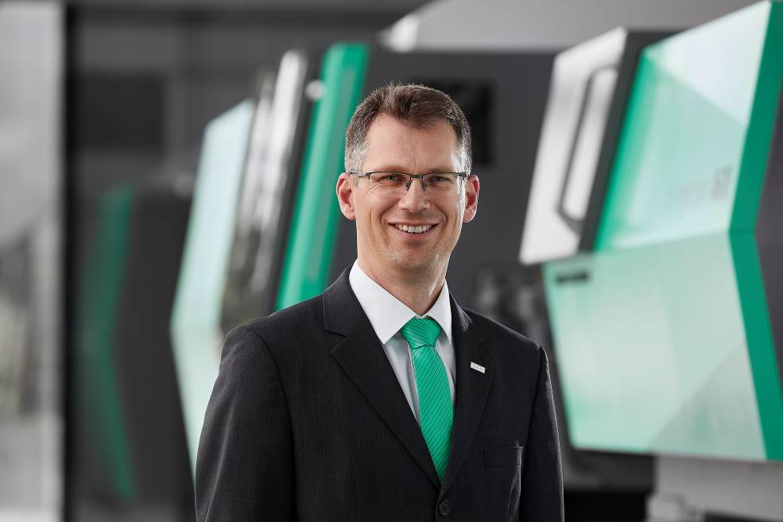

Steffen Eppler, Sales Director Europe at Arburg.

184914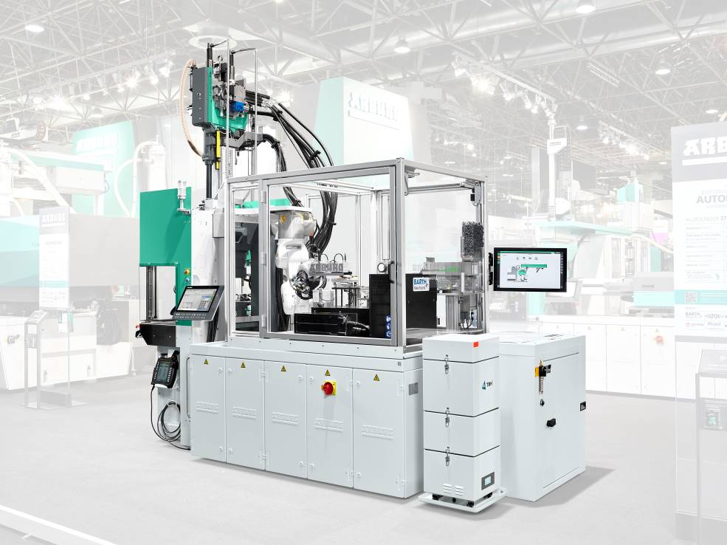

Compact: the turnkey system based around a vertical Allrounder 375 V with six-axis robot.

184281

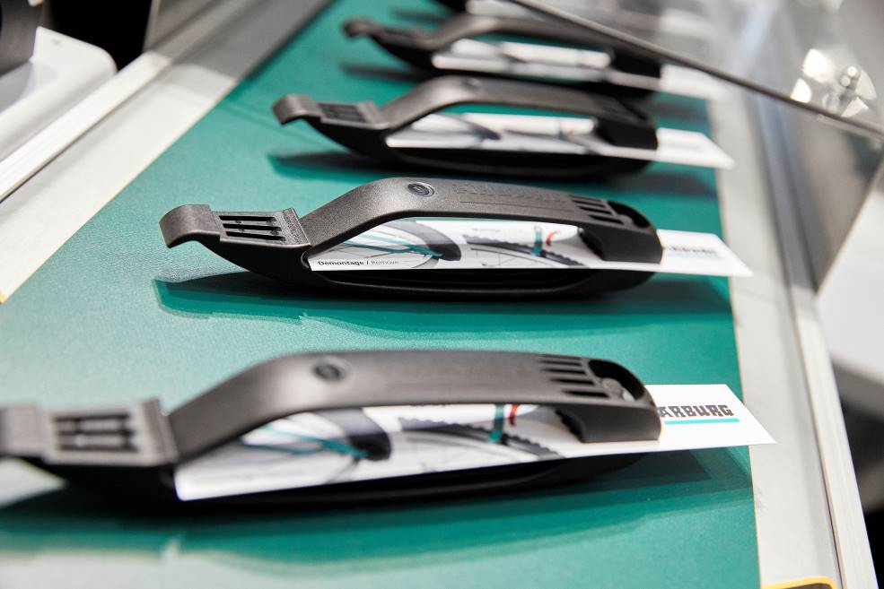

The practical tyre lever is created in a 1+1 family mould.

Photo: Arburg
Photo download:
https://media.arburg.com/portals/downloadcollection/29D5FC0B77E26FF4DFC78F66A92B3E46

Press release
File: Press preview Industry Fair 2023_en.docx
Characters: 4,067
Words: 633

This and other press releases are available for download from our website at www.arburg.com/de/presse/ (www.arburg.com/en/press/)

Contact
ARBURG GmbH + Co KG
Press office
Susanne Palm
Dr Bettina Keck
Postfach 1109
72286 Lossburg
Tel.: +49 (0)7446 33-3463
Tel.: +49 (0)7446 33-3259
presse_service@arburg.com

About Arburg
German family-owned company Arburg is one of the world's leading manufacturers of plastic processing machines. Its product portfolio encompasses Allrounder injection moulding machines with clamping forces of between 125 and 6,500 kN, the Freeformer for industrial additive manufacturing and robotic systems, customer and industry-specific turnkey solutions and further peripheral equipment.
Arburg is a pioneer in the plastics industry when it comes to production efficiency, digitalisation and sustainability. The “arburgXworld” program comprises all digital products and services and is also the name of the customer portal. The company’s strategies regarding the efficient use of resources and circular economy, as well as all related aspects and activities, are outlined in the “arburgGREENworld” program.
Arburg’s central aim is for customers to be able to produce their plastic products, from one-off parts to large-volume batches, in optimum quality at minimum unit costs. The target groups include, for example, the automotive and packaging industries, communication and entertainment electronics, medical technology and the white goods sector.
An international sales and service network ensures first-class customer support at a local level: Arburg has its own organisations at 34 locations in 25 different countries and, together with its trading partners, is represented in more than 100 countries. Its machines are produced at the company's German headquarters in Lossburg. Of a total of roughly 3,600 employees, around 3,000 work in Germany. About 600 further employees work in Arburg's organisations around the world. Arburg has triple certification, in accordance with ISO 9001 (quality), ISO 14001 (environment) and ISO 50001 (energy).
Further information about Arburg can be found at www.arburg.com

