Sustainability as a driver: Green, greener – Arburg

- Impressive figures from the “arburgGREENworld” program's Sustainability Report
- Arburg reduces its carbon footprint further
- Focus on people and the environment

Lossburg, 07/03/2022
Lots of companies are talking about it at great length, but Arburg is taking action! When it comes to environmental protection, there is hardly a term more frequently used than "sustainability". But how is it put into practice? Precisely that question is answered by the new Arburg Sustainability Report, backed up with a plethora of topical facts, figures and data. In an interactive PDF, a wide range of really interesting background information can be accessed online at any time. The 2021 version has been available on the Arburg website since the beginning of March 2022.

In its Sustainability Report, the traditional family company shares with the world its plans and practices for long-term sustainability in all relevant areas. Even the Sustainability Report itself is sustainable: The interactive document with fascinating facts, figures and data is ready to be browsed on the ARBURG website (www.arburg.com/en/arburggreenworld) – the company has taken a conscious decision not to produce a hard printed version.

Showing responsibility with arburgGREENworld
This Sustainability Report is a building block in the “arburgGREENworld” program, with which the company has defined sustainability through resource efficiency and the circular economy as an important goal. All backed by the tradition of conscious awareness of the need for sustainability. Back in 2012, Arburg became one of the very first companies ever to be awarded triple certification for quality, environment and energy. Not only that, but for decades the company has viewed the need for environmental protection, conservation of resources and efficiency as an obligation and as an incentive. This is expressed, for instance, in energy-efficient construction and sustainable manufacturing processes. Other contributing factors include central production at a location with a high proportion of in-house manufacturing and short supply chains, production-efficient machine technology, as well as the digital products and service of the “arburgXworld” program (www.arburg.com/en/arburgxworld/).

Impressive figures
One principle of the “arburgGREENworld” philosophy is that plastics are not rubbish, but recyclables! Giving value to resources, reducing emissions, putting finances to good use for Arburg and its employees and understanding digitalisation as sustainability – these are just a few of the central tenets that have been distinguishing the company for years. Tenets that it upholds consistently, as demonstrated clearly in this new 2021 Sustainability Report.
Would you care for another example? In the new assembly hall, with a floor area of 28,500 square metres, constructed to expand the capacities, Arburg is able to use the energy supplied to heat the building – just as it does by the way in the other assembly halls it has constructed over the last few years –, in a virtually cost- and carbon-neutral manner. In addition, the use of photovoltaics and geothermal energy contributes significantly to sustainable energy management.
Further impressive figures demonstrate how Arburg has implemented sustainability across the entire company:
- 90 percent of all waste generated in 2020 was recycled.
- 16 percent of the company's entire water consumption comes from rain water collected in a number of cisterns.
- 1.9 million kWh of solar energy were generated through photovoltaics and used in-house by Arburg in 2020. This corresponds to the energy needs of over 500 four-person households.
- 1.3 million kWh of wind energy were generated in 2020. This corresponds to the energy needs of over 340 four-person households.
- Over 90 million kilograms of carbon emissions were saved between 2010 and 2020.

Clearly structured
The "WIN-Charta" sustainability management system of the state of Baden-Württemberg is used as a basis when gathering data for the Sustainability Report. This "Charta" consists of twelve statements that address, among other topics, human and labour rights, employee well-being, resources, energy and emissions, product responsibility and anti-corruption. Another key factor is the added value that a company like Arburg can create for a region.

Photo

179719

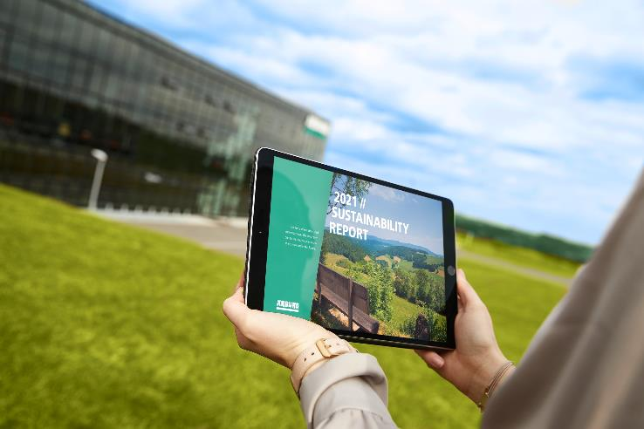

Sustainable: The Sustainability Report is only available online as an interactive PDF.

Photo: Arburg

Photo Download

https://media.arburg.com/portals/downloadcollection/126FE8C3E3D0B8FD7C508938135E3B1B

Press release
File: ARBURG Press release Sustainability Report 2021_en_GB.docx
Characters: 4,141
Words: 618

This and other press releases are available for download from our website at www.arburg.com/de/presse/ (www.arburg.com/en/press/)

Contact
ARBURG GmbH + Co KG
Press office
Susanne Palm
Dr Bettina Keck
Postfach 1109
72286 Lossburg
Tel.: +49 (0)7446 33-3463
Tel.: +49 (0)7446 33-3259
presse_service@arburg.com

About Arburg
German family-owned company Arburg is one of the world's leading manufacturers of plastic processing machines. Its product portfolio encompasses Allrounder injection moulding machines with clamping forces of between 125 and 6,500 kN, the Freeformer for industrial additive manufacturing and robotic systems, customer and industry-specific turnkey solutions and further peripheral equipment.
Arburg is a pioneer in the plastics industry when it comes to production efficiency, digitalisation, and sustainability. The “arburgXworld” program comprises all digital products and services and is also the name of the customer portal. The company’s strategies regarding the efficient use of resources and circular economy, as well as all related aspects and activities, are outlined in the “arburgGREENworld” program.
Arburg’s central aim is for customers to be able to produce their plastic products, from one-off parts to large-volume batches, in optimum quality at minimum unit costs. The target groups include, for example, the automotive and packaging industries, communication and entertainment electronics, medical technology and the white goods sector.
An international sales and service network ensures first-class customer support at a local level: Arburg has its own organisations at 35 locations in 26 different countries and, together with its trading partners, is represented in more than 100 countries. Its machines are produced exclusively at the company's German headquarters in Lossburg. Of a total of roughly 3,400 employees, around 2,850 work in Germany. About 550 further employees work in Arburg's organisations around the world. Arburg has triple certification, in accordance with ISO 9001 (quality), ISO 14001 (environment) and ISO 50001 (energy).
Further information about Arburg can be found at www.arburg.com

