Arburg at the Moldplas: Efficient, sustainable and digital

- Future-proof: Automated electric Allrounder 470 A
- Fit for the future: Processing a biodegradable wood material
- Future-oriented: Portuguese plastics industry on road to recovery

Lossburg, 19/09/2022
To produce sustainably, you must be positioned for the future. This can only succeed with more innovative energy- and production-efficient injection moulding technology and suitable automation. Also included is the ability to process biodegradable plastics. Arburg will present all of the above with an automated turnkey system in Hall 3, stand 3B12 of the Moldplas 2022. From 9 to 12 November, the industry will meet in Batalha, Portugal, around 120 kilometres north of Lisbon, to view the latest trends in plastic processing live.

"Our electric machines get a great reception in Portugal, because with this series, energy efficiency and precision complement one another in the best way possible. This means that quality products can be produced in way that saves resources," says Martin Cayre, who, as Managing Director of Arburg Spain, is also responsible for the Portuguese market. "The topics of energy efficiency, the circular economy and recycling are growing in importance, especially in the automotive and packaging industries." At the Moldplas, Arburg will therefore present a compact turnkey system, with an electric Allrounder 470 A that will manufacture a curved ruler from the biodegradable wood material, Biofibre Silva SI2900.

Compact turnkey system: Efficiently achieving the finished product
The exhibit has a clamping force of over 1,000 kN, a size 290 injection unit, and the Gestica control system with five assistance packages. These help with changeovers, parameter input, programming of non-standard sequences, quick production start-up, and system control, and offer time-saving online support. A Multilift Select robotic system with six kilogramme load capacity and adapted suction plate ensures parts are handled carefully. The compact protection of the Multilift Select provides for a very small installation area for the entire production cell, among other things. Material drying and conveying are done by a Thermolift-2. The rulers are given a centimetre scale downstream by a laser cell from a local manufacturer, and leave the system ready for use.

arburgXworld customer portal: Saving time and money
Our trade fair appearance also includes live demonstrations of the arburgXworld customer portal on a PC. This will showcase the Arburg app's wide range of capabilities. arburgXworld brings together all our digital services and provides round the clock access to this information from every end device. Even the free "Basic" package offers a great variety of services. For example, the applications "MachineCenter", "ServiceCenter" and "Shop" offer a better overview, simplified communication, increased flexibility and faster reaction times. This saves time and costs.

Our own organisation: Comprehensive service for customers in Portugal
"Arburg is represented by its own powerful organisation in Portugal. This allows our highly-qualified team to provide customers with first-class service quickly and directly on site. Professional support is also offered in application and process technology, as well as automation," Martin Cayre says, describing the advantages of the location in Marinha Grande. The company is strongly-positioned across the entire Iberian peninsula, especially in the areas of electric machines, multi-component technology, and special applications, such as the processing of LSR, thermoset, and the "fibre direct compounding" lightweight construction process. Regarding the current situation on the Portuguese market, he comments: "After two very difficult years due to the pandemic, we are gradually beginning to see a recovery. Mould makers in the region are working at almost 100 per cent capacity, and an improvement can also be felt in injection moulding. Even so, as with the rest of Europe, high energy and material costs are also posing a huge problem for the entire economy." The Arburg trade fair programme is precisely tailored to the current needs and requirements of the Portuguese market, so it is sure to be received with great interest.

Photos

165517

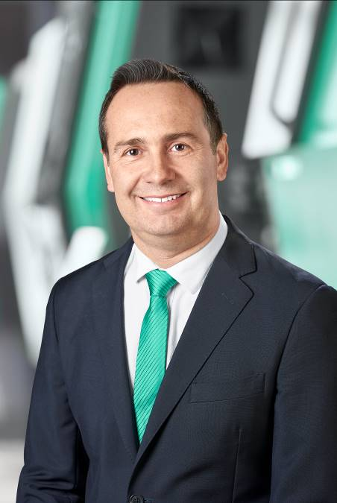

Martin Cayre, Managing Director of Arburg Spain, is also responsible for the Portuguese market.

177409 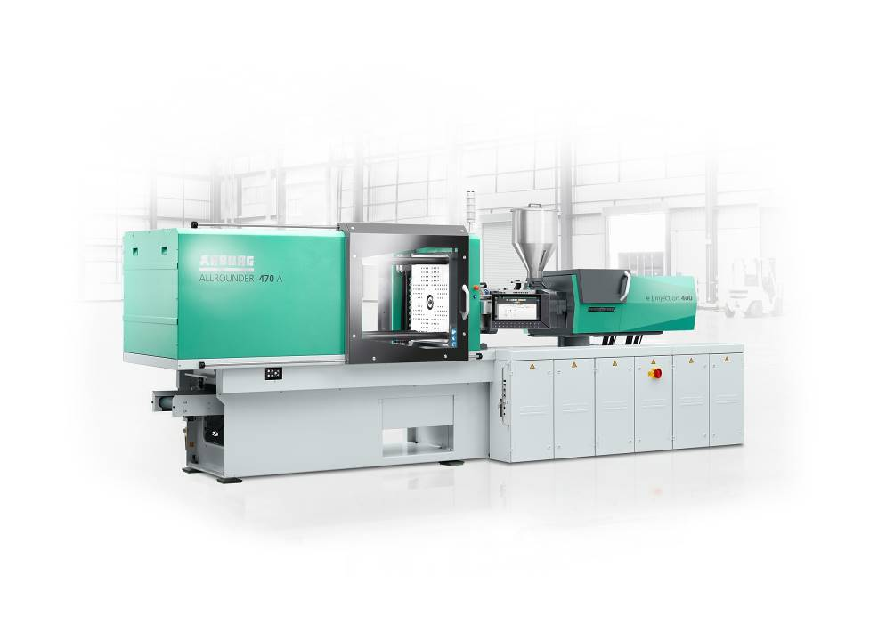At the Moldplas, an electric Allrounder 470 A, is integrated into a turnkey system and produces curved rulers from a biodegradable wood material.

182956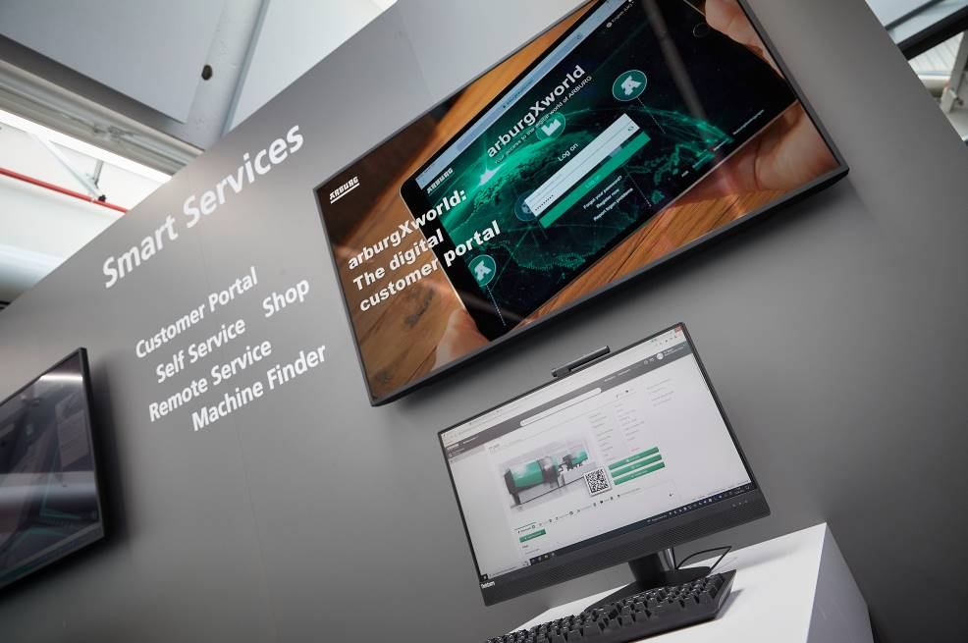At the Moldplas, the arburgXworld customer portal is presented live on a PC.

Photos: Arburg
Photo download:
https://media.arburg.com/portals/downloadcollection/A50A4D79EC28861076C063C3BC86A6E7

Press release
File: ARBURG Press preview Moldplas 2022_en_GB.docx
Characters: 4.009
Words: 603

This and other press releases are available for download from our website at www.arburg.com/de/presse/ (www.arburg.com/en/press/)

Contact
ARBURG GmbH + Co KG
Press office
Susanne Palm
Dr Bettina Keck
Postfach 1109
72286 Lossburg
Tel.: +49 (0)7446 33-3463
Tel.: +49 (0)7446 33-3259
presse_service@arburg.com

About Arburg
German family-owned company Arburg is one of the world's leading manufacturers of plastic processing machines. Its product portfolio encompasses Allrounder injection moulding machines with clamping forces of between 125 and 6,500 kN, the Freeformer for industrial additive manufacturing and robotic systems, customer and industry-specific turnkey solutions and further peripheral equipment.
Arburg is a pioneer in the plastics industry when it comes to production efficiency, digitalisation and sustainability. The “arburgXworld” program comprises all digital products and services and is also the name of the customer portal. The company’s strategies regarding the efficient use of resources and circular economy, as well as all related aspects and activities, are outlined in the “arburgGREENworld” program.
Arburg’s central aim is for customers to be able to produce their plastic products, from one-off parts to large-volume batches, in optimum quality at minimum unit costs. The target groups include, for example, the automotive and packaging industries, communication and entertainment electronics, medical technology and the white goods sector.
An international sales and service network ensures first-class customer support at a local level: Arburg has its own organisations at 34 locations in 25 different countries and, together with its trading partners, is represented in more than 100 countries. Its machines are produced exclusively at the company's German headquarters in Lossburg. Of a total of roughly 3,500 employees, around 2,900 work in Germany. About 600 further employees work in Arburg's organisations around the world. Arburg has triple certification, in accordance with ISO 9001 (quality), ISO 14001 (environment) and ISO 50001 (energy).
Further information about Arburg can be found at www.arburg.com

