Complete success: Arburg at Formnext 2022!

- Successful: Machines, variety of applications and expertise delight trade visitors
- New products: Freeformer 750-3X and TiQ2 make their debut before the AM world
- Comprehensive: ARBURGadditive and innovatiQ product portfolio

Lossburg, 23/11/2022
As an exhibitor from the very beginning, Arburg once again featured prominently at this year's Formnext. The Freeformer 750-3X and the innovatiQ printer TiQ2 literally took centre stage at the company's stand where, placed on a rotating platform, they wowed trade visitors. Interest in the processing of high-temperature materials and soft materials was also very high, with the result that the experts from ARBURGadditive and innovatiQ were fully booked for every day of the trade fair.

"Our presence at the trade fair was an impressive demonstration of the strength of ARBURGadditive and the potential of our machines," said Dr Victor Roman, Managing Director of ARBURGadditive. "With our new Freeformer 750-3X, we can offer customers a whole new range of possibilities in terms of part size and cost-effectiveness. Our stand was very busy every day and we were also able to forge a lot of new links with companies on the lookout for new solutions in the field of additive manufacturing," added a delighted Dr Victor Roman. Arburg's many examples of components, including a wide variety of success stories from customers such as Tesa and Wilson, were a great source of ideas and inspiration here.

Freeformer 750-3X opens up new fields of application
In industrial additive manufacturing, the trend is clearly moving in the direction of high cost-effectiveness in day-to-day production, both in the manufacture of larger individual parts and in the production of multiple items in a single work cycle.
The Freeformer 750-3X, which is systematically designed to meet the requirements of the AM industry, meets precisely these challenges. Compared to the previous Freeformer 300-3X, its part carrier is around 2.5 times larger – with the same external dimensions – and the process is faster and more economical. In addition, the Gestica control system has been optimised for additive manufacturing in terms of process stability, part quality and build time.

Freeformer – the specialist in soft materials
When it comes to processing soft materials, Arburg used a large number of parts to demonstrate that a very wide range of shore hardnesses can be achieved with the Arburg Plastic Freeforming (APF). Specifically for this sector, there is currently a limited sales promotion with the Freeformer 200-3X "soft". This machine has special equipment for processing soft materials and is also very attractively priced.

APF parts made of high-temperature materials
Another focus was the processing of high-temperature materials. A suitably equipped Freeformer 300-3X was exhibited for this purpose, as well as part of an aircraft cabin with various APF parts made of Ultem 9085, which is approved for aerospace applications. These post.processed lighting and ventilation components and the cup holder made it clear that the Freeformer can be used both to produce spare parts and to implement customised design requirements.

Photos

185296
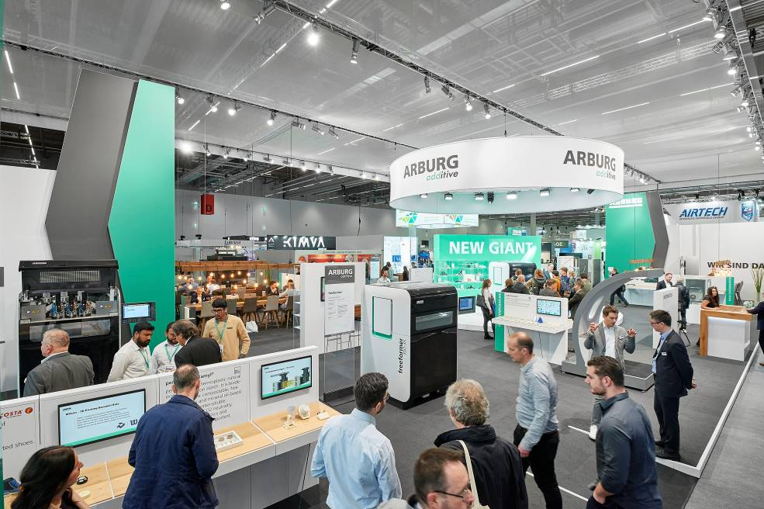

Successful mix: Machines and components showed the potential of the APF process.

85201
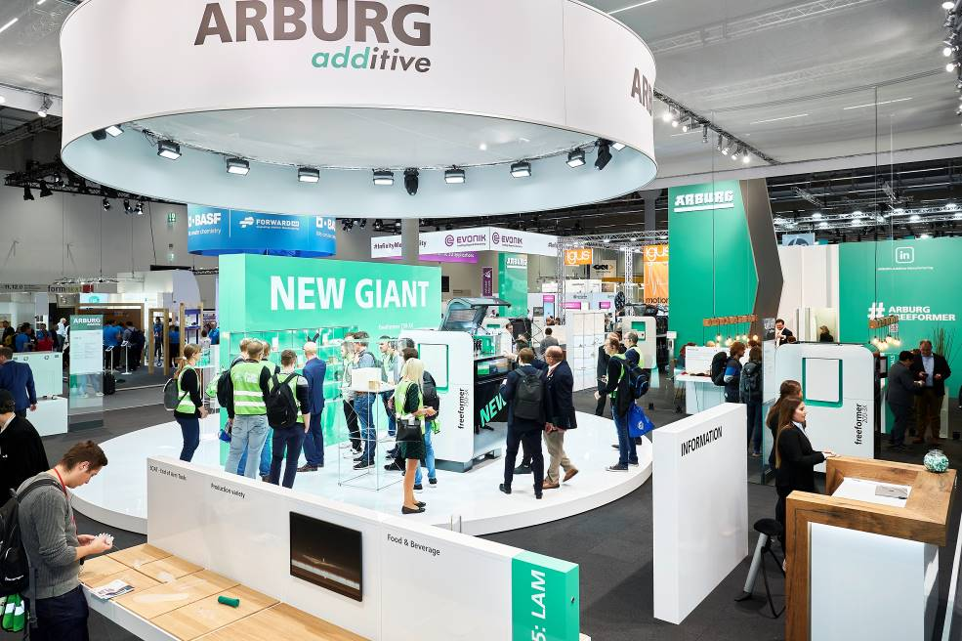

Taking centre stage at Formnext: the new Freeformer 750-3X.

185319

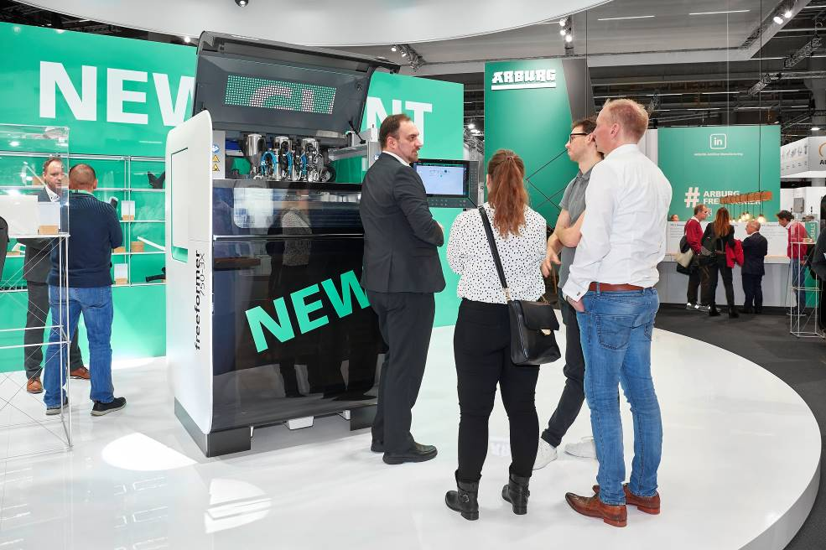

Visitors were able to take a close look at the new Freeformer 750-3X.

185239
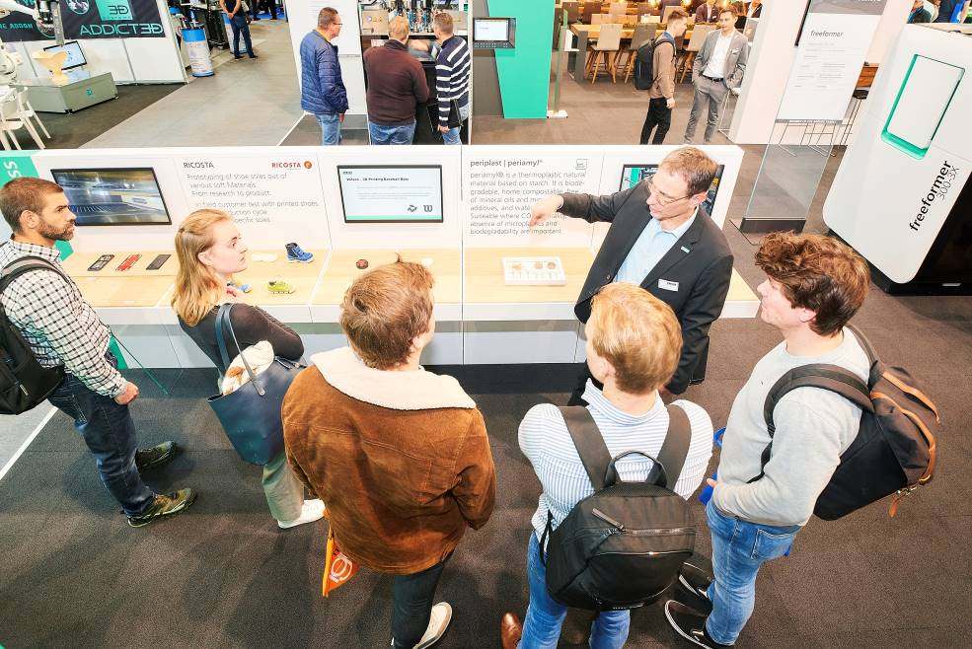
Success stories: Experts from ARBURGadditive used parts to illustrate how the Freeformer is used in practice.

185338
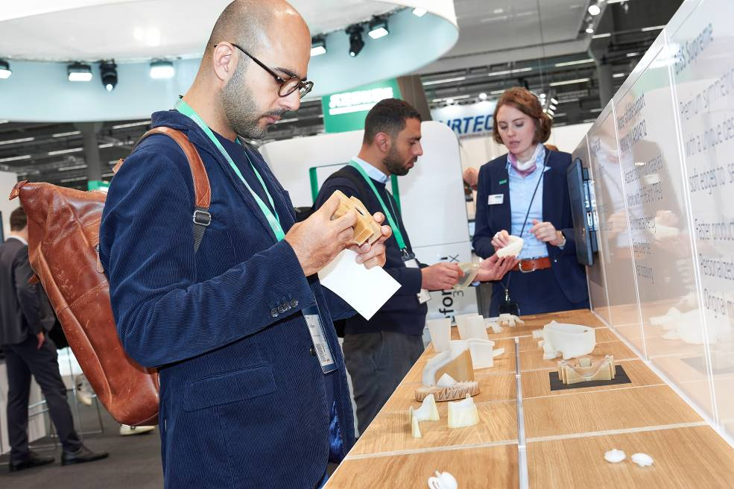

Hands-on: Trade visitors were impressed by the quality of the APF parts.
185196
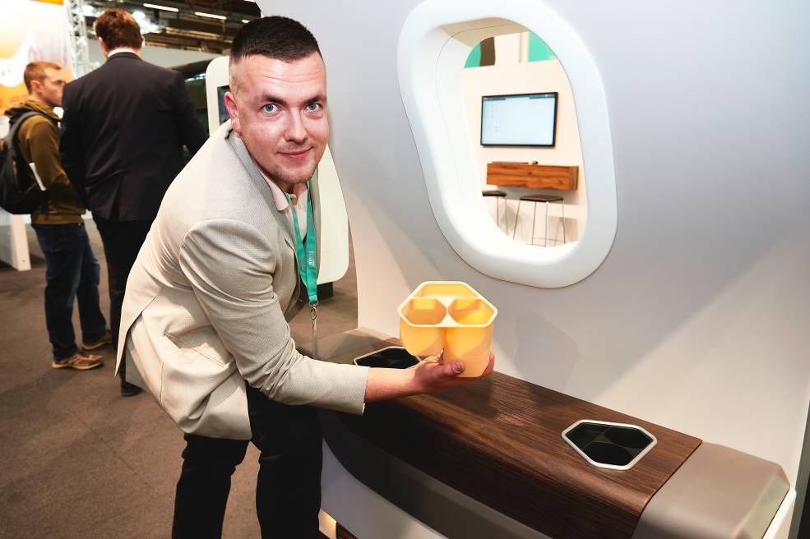

Before and after: The Ultem cup holder can be post-processed and used directly in the aircraft.

Photos: Arburg

Photo download:
https://media.arburg.com/portals/downloadcollection/16E389B76394E70B81F3591AC8C710D6

Press release
File: ARBURG Press review formnext 2022_en_GB.docx
Characters: 4,048
Words: 526

This and other press releases are available for download from our website at www.arburg.com/de/presse/ (www.arburg.com/en/press/)

Contact
ARBURG GmbH + Co KG
Press office
Susanne Palm
Dr Bettina Keck
Postfach 1109
72286 Lossburg
Tel.: +49 (0)7446 33-3463
Tel.: +49 (0)7446 33-3259
presse_service@arburg.com

About Arburg
German family-owned company Arburg is one of the world's leading manufacturers of plastic processing machines. Its product portfolio encompasses Allrounder injection moulding machines with clamping forces of between 125 and 6,500 kN, the Freeformer for industrial additive manufacturing and robotic systems, customer and industry-specific turnkey solutions and further peripheral equipment.
Arburg is a pioneer in the plastics industry when it comes to production efficiency, digitalisation and sustainability. The “arburgXworld” program comprises all digital products and services and is also the name of the customer portal. The company’s strategies regarding the efficient use of resources and circular economy, as well as all related aspects and activities, are outlined in the “arburgGREENworld” program.
Arburg’s central aim is for customers to be able to produce their plastic products, from one-off parts to large-volume batches, in optimum quality at minimum unit costs. The target groups include, for example, the automotive and packaging industries, communication and entertainment electronics, medical technology and the white goods sector.
An international sales and service network ensures first-class customer support at a local level: Arburg has its own organisations at 34 locations in 25 different countries and, together with its trading partners, is represented in more than 100 countries. Its machines are produced exclusively at the company's German headquarters in Lossburg. Of a total of roughly 3,600 employees, around 3,000 work in Germany. About 600 further employees work in Arburg's organisations around the world. Arburg has triple certification, in accordance with ISO 9001 (quality), ISO 14001 (environment) and ISO 50001 (energy).
Further information about Arburg can be found at www.arburg.com

