Arburg at Swiss Plastics Expo: sustainable and digital

- Front and centre: Swiss Plastics Expo in Lucerne is one of the first trade fairs of 2023
- Sustainable: cups made from recyclable materials
- Digital: Gestica “FillAssist” feature and “arburgXworld” customer portal

Lossburg, 28/11/2022
Once again in 2023, the trade fair year will start for Arburg with the Swiss Plastics Expo in Lucerne, Switzerland. From 17 to 19 January 2023, Arburg will be at stand C1061, hall 1, in both physical and digital. An electric Allrounder 370 A with Gestica control system will be producing cups from recycled PP. Visitors will also be introduced to the new expansion stage of the “aXw Control FillAssist” feature, which will be showcased on the Allrounder, and the “arburgXworld” customer portal for the digitalisation of services and business processes will also be demonstrated at the trade fair.

Marcel Spadini, Managing Director of the Arburg Switzerland subsidiary in Münsingen, says about Arburg’s appearance at the trade fair: "The Swiss Plastics Expo is a very important platform for us. It’s small but perfectly formed, as they say. Intelligent injection moulding, recyclate processing and the potential offered by digitalisation will all be on show for our customers. As Switzerland is viewed as a very advanced nation – in that it has a very strong focus on technology and is also very innovative – we have chosen exhibits that will strike exactly the right note with both customers and other interested visitors."

An Allrounder with digital features will be processing recycled materials
A turnkey system featuring an IT networked, electric Allrounder 370 A with a clamping force of 600 kN will be demonstrating how high-quality cups can be produced from recycled PP. The machine features the standard Arburg IIoT gateway and the Gestica control system – including the new expansion stage of the "aXw Control FillAssist". This feature supports AI-assisted variant analysis for time-saving mould filling studies and has been developed in partnership with Simcon. The exhibit will be producing the well-known “crinkle cup” with its distinctive look on a single-cavity hot runner mould made by Haidlmair. A Multilift V 20 Cartesian robot removes the cups and unloads them from the system – a robot not exhibited before in Switzerland.

“arburgXworld” portal connecting customers to Arburg
The stand will also feature a demo terminal to showcase the extensive features of the “arburgXworld” customer portal, which enables users to manage many of their services and business processes on a digital platform with Arburg. Customers have almost unlimited possibilities to access up-to-date information on the machine fleet, and to start and monitor machines, for example. Equally, 24/7 service requests can be made or online spare parts ordered – on all digital devices.

An exciting start to the year
In focussing on sustainability and digitalisation in Lucerne, Arburg is addressing two key topics that are of the utmost importance for the future development of the entire plastics processing sector. Arburg is at the forefront of developments in the industry on both counts. Marcel Spadini says: "The market trend towards automation and digitalisation will definitely continue, because operating costs in Switzerland are still very high, even compared with the EU. And let’s not forget the enormous potential the combination of digitalisation and automation offers for the circular economy. Visitors to the Arburg stand will leave the Swiss Plastics Expo with this message ringing in their ears."

Photos

137879

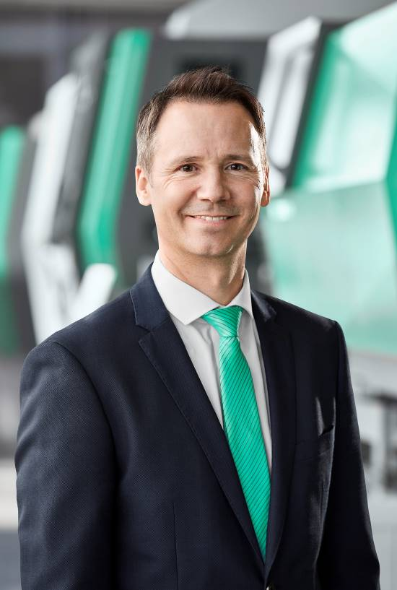

Marcel Spadini, Managing Director of the Arburg subsidiary in Switzerland

176310

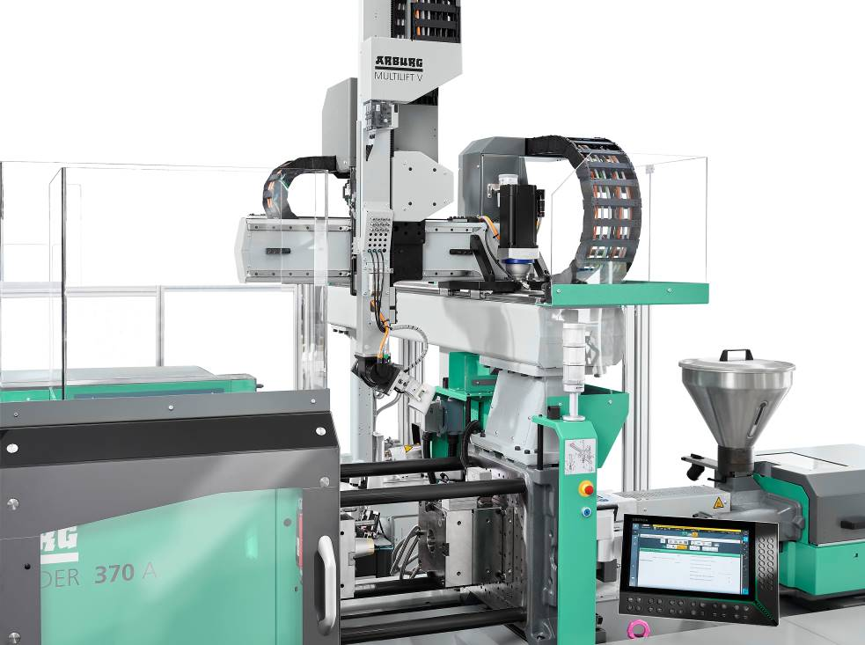

On show in Switzerland for the very first time: the Multilift V 20 Cartesian robot unloading “crinkle cups” from the Allrounder 370 A.

Photos: Arburg
Photo download:
https://media.arburg.com/portals/downloadcollection/D3E38A5707FFCFC10A7C07E9AC1B6AD3

Press release
File: Pressevorbericht Swiss Plastis Expo 2023_de.docx
Characters: 3.293
Words: 515

This and other press releases are available for download from our website at www.arburg.com/de/presse/ (www.arburg.com/en/press/)

Contact
ARBURG GmbH + Co KG
Press office
Susanne Palm
Dr Bettina Keck
Postfach 1109
72286 Lossburg
Tel.: +49 (0)7446 33-3463
Tel.: +49 (0)7446 33-3259
presse_service@arburg.com

About Arburg
German family-owned company Arburg is one of the world's leading manufacturers of plastic processing machines. Its product portfolio encompasses Allrounder injection moulding machines with clamping forces of between 125 and 6,500 kN, the Freeformer for industrial additive manufacturing and robotic systems, customer and industry-specific turnkey solutions and further peripheral equipment.
Arburg is a pioneer in the plastics industry when it comes to production efficiency, digitalisation and sustainability. The “arburgXworld” program comprises all digital products and services and is also the name of the customer portal. The company’s strategies regarding the efficient use of resources and circular economy, as well as all related aspects and activities, are outlined in the “arburgGREENworld” program.
Arburg’s central aim is for customers to be able to produce their plastic products, from one-off parts to large-volume batches, in optimum quality at minimum unit costs. The target groups include, for example, the automotive and packaging industries, communication and entertainment electronics, medical technology and the white goods sector.
An international sales and service network ensures first-class customer support at a local level: Arburg has its own organisations at 34 locations in 25 different countries and, together with its trading partners, is represented in more than 100 countries. Its machines are produced at the company's German headquarters in Lossburg. Of a total of roughly 3,600 employees, around 3,000 work in Germany. About 600 further employees work in Arburg's organisations around the world. Arburg has triple certification, in accordance with ISO 9001 (quality), ISO 14001 (environment) and ISO 50001 (energy).
Further information about Arburg can be found at www.arburg.com

