Arburg at Chinaplas 2024
Additive manufacturing: Industrial 3D printing with the Freeformer

- Multi-material: Freeformer exhibit produces gripper in hard/soft combination
- In demand: Additive components made from high-temperature plastics and in multi-material combinations
- Versatile: Processing a wide range of original plastic granulates

Lossburg, 16/04/2024
Arburg's enormous expertise in plastics processing also includes solutions for industrial 3D printing from sister company ARBURGadditive. The additive manufacturing of grippers and operating equipment, for example, is an interesting option for injection moulding plants. On the Arburg stand D 42 in Hall 4.1, a Freeformer 300-3X will be producing a gripper in a multi-material combination at Chinaplas 2024.

Arburg Plastic Freeforming (APF) can also reliably and reproducibly process a wide range of original and certified plastic granules, including granules for high-temperature applications. This makes the process particularly suitable for components used in areas such as medical technology and aerospace.

Additive manufacturing of end-of-arm tooling (EOAT)
At Chinaplas 2024, a Freeformer 300-3X will demonstrate how additive end-of-arm tooling (EOAT) for various robotic systems and handling tasks can be 3D printed on demand quickly, cost-effectively and customised for specific applications. One example is a multi-material gripper, which is created in a single step with the aid of support material and without the need for any additional assembly work. The result is a resilient functional component in hard/soft combination. The hard housing is made of PC/ABS, while the soft TPE nozzle closure expands positively using compressed air to reliably remove a moulded part from the mould.

Wide range of components
The Freeformer can be used to realise sophisticated designs and complex geometries. Many examples of components will be on display at Chinaplas 2024, including products for the aerospace industry made from Ultem 9085. The Freeformer, which is suitable for clean rooms, can also be used in medical technology, for example to produce resorbable implants, breast prostheses and medical devices and aids. Customised multi-material applications such as shoe insoles made of flexible TPE and a hard zone made of PP are also very interesting. The APF process is also ideal for sophisticated AM parts made from semi-crystalline PP.

Photos

183833

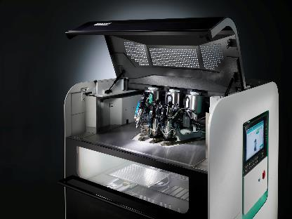

The Freeformer 750-3X has three discharge units and additively manufactures resilient functional parts, including in hard/soft combination and from original plastic granules.

174806
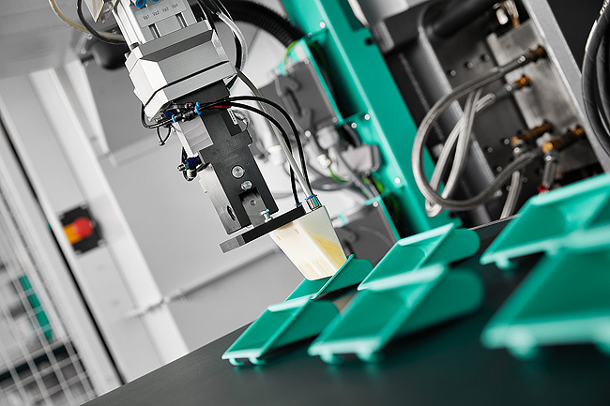
Operating equipment and EOAT in hard/soft combination: the Freeformer can additively manufacture items such as individual multi-material grippers for robotic systems.

Photo download:
https://media.arburg.com/web/b40b7f831e37eadc/freeformer-chinaplas-2024/

Press release
File: Pressemitteilung additive Fertigung Chinaplas 2024_en_GB.docx
Characters: 2,039
Words: 205

This and other press releases are available for download from our website at www.arburg.com/de/presse/ (www.arburg.com/en/press/)

Contact
ARBURG GmbH + Co KG
Press office
Susanne Palm
Dr Bettina Keck
Postfach 1109
72286 Lossburg
Tel.: +49 (0)7446 33-3463
Tel.: +49 (0)7446 33-3259
presse_service@arburg.com

About Arburg
Founded in 1923, the German family-owned company is one of the world's leading manufacturers of plastic processing machines. The ARBURG family also comprises AMKmotion and ARBURGadditive, including innovatiQ.
Its portfolio includes injection moulding machines, 3D printers for industrial additive manufacturing, robotic systems and customer- and industry-specific turnkey solutions. It also includes digital products and services.
ARBURG is a pioneer in the plastics industry when it comes to energy and production efficiency, digitalisation and sustainability. ARBURG machines are used to manufacture plastic products for industries such as mobility, packaging, electronics, medicine, construction and equipment engineering, and leisure.
The company headquarters are located in Lossburg, Germany. In addition, ARBURG has its own organisations at 36 locations in 26 countries and, together with trading partners, is represented in over 100 countries. Of a total of around 3,700 employees, some 3,100 work in Germany while around 600 are based in ARBURG organisations around the world.
ARBURG is certified in accordance with ISO 9001 (quality), ISO 14001 (environment), ISO 27001 (information security), ISO 29993 (training) and ISO 50001 (energy).
Further information can be found at: www.arburg.com, www.amk-motion.com and www.arburg.com/arburgadditive.

