First "Diplomado" course in Mexico completed

Class of 2023 receives diplomas

- Theoretical and practical sections of first training course for qualified Mexican plastics personnel successfully completed
- A collaboration between the prestigious TEC de Monterrey University and Arburg
- 16 participants receive their Diploma degree

Lossburg, 11/01/2024
On 17 November, the final project presentation and graduation ceremony took place for the first 16 participants in the "Diplomado" training course for plastic injection Technologies in Mexico. Arburg offers this four-month further academic training course in conjunction with the renowned Instituto Tecnológico de Estudios Superiores Monterrey (TEC de Monterrey) as basic and advanced training for qualified Mexican personnel. Interested parties from the local plastics industry learn content that is practice-orientated and concise.

The participants from the first training year worked on four different projects, which also picked up on knowledge they had already acquired in areas like production efficiency, sustainability, bioplastics, improvement management, modernisation of plastics processing and digitalisation.
Managers from Arburg's Mexico branch and the GiTamsa Technical Innovation Centre in Querétaro came to give the learners feedback on their presentations along with recommendations and best practices they can implement directly in their respective companies.

“Diplomado” for plastics recognized by the Ministry of Public Education SEP
The goal is to establish the "Diplomado" training programme as a unique studying course focused on attaining theoretical and practical knowledge. As well as expertise in plastic injection moulding technology and processes, it is about training managers with a global business vision that enables them to assess and improve the profitability of proposed modernisation and digitalisation processes for their production. This content in particular is of crucial importance for the Mexican plastics industry, acting as it does as a "workbench for North America".

Closing event at TEC de Monterrey
After the project presentations, the final event took place in the conference room. In their opening speeches to the successful students Carlos Ibarra, Director of Continuing Education at the TEC de Monterrey, as well as Managing Director Mario Rodríguez and Commercial Director Edgar Calderon of Arburg Mexico all paid tribute to the first generation of specialists who together constitute a change for the Mexican plastics industry. At the same time, they were encouraged to continue their professional development with the same determination. All the speakers also congratulated this first generation of "Diplomado" graduates for their enthusiasm, perseverance and outstanding performances. The TEC de Monterrey and Arburg also thanked the local companies that had been open to supporting this course, which will be the first of hopefully many.
Thereafter each of the successful graduates was awarded their professional certificate. The event concluded with a celebratory toast to the new plastics specialists.

Photo

197366
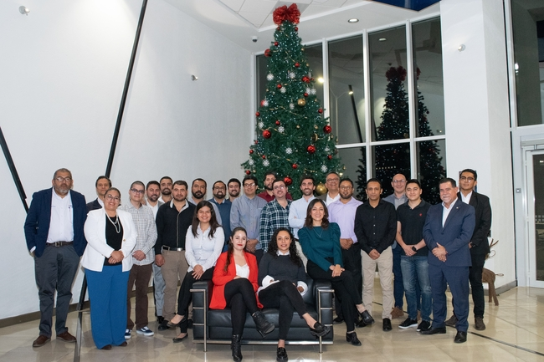

Feliz Navidad: A Merry Christmas for the 16 plastics specialists in Mexico, who celebrated their successful graduation together with trainers from Arburg and TEC de Monterrey.

Photo: ARBURG
Photo download:
https://media.arburg.com/portals/downloadcollection/D5C78AE801EA2F155BBB480AE1F06396

Press release
File: ARBURG Press release Diplomado graduation Mexico_en_GB.docx
Characters: 2,843
Words: 406

This and other press releases are available for download from our website at www.arburg.com/de/presse/ (www.arburg.com/en/press/)

Contact
ARBURG GmbH + Co KG
Press office
Susanne Palm
Dr Bettina Keck
Postfach 1109
72286 Lossburg
Tel.: +49 (0)7446 33-3463
Tel.: +49 (0)7446 33-3259
presse_service@arburg.com

About Arburg
German family-owned company Arburg is one of the world's leading manufacturers of plastic processing machines. Its product portfolio encompasses Allrounder injection moulding machines with clamping forces of between 125 and 6,500 kN, the freeformer for industrial additive manufacturing and robotic systems, customer and industry-specific turnkey solutions and further peripheral equipment.
Arburg is a pioneer in the plastics industry when it comes to energy and production efficiency, digitalisation and sustainability. The "arburgXworld" program comprises all digital products and services and is also the name of the customer portal. The company’s strategies regarding the efficient use of resources and circular economy, as well as all related aspects and activities, are outlined in the 'arburgGREENworld' program.
Arburg's main aim is to enable its customers to manufacture their plastic products, from one-off parts to large-volume batches, to optimum quality standards and in a way that conserves resources, is sustainable and minimises unit costs. Target groups include the automotive and packaging industries, communication and entertainment electronics, medical technology and the white goods sector.
First-class customer support on-site is guaranteed by the international sales and service network: Arburg has own organisations in 26 countries at 36 locations and is represented in over 100 countries together with trade partners. Its machines are produced at the company's German headquarters in Lossburg. Of a total of roughly 3,800 employees, around 3,200 work in Germany, with another 600 employees based in Arburg's organisations around the world. Arburg is certified to ISO 9001 (quality), ISO 14001 (environment), ISO 27001 (information security), ISO 29993 (training) and ISO 50001 (energy).
Further information about Arburg can be found at www.arburg.com

