Arburg exhibit at NPE 2024
Allrounder Cube 1800: Compact cube-mold machine reduces cycle times

- Compact injection molding machine: Efficient cube-mold technology even for smaller quantities
- Efficient production: Four mold sides can be used simultaneously
- Fully automated: Four 2-component medical caps in around nine seconds

Lossburg, 18/04/2024
Innovative cube-mold technology significantly reduces cycle time. This increases productivity and quickly pays for itself despite the higher outlay on the mold. At NPE 2024, an Allrounder Cube 1800 with a clamping force of 200 tons (1,800 kN) will produce two-color medical caps and demonstrate that a machine with a "compact cube" can significantly reduce unit costs even with smaller output quantities.

The compact Allrounder Cube 1800 is particularly suitable for the cost-effective production of technical and medical products as well as for personal care products.

Allrounder Cube 1800 – compact and efficient
The Allrounder Cube 1800 has a clamping force of 200 tons (1800 kN) and a distance between tie-bars of 22.44 x 22.44 inch (570 x 570 mm). It can be equipped with horizontal injection units in sizes 8.2 to 29.8 oz (EUROMAP 400 to 1300) and moving injection units in sizes 1.4 to 15.3 oz (EUROMAP 70 to 800). At its heart is a compact cube from partner company Foboha, which is easily accessible from above. The rotation of the cube is powered servo-electrically and the horizontal movement relies on rack and pinion mechanisms.
An Allrounder Cube 1800 equipped with an 8+8-cavity mold can achieve more than twice the output of a conventional size 570 Allrounder with a 4+4-cavity rotary mold working with the same mold mounting surface. The cube machine can replace two standard injection molding machines – which drastically reduces the installation area.

Compact cube – example of 2-component medical caps
The exhibit at NPE 2024, an Allrounder Cube 1800 with two injection units in sizes 8.2 and 3.7 oz, uses a 4+4-cavity mold from Foboha to produce four two-color PP medical caps in a cycle time of around nine seconds. Four frames are injection molded at station 1. Having been rotated 90 degrees onto the passive side of the cube, the pre-molded parts are cooled at station 2. After another rotation, the second component is injected at station 3. Finally, the finished parts are removed automatically at station 4. That sequence results in a fast cycle time for such a part of around 9 seconds.
A six-axis robot places the finished parts on a conveyor belt and ejects any faulty parts detected by the control system. In addition, test samples can be removed at the touch of a button and set down in QA trays sorted by cube side for subsequent visual inspection of the injection molded parts.

Allrounder Cube for short cycles and high productivity
The Allrounder Cube hybrid series combines speed and precision with reliability and energy efficiency. The cube-mold machines from Arburg are available with clamping forces of 200, 325 and 515 tons (1,800, 2,900 and 4,600 kN). Injection molding in two mold parting lines arranged one behind the other takes place simultaneously with cooling and removal. Just using the passive sides of the cube can reduce the cooling time by 30 per cent. Other processes that do not influence cycle time (including loading inserts, unscrewing, the assembly of individual components, integrated checks and automated parts removal, for example) enable cost-effectiveness to be increased further beyond that of conventional free-fall packaging applications.

Tailor-made complete solutions
Combined with a "smart" machine controller, the modularity of the Allrounder Cube series delivers high levels of flexibility and a perfect match to the mold technology. The robotic systems that are increasingly being used can also be integrated into the controller. At Arburg, an interdisciplinary cube team consisting of colleagues from application technology, sales and automation to achieve very specific targets in the delivery of all aspects of "the cube". This means that customers who are interested in cube-mold technology can get custom-made complete solutions from a single source.

(Video on the application: https://www.youtube.com/watch?v=HKOsIxOsKVg)

Photos

179296
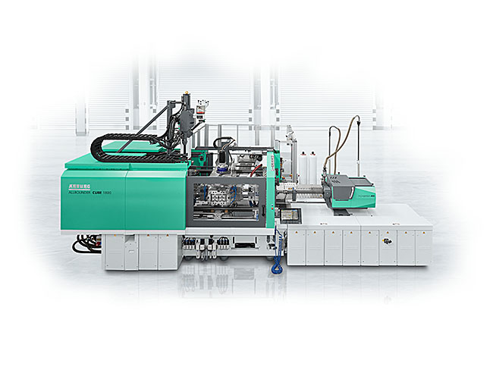
At NPE 2024, an Allrounder Cube 1800 with a compact cube mold will produce two-component medical caps. Cooling and removal with a six-axis robot are carried out with no impact on the cycle time.

2C-closures NPE 2024_0431
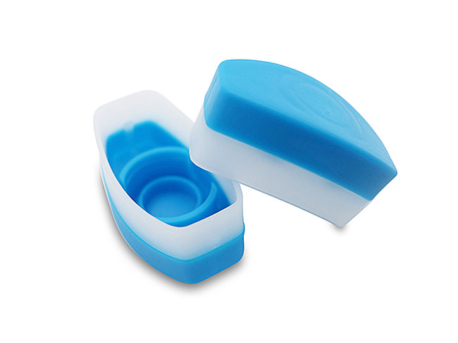
Using a 4+4-cavity mold from partner Foboha, an Allrounder Cube 1800 produces four two-color PP medical caps in a cycle time of around nine seconds.

Photos: ARBURG

Photo download:
https://media.arburg.com/web/95513158f1e2147b/allrounder-cube1800-npe-2024/

Press release
File: ARBURG Press release Allrounder Cube1800 NPE 2024_en_US.docx
Characters: 3,818
Words: 610

This and other press releases are available for download from our website at www.arburg.com/de/presse/ (www.arburg.com/en/press/)

Contact
ARBURG GmbH + Co KG
Press office
Susanne Palm
Dr Bettina Keck
Postfach 1109
72286 Lossburg
Tel.: +49 (0)7446 33-3463
Tel.: +49 (0)7446 33-3259
presse_service@arburg.com

About Arburg
Founded in 1923, the German family-owned company is one of the world's leading manufacturers of plastic processing machines. The ARBURG family also comprises AMKmotion and ARBURGadditive, including innovatiQ.
Its portfolio includes injection molding machines, 3D printers for industrial additive manufacturing, robotic systems and customer- and industry-specific turnkey solutions. It also includes digital products and services.
ARBURG is a pioneer in the plastics industry when it comes to energy and production efficiency, digitalisation and sustainability. ARBURG machines are used to manufacture plastic products for industries such as mobility, packaging, electronics, medicine, construction and equipment engineering, and leisure.
The company headquarters are located in Lossburg, Germany. In addition, ARBURG has its own organisations at 36 locations in 26 countries and, together with trading partners, is represented in over 100 countries. Of a total of around 3,700 employees, some 3,100 work in Germany while around 600 are based in ARBURG organisations around the world.
ARBURG is certified in accordance with ISO 9001 (quality), ISO 14001 (environment), ISO 27001 (information security), ISO 29993 (training) and ISO 50001 (energy).
Further information can be found at: www.arburg.com, www.amk-motion.com and www.arburg.com/arburgadditive.

