Arburg at Rapid.Tech 2024
Exciting exhibits from ARBURGadditive –
20 years 3D printing showcase in Erfurt

- ARBURGadditive: Specialised range for industrial
3D printing
- Exhibits: Freeformer 750-3X and LiQ 5 3D printer process granulate and liquid silicone
- Good things come in threes: Congress, 3D printing exhibition and networking

Lossburg, 25/03/2024
Rapid.Tech in Erfurt has established itself as an important event in the 3D printing scene, and ARBURGadditive will be among those taking part in its 20th anniversary event from 14 to 16 May 2024. The company will be presenting two exciting exhibits: a large 750-3X Freeformer, which works on the basis of plastic granules, and an LiQ 5 for 3D printing liquid silicone (LSR). Visitors will find ARBURGadditive in Hall 2/2-215 at Rapid.Tech.

It is the triple combination of congress, exhibition and networking that makes this event special and interesting for the entire industry. As Dr Victor Roman, Managing Director of ARBURGadditive, explains: “Alongside the world’s leading trade fair Formnext in Frankfurt, Rapid.Tech is one of the most important German trade fairs in the field of additive manufacturing. It offers researchers and developers in particular a great platform for exchanging ideas.”

Focus on automotive, aviation and medical technology
The main areas of focus will be transport, aviation and medical technology, as well as software/AI and design for additive manufacturing and 3D-printed electronics. Commenting on the ARBURGadditive exhibits, Dr Victor Roman adds: “Demand for additively manufactured components for industrial applications is increasing and the requirements for part quality and material properties are becoming more stringent as a result. With our Freeformers and 3D printers from the TiQ and LiQ series, ARBURGadditive offers a suitable solution for practically every requirement.” The LiQ 5 3D printer will be demonstrating LAM (liquid additive manufacturing) technology for processing liquid silicone. This can be used to produce customised orthopaedic accessories and products for the food sector, for example.

Freeformer 750-3X – a very hot machine
With the large Freeformer 750-3X in the high-temperature version, the build chamber can be heated up to 200 degrees Celsius, with plasticising taking place at up to 450 degrees Celsius. This means that geometrically sophisticated ventilation ducts for the aerospace industry can be produced from Ultem 9085, for example. With its large build chamber (max. 330 mm x 230 mm x 230 mm), the Freeformer 750-3X also offers the option of additively manufacturing larger functional parts or small batches industrially – such as orthopaedic insoles up to shoe size 50. The possibility of additively manufacturing components from soft materials and high-temperature plastics or in hard/soft combinations is an impressive illustration of the machine’s wide range of applications. Short fibre-reinforced parts made of PA with 25 percent glass fibres and sealing components made of coloured LSR are other innovations that will be presented on the trade fair Freeformer in Erfurt.

The “comprehensive carefree package” from ARBURG
However, it is not only the premium-quality AM systems that make ARBURGadditive products so attractive to customers. The company also offers extensive and intensive training courses at the Arburg headquarters in Lossburg. Highly qualified application and service technicians also support customers on site with commissioning and trials as well as with material qualification in the form of a constantly growing material database.

Photos

180187

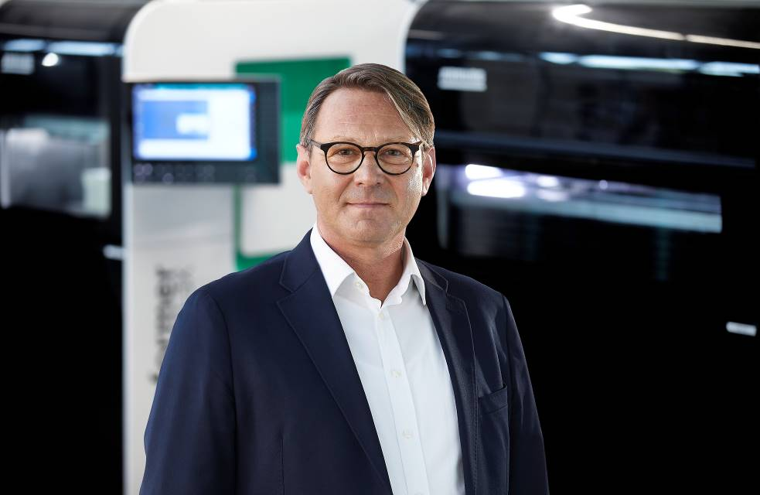

Dr Victor Roman, Managing Director of ARBURGadditive.

Additive_14032024_DSC5849

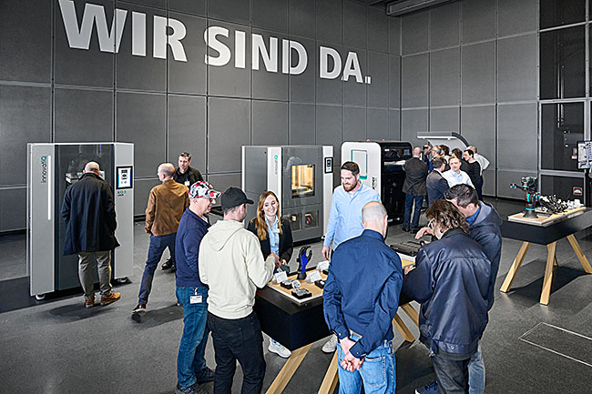

With Freeformers and 3D printers from the TiQ and LiQ series (from right), ARBURGadditive offers a suitable solution for practically every requirement.

Photos: ARBURG

Photo download:
https://media.arburg.com/web/f75a3fb46a35010/rapid-tech-2024-arburg-press-preview/

Press release
File: ARBURG press preview RapidTech 2024_en_GB.doc
Characters: 3,230
Words: 418

This and other press releases are available for download from our website at www.arburg.com/de/presse/ (www.arburg.com/en/presse/)

Contact
ARBURG GmbH + Co KG
Press office
Susanne Palm
Dr Bettina Keck
Postfach 1109
72286 Lossburg, Germany
Tel.: +49 (0)7446 33 3463
Tel.: +49 (0)7446 33 3259
presse_service@arburg.com

About Arburg
Founded in 1923, the German family-owned company is one of the world’s leading manufacturers of plastic processing machines. The ARBURG family also includes AMKmotion and ARBURGadditive, including innovatiQ.
The portfolio includes injection moulding machines, 3D printers for industrial additive manufacturing, robotic systems and customer- and industry-specific turnkey solutions. It also includes digital products and services.
ARBURG is a pioneer in the plastics industry when it comes to energy and production efficiency, digitalisation and sustainability. ARBURG machines are used to manufacture plastic products for industries such as mobility, packaging, electronics, medicine, construction and equipment engineering and leisure.
The company headquarters are located in Lossburg, Germany. In addition, ARBURG has its own organisations at 36 locations in 26 countries and, together with trading partners, is represented in over 100 countries. Of a total of around 3,700 employees, some 3,100 work in Germany while around 600 are based in ARBURG organisations around the world.
ARBURG is certified in accordance with ISO 9001 (quality), ISO 14001 (environment), ISO 27001 (information security), ISO 29993 (training) and ISO 50001 (energy).
Further information: www.arburg.com, www.amk-motion.com and www.arburg.com/arburgadditive.

