Arburg at DKT 2024
Efficient processing of solid silicone (HCR) on an electric Allrounder injection moulding machine

- Reliable: Silicone processing with an electric Allrounder 570 A
- Continuous: Material feed via ACH Turnmix in the
new M size
- Soft, yet hardwearing: Bottle opener made of solid silicone (HCR)

Lossburg, 07/05/2024
From 1 to 4 July 2024, Arburg will be presenting its extensive portfolio for elastomer processing at the German Rubber Conference DKT in Nuremberg, Germany. The exhibit at Arburg's stand 327 in hall 9 will produce bottle openers made of solid silicone (HCR, high consistency rubber) for demonstration purposes. For this, the electric machine will be equipped with a material feed in the new M size from partner company ACH Solution.

With its presence at the DKT in Nuremberg, the international industry meeting place Arburg has its sights firmly set on manufacturers of elastomer components as well as processors of rubber, HCR and liquid silicone (LSR). It sees great potential in fields such as the automation of silicone processing and multi-component technology, as well as e-mobility, fuel cells and medical technology.

Energy and production efficiency on an Allrounder 570 A
The energy- and production-efficient injection moulding of solid silicone (HCR) will be demonstrated by an electric Allrounder 570 A with a clamping force of 2,000 kN and a size 400 injection unit. The material processed will be Elastosil R plus 4001/70 from Wacker Chemie. Dosing system ACH Turnmix, now available in M and L versions along with the proven S size, provides constant and bubble-free feed at continuous pressure. This enables this production of silicone parts ranging from small to large shot volumes. The exhibit will be equipped with the new M size, which is particularly suitable for medium-sized injection units and HCR with a wide range of Shore hardnesses. The cavities of the 4-cavity mould will be injected directly via a cold runner system. This prevents burr formation and avoids the need for finishing work on the injection moulded parts. Four bottle openers at a time will be produced in a cycle time of around 60 seconds. As part of the silicone equipment package, the injection unit features a special screw geometry, cylinder temperature control and nozzle technology. The equipment, which is precisely adapted to the processing of solid silicones, transforms the Allrounder in conjunction with the ACH Turnmis into a compact and cost-effective injection moulding solution.

Pioneer in silicone processing
Arburg is a pioneer in the processing of liquid and solid silicones as well as multi-component injection moulding, and boasts an extensive portfolio of injection moulding machines and automation through to complete turnkey systems. The large selection of machine sizes, drive versions, equipment options, automation and peripheral equipment provides the perfect starting point for perfectly tailored solutions. A special feature is the 3D printing of liquid silicone components. For this, Arburg's range includes the LiQ from innovatiQ and the matching LAM (liquid additive manufacturing) process. With its expertise, Arburg also meets the needs of highly industrialised markets for digitalisation opportunities as well as minimisation of the carbon footprint.
Customers from the elastomer processing sector also benefit from Arburg's comprehensive consultation services, from procurement and technical equipment, process optimisation, mould tests and machine comparisons to training on cross-linkable moulding compounds in the Arburg Customer Center in Lossburg and in its subsidiaries worldwide.

Photo

ARBURG 188507 HCR processing 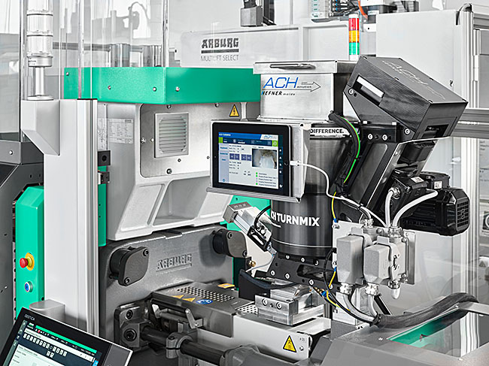

At DKT 2024, an electric Allrounder 570 A will demonstrate a reliable process for the production of solid silicone (HCR) parts. The dosing system ACH Turnmix, which has already proven itself in practice in the S size, is now also available in M and L versions for larger shot volumes.

Photo: ARBURG
Photo download links:
https://media.arburg.com/web/c9cb1ab673019d3/dkt-2024-press-preview

Press release
File: ARBURG Press preview DKT 2024_en_GB.docx
Characters: 3,307
Words: 503

This and other press releases are available for download from our website at www.arburg.com/de/presse/ (www.arburg.com/en/press/)

Contact
ARBURG GmbH + Co KG
Press office
Susanne Palm
Dr. Bettina Keck
Postfach 1109
72286 Lossburg, Germany
Tel.: +49 7446 33-3463
Tel.: +49 7446 33-3259
presse_service@arburg.com

About Arburg
Founded in 1923, the German family-owned company is one of the world's leading manufacturers of plastic processing machines. The ARBURG family also includes AMKmotion and ARBURGadditive, including innovatiQ.
The portfolio includes injection moulding machines, 3D printers for industrial additive manufacturing, robotic systems and customer- and industry-specific turnkey solutions. It also includes digital products and services.
ARBURG is a pioneer in the plastics industry when it comes to energy and production efficiency, digitalisation and sustainability. ARBURG machines are used to manufacture plastic products for industries such as mobility, packaging, electronics, medicine, construction and equipment engineering, and leisure.
The company headquarters are located in Lossburg, Germany. In addition, ARBURG has its own organisations at 36 locations in 26 countries and, together with trading partners, is represented in over 100 countries. Of a total of around 3,700 employees, some 3,100 work in Germany while around 600 are based in ARBURG organisations around the world.
ARBURG is certified in accordance with ISO 9001 (quality), ISO 14001 (environment), ISO 27001 (information security), ISO 29993 (training) and ISO 50001 (energy).
Further information: www.arburg.com, www.amk-motion.com and www.arburg.com/arburgadditive.

