Arburg: Three anniversary events at Lossburg
All good things come in threes: Fantastic start to "100 years of the Hehl family company"

- Enthusiastic: Arburg celebrates 100 years of the company's existence with around 1,200 guests from 32 countries
- Familial: Partners provide insights into the past and coming 100 years
- Successful: Two hybrid anniversary machines set the stage for new machine technology

Lossburg, 17 February 2023
In February 2023, Arburg celebrated the first three events marking "100 years of the Hehl family company". Regional guests, German and international customers and other associates closely involved in Arburg's success story were invited to the event in Lossburg. Whether they came from Lossburg, the US or China, everyone was enthusiastic about the fantastic events programme, recently unveiled machines, and friendly and innovative spirit given off by the company.
The company's three managing partners, Juliane Hehl, Renate Keinath and Michael Hehl, kicked off the evenings with an amusing question-and-answer session and explained in a very authentic and personal way all the things that have made Arburg what it is for a century and the path it is taking for the next 100 years.

Substance over style: As true today as it was back then
Juliane Hehl told of how her grandparents Arthur and Maria Hehl courageously founded the company in 1923, and how her father Eugen and uncle Karl Hehl played a key role in shaping its success and making Arburg one of the world's leading manufacturers of machines for plastics processing. Renate Keinath talked about the importance of independence, dynamic employees, innovative strength and reliability to the family company. She explained how Arburg had always trodden its own path, conducting business globally and acting locally, assuming responsibility for people and the environment, both then and now. Michael Hehl emphasised the need for Arburg to change in order to stay true to itself while retaining the fundamental positive and character-forming features of a family company. "Substance over style", the motto of previous generations, could be a valuable guide through the next decades, he felt.

Journey in time through Arburg's history
A review of 100 years of success was presented on two 45 x 4.5 metre LED screens. The 400 to 500 guests were taken on an exciting journey through time, interspersed with Arburg milestones and pictures of various events from the past. These included the company's first in-house injection moulding machine for overmoulding flash contacts, the "Informant" bus, appearances at various trade fairs, and much more.
The audience could also follow performances by freestyle artists on stage and via the LED screens. The golden 20s were reflected by five young men in a breathtaking swing & breakdance show.
Drummers provided a glimpse into the future with a spectacular LED drum show, which ended in front of two "display windows", behind which a world premiere was revealed: two new machines paving the way for a new kind of machine technology.

World premiere for two anniversary machines
Sales and Technology Managing Directors Gerhard Böhm and Guido Frohnhaus presented the two anniversary machines in an animated conversation: The hybrid Allrounder 470 H in "Comfort" and "Premium" performance variants, featuring many technical innovations that are only available from Arburg.
Guido Frohnhaus listed a number of features set to thrill sales staff and customers alike, while also quickening the pulse of any technicians in the audience: an energy footprint up to 50 per cent better than with the hydraulic machine, up to 12,000 kilograms less CO₂ emissions, and a new oil management concept requiring around 35 per cent less oil. Added to this was a reduction in dry cycle time of up to 33 per cent, flow rate splitting for simultaneous movements of the axes, and options for preventive maintenance.
Gerhard Böhm pointed out that the future is electric because this reduces the energy requirement, operating costs and carbon footprint. In his opinion, the anniversary machines would be of particular interest to customers looking for an energy-saving alternative, who appreciate an electric clamp and want the cost effectiveness of the hydraulic injection unit. An "Ultimate" performance variant and other sizes will follow later this year.

Varied event programme
Video greetings sent in advance by many of Arburg's 3,600 employees worldwide were another highlight at the anniversary celebrations, and a selection of these was played on the big screens. The individual videos finally came together to form a mosaic image of the heads of Eugen and Karl Hehl. The evening ended with a party featuring the band "Fabelhaft". Accompanied by live music, many guests made the most of the opportunity to chat deep into the night, holding stimulating conversations with old acquaintances and new faces at the bar and looking forward with pleasure to the next 100 years of Arburg's success story.

Photos

186472
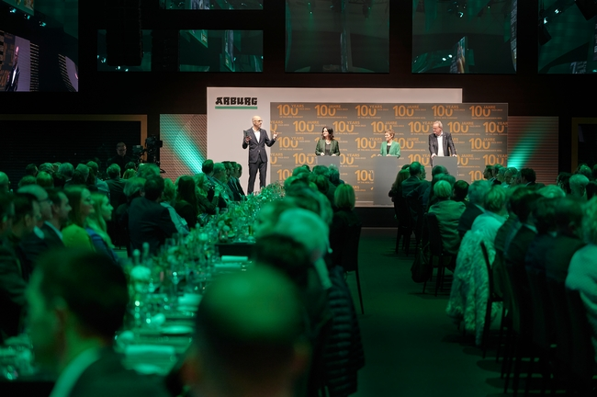
Partners kick off anniversary celebrations: Hundreds of enthusiastic guests listened intently to moderator Kai Spitzl's Q&A session with Juliane Hehl, Renate Keinath and Michael Hehl (from left).

186455
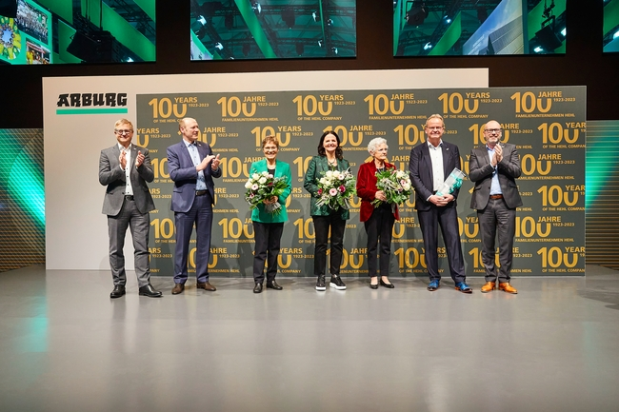
Emotional conclusion: On behalf of all employees, Managing Directors Gerhard Böhm (left), Jürgen Boll (2nd from left) and Guido Frohnhaus (right) thanked Managing Partners Renate Keinath (3rd from left), Juliane Hehl (4th from left) and Michael Hehl (2nd from right) at the end of the anniversary celebration. There was a standing ovation when Gisela Hehl (3rd from right) was asked to come on stage.
186685
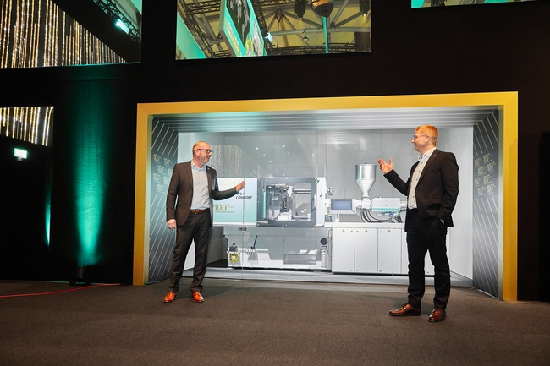
Display window: Managing Director Technology & Engineering Guido Frohnhaus (left) and Managing Director Sales Gerhard Böhm presented the world premiere of the hybrid Allrounder 470 H machines featuring new machine technology.

186744
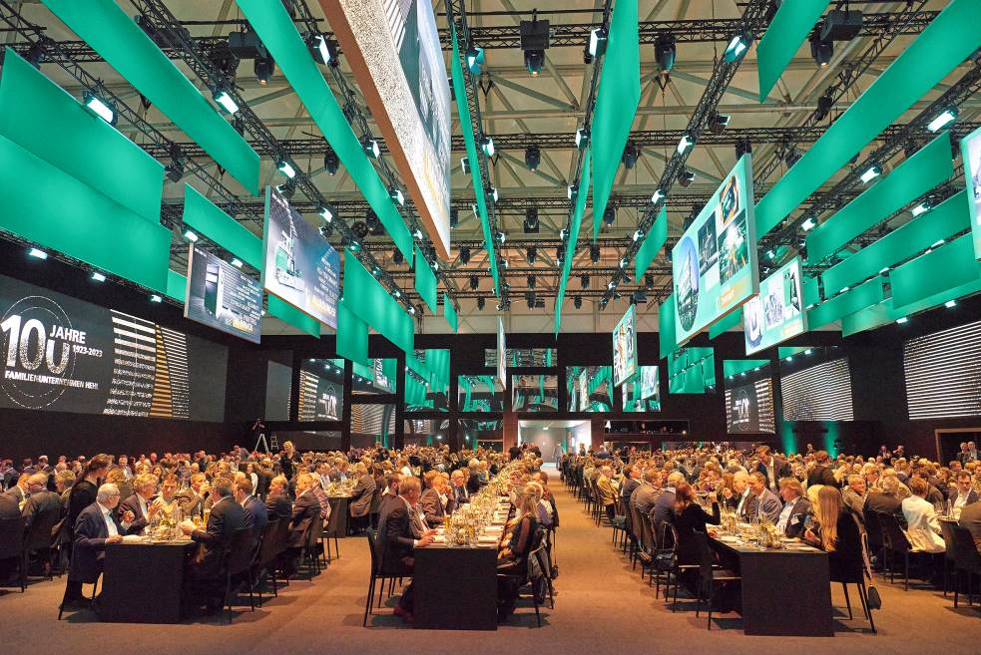
Unique: the ARBURG Cube event location.

186550 + 186482
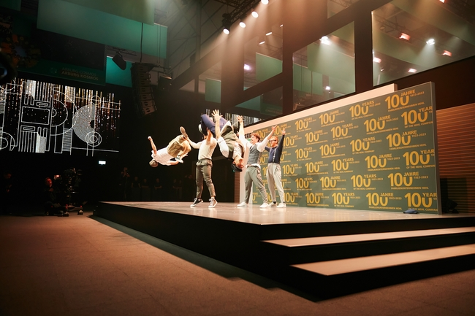

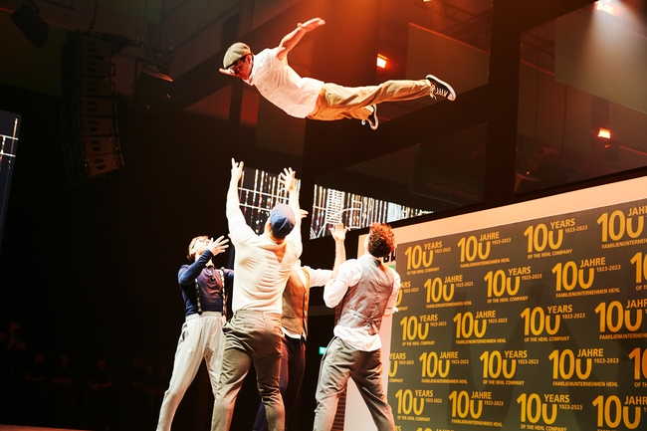
Even the breakdancers jumped for joy in celebration of "100 years of the Hehl family company".

186694 + 186476
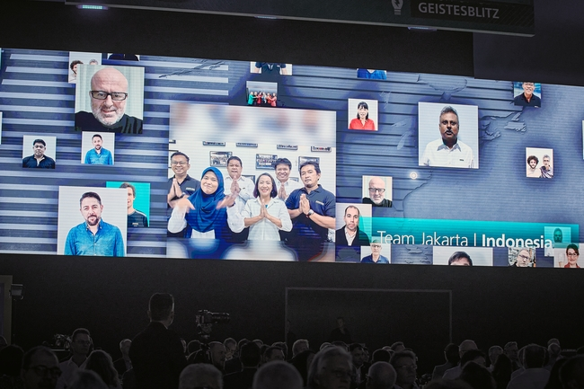
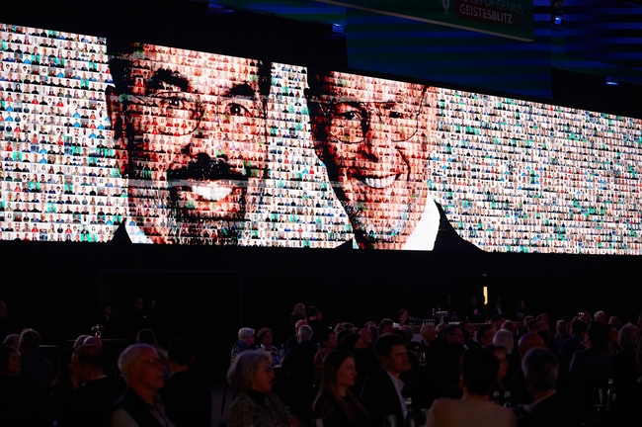
Two large LED screens broadcast greetings from Arburg employees from all over the world, with their images finally coming together to form a mosaic of the heads of Karl and Eugen Hehl (from left).

186508 + 186396
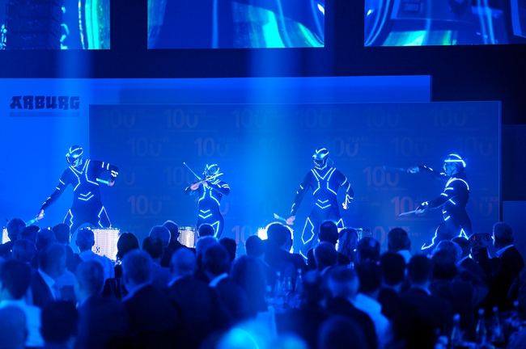

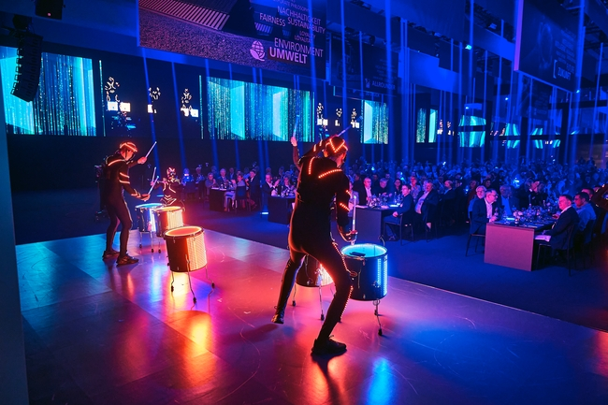
An LED drum show treated guests to a vibrant experience of sound and colour.

Photos: ARBURG

Photo download:
https://media.arburg.com/portals/downloadcollection/344D2E155A748C86EE1108396FE624B0

Press release
File: 0000.doc
Characters: 4,562
Words: 726

This and other press releases are available for download from our website at www.arburg.com/de/presse/ (www.arburg.com/en/press/)

Contact
ARBURG GmbH + Co KG
Press office
Susanne Palm
Dr Bettina Keck
Postfach 1109
72286 Lossburg
Tel.: +49 (0)7446 33-3463
Tel.: +49 (0)7446 33-3259
presse_service@arburg.com

About Arburg
German family-owned company Arburg is one of the world's leading manufacturers of plastic processing machines. Its product portfolio encompasses Allrounder injection moulding machines with clamping forces of between 125 and 6,500 kN, the Freeformer for industrial additive manufacturing and robotic systems, customer and industry-specific turnkey solutions and further peripheral equipment.
Arburg is a pioneer in the plastics industry when it comes to production efficiency, digitalisation and sustainability. The “arburgXworld” program comprises all digital products and services and is also the name of the customer portal. The company’s strategies regarding the efficient use of resources and circular economy, as well as all related aspects and activities, are outlined in the “arburgGREENworld” program.
Arburg’s central aim is for customers to be able to produce their plastic products, from one-off parts to large-volume batches, in optimum quality at minimum unit costs. The target groups include, for example, the automotive and packaging industries, communication and entertainment electronics, medical technology and the white goods sector.
An international sales and service network ensures first-class customer support at a local level: Arburg has its own organisations at 34 locations in 25 different countries and, together with its trading partners, is represented in more than 100 countries. Its machines are produced at the company's German headquarters in Lossburg. Of a total of roughly 3,600 employees, around 3,000 work in Germany. About 600 further employees work in Arburg's organisations around the world. Arburg has triple certification, in accordance with ISO 9001 (quality), ISO 14001 (environment) and ISO 50001 (energy).
Further information about Arburg can be found at www.arburg.com

