Arburg exhibit at Fakuma 2023
ARBURGadditive: Industrial 3D printing with Freeformer 750-3X and TiQ 2

- Freeformer 750-3X: High-temperature version for processing original Ultem plastic granules
- TiQ 2: Compact 3D printer will produce robotic grippers from reinforced filament
- ARBURGadditive: Comprehensive range of products for industrial additive manufacturing

Lossburg, 17/10/2023
Arburg will be present at Fakuma 2023 with nine exhibits on stand 3101 in Hall A3, plus eleven additional machines on partner stands. In the additive manufacturing area, the company will be presenting a high-temperature version of its new Freeformer 750-3X, processing Ultem 9085 original plastic granules. A TiQ 2 from innovatiQ will demonstrate the 3D printing of operating equipment and robotic grippers from fibre-reinforced filament.

The compact 3D printers from the TiQ series process filaments and are an ideal first step into the world of additive manufacturing. The Freeformers produce resilient functional components from original and certified plastic granules, including in hard/soft combination. These high-end machines are suitable for sophisticated applications in areas such as medical technology, the automotive industry and aerospace.

Processing of high-temperature plastics
At Fakuma, a new high-temperature version of the Freeformer 750-3X will be producing geometrically sophisticated ventilation ducts from original material Ultem 9085. To achieve this, the temperature of the build chamber can be raised to 200 degrees Celsius, and the granules are plasticised at up to 450 degrees Celsius.
The high-end machine has three discharge units and, from the outside, is indistinguishable from the Freeformer 300-3X. However, at around 750 square centimetres, the part carrier is around 2.5 times larger. This means that larger functional parts can be produced with plastic granules using Arburg Plastic Freeforming (APF) and small batches can be additively manufactured on an industrial basis. Many APF components will be on display at Fakuma, including orthopaedic insoles as two-component parts that can be individually adapted to the footbed.
Data processing and the Gestica controller, which was developed and manufactured by Arburg in-house, have been optimised in terms of process stability, component quality and build time. The result is significantly reduced costs per part and lower material usage.
For seamless documentation and traceability of each individual part, there is the "ProcessLog" customer portal app. This allows a wide range of process and build job data from parts manufactured using the APF process to be displayed in clear graphical form and documented – which in turn ensures transparency, high part quality and can significantly reduce rejects and error rates.

Compact 3D printer processes fibre-reinforced filaments
The second machine exhibit is a TiQ 2, which can process fibre-reinforced filaments based on PA and PP, for example, using the fused filament fabrication (FFF) process. This 3D printer is particularly economical and also ideal as an entry-level additive manufacturing solution thanks to its open material system. The compact production machine has a CNC controller, metal chassis and an enclosed safety area.
Items on show at Friedrichshafen will include resilient suction pads and mechanical grippers made of fibre-reinforced PA and PP with individualised fingers for picking up components, mounted on robot arms. In addition to the additive manufacturing of end-of-arm tooling (EAOT), the open material system is perfect for the cost-effective 3D printing of devices and other operating equipment. All 3D printers from innovatiQ are operated using the intuitive GestiQ-Pro industrial controller. The optional SmartMonitoring system allows several printers to be monitored simultaneously during production.

Photos

183833

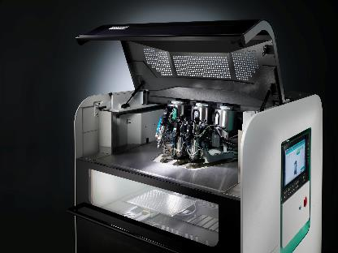

The Freeformer 750-3X has three discharge units and additively manufactures resilient functional parts, including in hard/soft combination and from original plastic granules.

195661
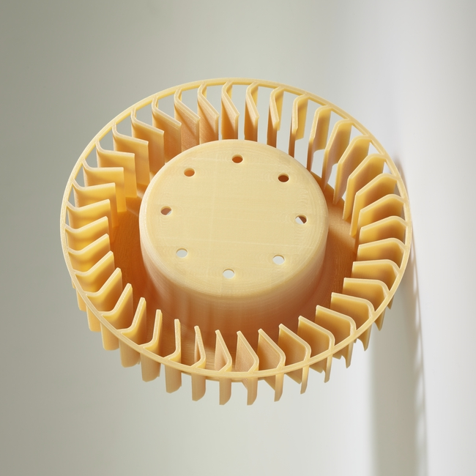
For ventilation ducts made of original Ultem and other aerospace components, seamless documentation of the process data also plays an important role.

184505

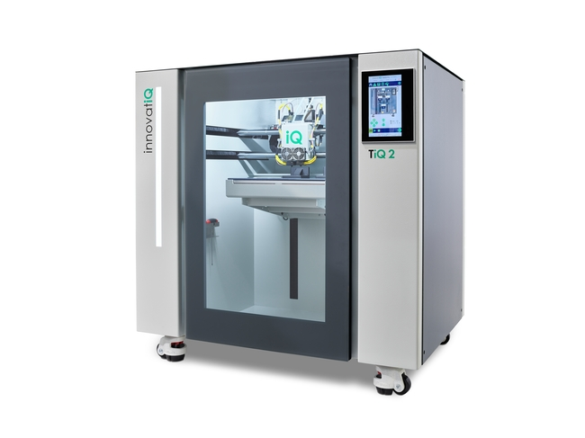

The TiQ 2 3D printer from InnovatiQ really comes into its own when processing fibre-reinforced materials for operating equipment such as devices and removal modules.

194726

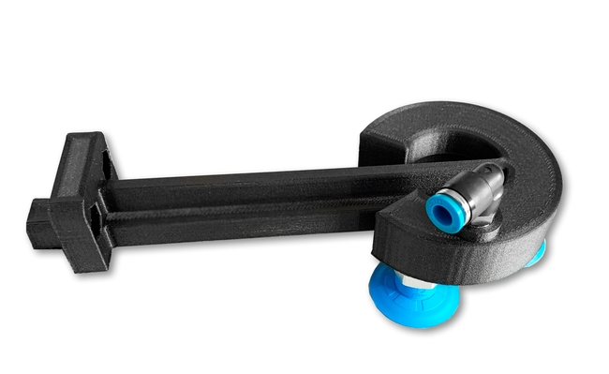

At Fakuma 2023, a TiQ 2 will demonstrate the additive manufacturing of robotic grippers. The 3D printer is optimised for processing fibre-reinforced filaments.

Photos: ARBURG

Photo download – updated with motifs from the trade fair:
https://media.arburg.com/portals/downloadcollection/A2555796F192D8A5E555B41DD3D6FE9B

Press release
File: ARBURG Press release Additive Manufacturing Fakuma 2023_en_GB.docx
Characters: 3,463
Words: 508

This and other press releases are available for download from our website at www.arburg.com/de/presse/ (www.arburg.com/en/press/)

Contact
ARBURG GmbH + Co KG
Press office
Susanne Palm
Dr Bettina Keck
Postfach 1109
72286 Lossburg
Tel.: +49 (0)7446 33-3463
Tel.: +49 (0)7446 33-3259
presse_service@arburg.com

About Arburg
German family-owned company Arburg is one of the world's leading manufacturers of plastic processing machines. Its product portfolio encompasses Allrounder injection moulding machines with clamping forces of between 125 and 6,500 kN, the freeformer for industrial additive manufacturing and robotic systems, customer and industry-specific turnkey solutions and further peripheral equipment.
Arburg is a pioneer in the plastics industry when it comes to energy and production efficiency, digitalisation and sustainability. The "arburgXworld" program comprises all digital products and services and is also the name of the customer portal. The company’s strategies regarding the efficient use of resources and circular economy, as well as all related aspects and activities, are outlined in the 'arburgGREENworld' program.
Arburg's main aim is to enable its customers to manufacture their plastic products, from one-off parts to large-volume batches, to optimum quality standards and in a way that conserves resources, is sustainable and minimises unit costs. Target groups include the automotive and packaging industries, communication and entertainment electronics, medical technology and the white goods sector.
First-class customer support on-site is guaranteed by the international sales and service network: Arburg has own organisations in 26 countries at 36 locations and is represented in over 100 countries together with trade partners. Its machines are produced at the company's German headquarters in Lossburg. Of a total of roughly 3,800 employees, around 3,200 work in Germany, with another 600 employees based in Arburg's organisations around the world. Arburg is certified to ISO 9001 (quality), ISO 14001 (environment), ISO 27001 (information security), ISO 29993 (training) and ISO 50001 (energy).
Further information about Arburg can be found at www.arburg.com

