ARBURG at Chinaplas 2024
arburgSOLUTIONworld – a world of answers

- "Lighthouse": Interactive exhibition area around four-metre-high LED column
- Added value: Individual advice on digitalisation, automation, moulds, sustainability and service
- Presented live: Host computer system, customer portal and other digital products and services

Lossburg, 21/03/2024
Arburg will also be offering an interactive exhibition area at Chinaplas 2024 in Shanghai (hall 4.1, stand D42). The striking arburgSOLUTIONworld will be a lighthouse in the sea of plastics processing, bringing together Arburg's consulting expertise and providing trade visitors with real added value. The experts from Arburg China will be on hand at five stations around the tall LED column to provide personalised advice on current topics and present digital products as well as automation solutions and services.

China has built the world's largest 5G network, and the digital transformation is currently a major topic for many plastics processors. In arburgSOLUTIONworld, customers and interested parties will receive answers and solutions to their questions.

Arburg: Expert solution provider
Arburg is not only an innovative machine manufacturer, but also a provider of complete solutions for plastics processing and the industry's number one in digital transformation. arburgSOLUTIONworld contains the company's combined knowledge and expertise on topics such as increasing efficiency through automation, the arburgGREENworld sustainability programme, mould design and application technology, plus service and training. Arburg's experts provide practical advice and work with customers to find the right levers to increase efficiency and reduce costs. With intelligent production solutions that are tailored to their respective requirements.

Digital products and services increase efficiency
With products such as the Arburg host computer system ALS and arburgXworld, the customer portal that can be networked with it, Arburg is demonstrating how digitalisation can make a significant contribution to increasing the energy and production efficiency of machines and systems. In a representative survey in November 2023, 96 per cent of users indicated that they were very satisfied or satisfied with ALS, particularly in terms of transparency, improved data quality and the reduction in machine standstills. As a result, the respondents were able to increase OEE (overall equipment effectiveness) and overall plant efficiency by an average of more than 26 per cent. Added to this is the Gestica control system with its intelligent assistance and pilot functions that help users to work with the optimum process parameters. All injection moulding exhibits at Chinaplas will be equipped with an IIoT gateway and cross-linked via ALS. The machine dashboard will be displayed on a large screen, and there will also be machine terminals on the Allrounders.

Local automation solutions
Another topic on which Arburg will be briefing Chinaplas visitors is the potential of automated injection moulding production. Together with local partners, Arburg implements a wide range of automation solutions. At the Arburg Technology Factory (ATF) in Pinghu, the machines are adapted to meet customer-specific requirements – right through to the complete production cell. Customers can also have their moulds validated there and take part in training courses. They are provided with comprehensive application-related support.
The Flexlift is a linear robotic system designed for the Asian market. At Chinaplas 2024, it will be handling two applications: the production of LSR components on an Allrounder 470 E Golden Electric and medical technology adapters on a hybrid Allrounder 470 H.

Photos

196652
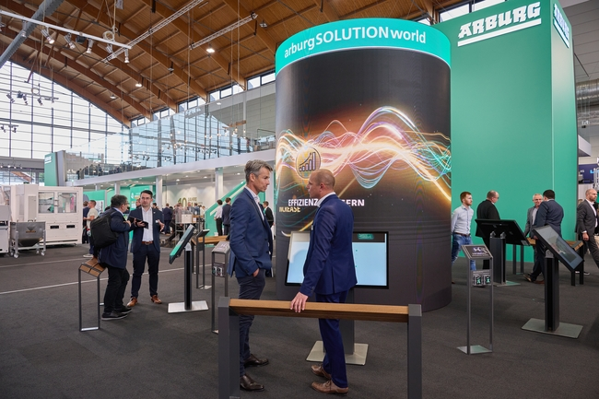

At Chinaplas 2024, Arburg will also be bringing together its consulting expertise in arburgSOLUTIONworld, an interactive exhibition area. Arburg experts will provide advice on topics such as digital transformation, automation and service around the interactive LED column.

191867
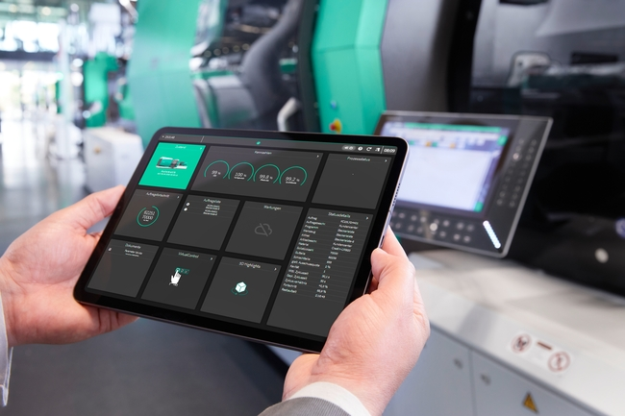

"ALS mobile" contributes to greater transparency and efficiency in production. This mobile Arburg host computer system provides direct access to indicators on machines, orders and quality, for example.

Photos: Arburg
Photo download:
https://media.arburg.com/web/ea5894cf3695e08/arburgsolutionworld-chinaplas-2024---arburg-press-release/

Press release
File: ARBURG press release arburgSOLUTIONworld Chinaplas 2024_en_GB.doc
Characters: 3,367
Words: 496

This and other press releases are available for download from our website at www.arburg.com/de/presse/ (www.arburg.com/en/press/)

Contact
Arburg GmbH + Co KG
Press office
Susanne Palm
Dr Bettina Keck
Postfach 1109
72286 Lossburg
Tel.: +49 (0)7446 33-3463
Tel.: +49 (0)7446 33-3259
presse_service@arburg.com

About Arburg
Founded in 1923, the German family-owned company is one of the world's leading manufacturers for plastics processing machines. AMKmotion and ARBURGadditive including innovatiQ also belong to the ARBURG family.
The portfolio encompasses injection moulding machines, 3D printers for industrial additive manufacturing, robotic systems as well as customer- and industry-specific turnkey solutions. It also includes digital products and services.
ARBURG is a pioneer in the plastics industry when it comes to energy and production efficiency, digitalisation and sustainability. ARBURG machines are used to manufacture plastic products for the mobility, packaging, electronics, medical, construction and equipment engineering and leisure industries, for example.
The company headquarters are located in Lossburg, Germany. In addition, ARBURG has own organisations in 26 countries at 36 locations and is represented in over 100 countries together with trading partners. Of a total of roughly 3,700 employees, around 3,100 work in Germany, with another 600 employees based in ARBURG's organisations around the world.
ARBURG is certified to ISO 9001 (quality), ISO 14001 (environment), ISO 27001 (information security), ISO 29993 (training) and ISO 50001 (energy).
Further information: www.arburg.com, www.amk-motion.com as well as www.arburg.com/arburgadditive.

